Year 1 Health and well being
Week 1 | To know what keeps our bodies healthy. | Enquiry question:  How do I stay healthy? | Lesson plan 1a
Week 2 | To know how I keep clean. | Enquiry question  How do I keep clean | Lesson plan 1b
Week 3 | To recognise what I am good at and to set a target. | Enquiry question  What am I good at? | Lesson plan 1c
Week 4 | To understand what change is (growing and changing) |  | Christopher Winters lesson plans
Week 5 | To know how to stay safe at home. | Enquiry question  How do I stay safe at home? | Lesson plan 1d
Week 6 | To know how to ask for help when I need it.  CSE year 1. | Enquiry question  How do I ask for help? | Lesson plan 1e

Year 1 summer term: Health and wellbeing
Lesson plan 1a
Aim: To know what keeps our bodies healthy
Enquiry question: How do I stay healthy?
Starter: what does healthy mean? What do we know about keeping healthy? Ask children to discuss with partners what healthy means and what they know. Write up on board key words/ phrases children come up with. Come up with a class three top tips for staying healthy.
Main: watch this BBC KS1 video “What do humans need to stay healthy” https://www.bbc.co.uk/bitesize/clips/zgtr82p
Then ask and discuss these questions about the video:
- How does being healthy help you?
- What kinds of food are healthy?
- How do we make our body stronger and fitter?
- What does good hygiene mean?
- How do we help stop germs getting inside us?
- Why do we need sleep?
Activity: Children draw a picture of themselves and around the figure record ways to keep healthy using the information gathered in the discussion.
Plenary: return to the three top tips you came up with in the starter – do we need to change any of them or add anything? Did we miss anything out? What do you think is the most important healthy tip?

Year 1 summer term: Health and wellbeing
Lesson plan 1b
Aim: To know how I keep clean
Enquiry question: How do I keep clean?
Starter: Last lesson we mentioned the word hygiene; what does that mean? What do we know about hygiene so far? Why is keeping clean important?
Main: watch this youtube video “Personal hygiene for kids- showering, handwashing, tooth brushing, face washing” https://www.youtube.com/watch?v=D5BtnvQqbWs

During the video the cartoon character makes clear how and why we do all the things listed in the title. Pause the video at opportune moments to ask what the children think the child will do next e.g. we see him looking sweaty after playing basketball; what do you think they will do now? why? Where does the child put their clothes, why don’t they drop the clothes on the floor and leave them there?
Activity: give children the following headings:
Washing hair
Showering
Handwashing
Cleaning teeth
Washing face
Children draw and record each one and write a sentence to say each is important. Or give the children the following images, children stick in and label each.
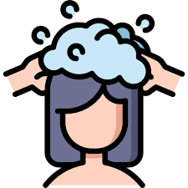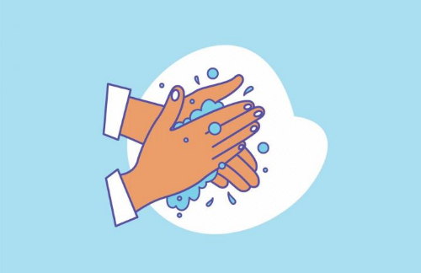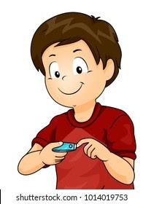

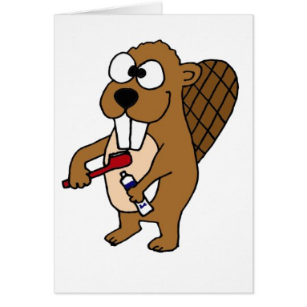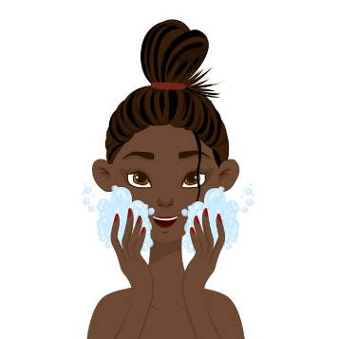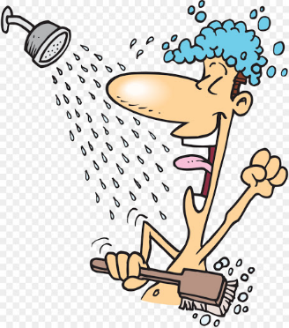

Plenary: What happens if we don’t keep ourselves clean? Whose job is it to stay clean and healthy? Is it your mum or your dads job to keep you clean, or is this something you have to do yourself? Can babies keep themselves clean? How are we different from babies?

Year 1 summer term: Health and wellbeing
Lesson plan 1a
Aim: To recognise what I am good at and to set a target.
Enquiry question: what am I good at?
Starter: what things are we good at in our school? Ask children to no nominate things that other children are good at in their class. Ask how does it feel when someone says you are good at something?
Main: When you are good at something, can you always improve? Giver an example- if someone is good at counting, how can they improve? They can count to a higher number or learn their times tables. If someone is good at running, how can they improve? What if someone is good at dancing?
Have a look at this photo and ask children what they see, what do you think this photo is about?
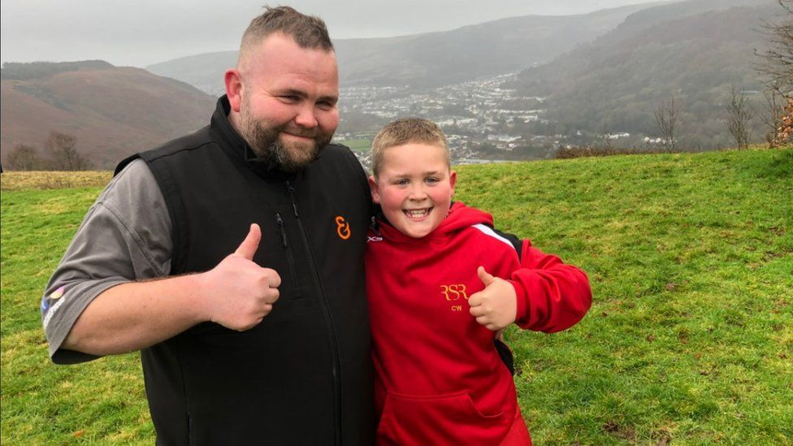
Corey Williams is 10 years old and lives in Wales. He’s very good at running and quite strong. He set himself a target to improve himself. What do you think his target was?
Corey set himself a target to run up a hill carrying a sack of potatoes to raise money to buy I-pads for people in hospital. When he reached his target, what do you think he did next? He ran up two hills, and then a third! Why didn’t he just stop after the first time? Why do you think he set himself this target?
Activity: We don’t have to run up hills to achieve our targets; we might do that when we are older but what can we do now, today, to improve ourselves? Children record what they are good at now and write a target to improve. Draw and label their target.
Plenary: After his runs, Corey said, “If I’ve learned one thing it’s that anything is achievable and anything is possible in your life” what does he mean by that? What can we learn from Corey? What targets can we set ourselves in our class?

Year 1 summer term: Health and wellbeing
Lesson plan 1d
Aim: To know how to stay safe at home.
Enquiry question: How do I stay safe at home?
Starter: put the words safe and dangerous on the board and ask what they mean. Show this pictures and discuss what is safe and what could be dangerous here and why:
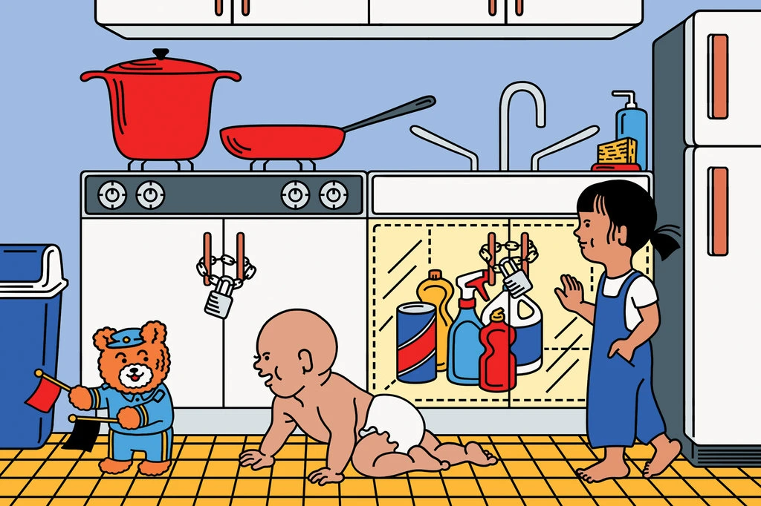

Main: Show the children the worksheet on the next page. Children use the images to decide what is safe and unsafe in the home.
Activity: Children record which objects are safe and which are unsafe in the home. As an extension children could write how to make all the images safe.
Plenary: What is safe and unsafe at school? Is there anything unsafe in our classroom? What about the way we move around or the way we sit at our tables? How can we make sure our classroom is a safe place for everyone?

Year 1 summer term: Health and wellbeing
Lesson plan 1e
Aim: To know how to ask for help when I need it.
Enquiry question: How do I ask for help?
Starter: when do we ask for help? Ask children to think about the last time they asked for help. Would anyone like to share? How do you know if someone needs help? Do people always ask if they need help? Why not?
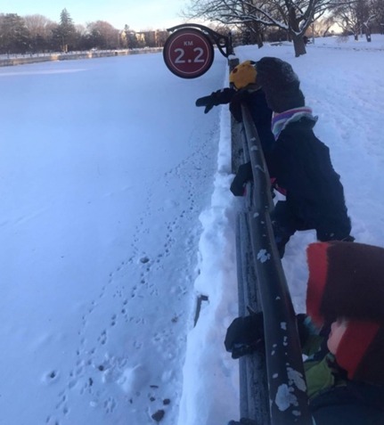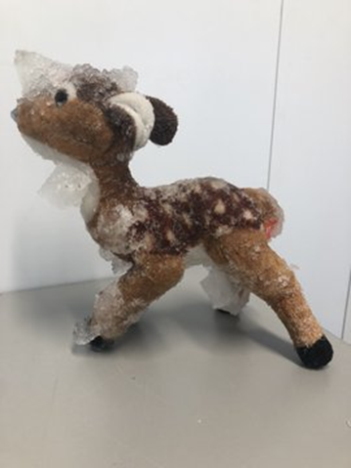
Ask children what they see in this photo. Any guesses what the story might be?
Nico Lavallee is four years old and lives in Canada. His favourite toy is a reindeer but unfortunately while on a walk in the snow lasty week, his little brother tossed the reindeer over a fence and it landed in a frozen lake. No one could reach it and it was too dangerous to step on the ice to retrieve it. Every day for the next few days, the family walked to the lake to see if reindeer was still there. Gradually the reindeer was covered with snow and all that could be seen was a lump in the lake.
Nico’s older brother had an idea; he knew that social media had helped people keep in touch during lockdown. He suggested Mum sent as message out to see if anyone could help. Mum thought “I didn’t want to bother anyone; I thought no one would care.”

Owners of a skating rink mounted a rescue mission. Reindeer was found, thawed out and dried and returned to Nico. Duke from the skating rink said, “You just have to just have to ask,” said Duke. “People do care.”
Activity: How do you think Mum asked for help? Draw a picture of Mum next to the lake with a speech bubble. Write how Mum asked for help in the speech bubble. Draw Duke and give him a speech bubble too; how does Duke respond?
Plenary: why do you think Mum thought no-one would care? If she hadn’t asked for help, what would have happened to the reindeer? What did Mum learn about asking for help?
Who can you ask for help if you need it? Ask children to nominate someone at home and someone at school they can talk to if they need help or if they feel worried.
Year 2 Health and well being
Week 1 | To make informed choices about my health. | Enquiry question | Lesson plan 2a
Week 2 | To recognise my feelings and describe them. | LO To have self confidence  How to be a lion – Ed Vere | No Outsiders lesson plan
Week 3 | Sex education (check parental consent)  To use correct names for body parts (boys and girls)  Christopher winters |  | Christopher Winters lesson plan
Week 4 | End of year reports -  To recognise what I am good at and set myself goals | Enquiry question  What are my goals?  Impossible by Tracey Courderoy | Lesson plan 2b
Week 5 | To know how to stay safe online. | Enquiry question  How can we use the internet? | Lesson plan 2c
Week 6 | To know how to stay safe outside  (road, water, fire etc) | Enquiry question | Lesson plan 2d

Year 2 summer term: Health and wellbeing
Lesson plan 2a
Aim: To make informed choices about my health.
Enquiry question: What does it mean to be healthy?
Starter: Discuss what children understand about being healthy and the choices we make. What choices do we have regarding food and drink? What choices do we have regarding activities at home? Can we choose to stay healthy?
Main: Watch the Tesco Healthy eating- an introduction for 5-11 year olds https://www.youtube.com/watch?v=mMHVEFWNLMc
Discuss:
- What do all living things need to stay alive? (palnts)
- How does being hungry make you feel?
- What happens to a car if it runs out of petrol? Why is this like humans?
- What is a balanced diet, why don’t we eat just chocolate or just carrots?
Activity: Under the heading, how can I keep healthy? Split the page in to two halves and on one half write “food” and the other write “activity”. Now record examples of food and activity that keeps us healthy.
Underneath, children answer the following:
Why don’t we eat just chocolate?
Why don’t we eat just apples?
What is a balanced diet?
Plenary: We want children to be excited about fruit and veg; show the children a range of colourful fruit and veg and show how they can be cut up and shared: carrots, peppers, tomatoes, bananas etc which ones do we like best as a class? (this could be an activity in itself)

Year 2 summer term: Health and wellbeing
Lesson plan 2a
Text: Impossible by Tracey Courderoy
Aim: To recognise what I am good at and set myself goals
RSE link: Caring friendships- the characteristics of friendships, including mutual respect, truthfulness, trustworthiness, loyalty, kindness, generosity, trust, sharing interests and experiences and support with problems and difficulties.
Enquiry question: What are my goals?
Starter: what is a goal in football? What is a goal in life? How do we know what we are good at? How can we identify a goal? Can anyone think of a goal they have reached this year in Year two? (knowing times tables, achieving a sporting target, completing a piece of work or project)
Main: read the book “impossible” by Tracey Corderoy there is a youtube video of the author reading the story here
https://www.youtube.com/watch?v=TWI1DPl91zY (start at 3:40 stop at 15.30)
Discuss:
- At the beginning, why does Dog think he’ll never see the sea?
- What changes for Dog?
- How does Crab persuade Dog to travel to the sea? Why do you think he chooses to pack Dog’s suitcase?
- How is Dog feeling as the start the journey? Lok at the selfies ; what is Crab teaching Dog?
- Mouse said he used be scared of heights, Flamingo got in to flaps; what is Dog learning about other animals?
- Who helps to move the tree- what is dog learning about friends?
Why do you think Dog doesn’t go home? What has he learned?
Activity: Give children the images from the book below. Children use the selfies to track dogs journey and write about how he is trying new things and crab is teaching him to grow and be brave.
Children then consider and record their own goal for the next year.
Plenary: Look at the dedication in the front of the book; “For anyone out there brave enough to try” what do you think that means and why did the author choose those words? Why is this books about setting goals?
Every time Dog says something is impossible, how does he find solutions? On his own or in another way? How do you think friends help to find solutions? How can friends help us to achieve our goals? Under their goal, children record the friends who are going to help them achieve their goal.
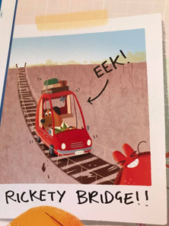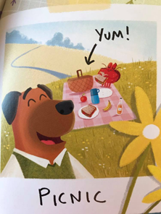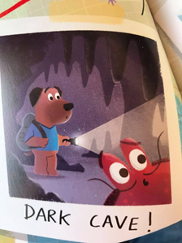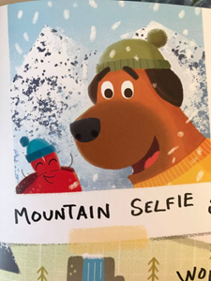

Year 2 summer term: Health and wellbeing
Lesson plan 2a
Aim: To know how to stay safe online.
RSE link:
Enquiry question: How can we use the internet?
Starter: What is the internet? Who uses the internet? What sort of ways do people use the internet?
What can we find out from the internet? Can we find out about how to do times tables? Can we find out how to make a cake? Can we find out how to travel to Africa? Can we find out what the moon looks like? Can we buy a house? What else can we do?
Main: the internet is a wonderful resource and when we use it safely we can find out lots of interesting things. What is a webcam? How are webcams used safely? Show the children the webcam for Edinburgh zoo – what do you think we will be able to see?
https://www.edinburghzoo.org.uk/webcams/panda-cam/

Now show the children this webcam for underwater in Innahura, the Maldives
https://www.skylinewebcams.com/en/webcam/maldives/lhaviyani-atoll/naifaru/underwater-cam.html

When we are with an adult, webcams can be fun and safe. But when can a webcam be dangerous for children, especially if you are on your own? What could happen?

If someone tries to contact you on the internet, asking you to be friends with them, what might happen? If someone asks you to use a webcam and say hello, what might be happening?
Sometimes people pretend to be someone else to make friends. Why can’t we know who people really are when we are on the internet?

If someone starts speaking or messaging you and asking your name, what should you do?

Activity: children record a response to the webcam, at Edinburgh zoo. What did they see, what would they like to see next? Why was this a safe internet activity for us?
Plenary: when is the internet safe to use? When do we use cameras safely? (during lockdown we all used webcams safely -how did we know we were safe then?)
If you are worried about anything you see on the internet, who can you speak to?

Year 2 summer term: Health and wellbeing
Lesson plan 2a
Aim: To know how to stay safe outside
RSE link: the rules and principles for keeping safe online, how to recognise risks, harmful content and contact, and how to report them.
Enquiry question: How do I stay safe outside?
Starter: how do we cross a road?
Main: Watch this CBeebies video about road safety.
Discuss the main points in the video -
https://www.youtube.com/watch?v=MTJUBz6Rps0
- Always hold hands with a grown up when walking near roads
- Never run out in to a road
- Find a safe spot to see the road clearly before crossing
- Look both ways and listen
- In the dark be seen
Activity: Children then record the three rules for crossing the road: stop, look, listen. What do they mean, why are they important. Children record a cartoon strip detailing how to cross the road.
Plenary: what else can we use to cross the road? Show an image of a zebra crossing – what is it?how does it work? Do you still have to stop, look listen? Why?
Are there any other ways to cross a road? What’s the difference between a zebra crossing and a pedestrian crossing with lights?
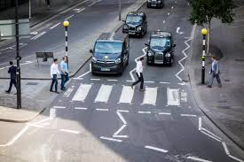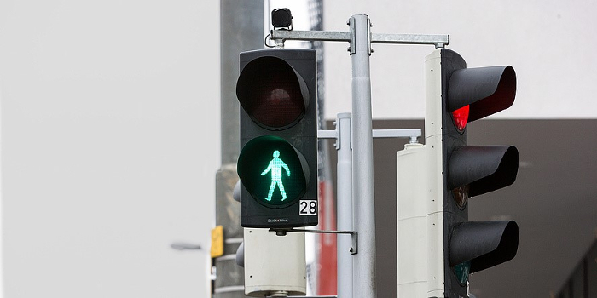

Year 3 Health and well being
Week 1 | To understand what makes a balanced diet. | Enquiry question | Lesson plan 3a
Week 2 | To understand what habits are.  hygienic | Enquiry question | Lesson plan 3b
Week 5 | To understand who helps me keep healthy and safe.  (Doctor/Dentist) | Enquiry question | Lesson plan 3d
Week 6 | To understand how to help people in need.  (fires etc) | Enquiry question  What do I do if a fire starts in my home? | Lesson plan 3e

Year 3 summer term: Health and wellbeing
Lesson plan 3a
Aim: To understand what makes a balanced diet.
Enquiry question: what are nutrients?
Starter: what is a balanced diet? What are nutrients? Can anyone name any? Where do we get nutrients from?
Main: https://www.youtube.com/watch?v=mMHVEFWNLMc

There are 5 videos to watch: Fruit and vegetables, dairy, protein, carbohydrates, food we need to eat less often. I would watch one per session as there is a lot of info in each. Follow the same lesson plan for each, I have listed main points for discussion on each video in the tables below. Watch each video and then discuss the main points asking the following questions:

Fruit and vegetables-main points. Ask children questions about each point below.
- Fruit and veg give us vitamins, minerals, fibre
- What do vitamins and minerals do for our body?
- What’s the best way to make sure we get all the nutrients we need?
- Why don’t we just eat one type of fruit and vegetable?
- Vitamin A found in orange fruit and veg, dark leafy veg – spinach, savoy cabbage, good for healthy vision.
- Vitamin B1 – helps give us energy (peas, spinach, mushrooms)
- Vitamin C- citrus fruits (helping our body heal)
- Fibre – keeps digestive system healthy.
- Eat 5 portions of fruit and veg a day ( a portion is the amount you can hold in your cupped hand)
- Eat as many different colours as possible
Activity: Record a fact sheet about nutrients in fruit and veg. Include advice about how to achieve a balanced diet.
Plenary: what other foods do we need to achieve a balanced diet?

Dairy main points
- dairy foods are made with milk, cheese and yoghurt
- they are a good source of protein and also a mineral called calcium which is important for healthy bones and teeth
- almost all the calcium in our body is stored in our bones
- strong bones are important to hold us up and move
- Children must get calcium because they are growing.
- calcium is also found in green leafy veg like cabbage, and also tofu

Protein main points
-chicken, ham, beef, salmon
- Eggs, tofu, pulses lentils/ beans
- mend our bodies, repair muscles, skin hair, helps us to breathe.
- The building blocks of our body
- attack germs and bacteria
Must eat proteins every day

Carbohydrates main points
- Bread, pasta, potatoes- startchy carbohydrates
- Rice, noodles, cereal, porridge
- Give us energy- the fuel that keeps us going
- When we eat potatoes they are not part of 5 a day (because they have lots of starch) it’s always best to eat the whole of the potato as the skin is full of nutrients.
- Best to eat wholegrain bread, rice, pasta (the whole grain = the whole grain / seed of the plant. We get all of the goodness with nothing is stripped away.
- Parts of a whole grain are the bran, endosperm and germ.
- Bran – protective outer layer, full of fibre and B vitamins
- Germ -embryo- will become a new plant if the seed is planted
- Endosperm – largest part contains all the food for the seed to grow in to a plant
- White bread, pasta and rice contains must less of the fibre that whole grain foods contain

Foods we need to eat less often main points
- Some foods taste nice but don’t give out bodies any of the nutrients we need
- They often contain higher levels of fat, salt or sugar
- Sweets, crisps, chocolates, cakes
- Too many cakes and sweets = tooth decay. Children aged 4-6 should have no more than 5 sugar cubes a day. One can of fizzy cola contains 9 sugar cubes!
- Fruit and cheese also contain sugars but the difference is they also contain nutrients that we need.

Year 3 summer term: Health and wellbeing
Lesson plan 3b
Aim: To understand what bacteria is
Enquiry question: what is bacteria?
Starter: ask the children what is bacteria, where does it come from? How does it affect us? How does it grow? What can we do to stop it growing? Is there bacteria now in our classroom? Should we be worried?
Main: watch this short BBC bitesize clip about bacteria https://www.bbc.co.uk/bitesize/clips/zq4ygk7

Discuss:
- Where did the bacteria on the man’s hand come from?
- Why can’t we see the bacteria on our hands?
- “Every day our hands come in to contact with millions of organisms of bacteria” how? Where are they?
- How long does it take for a single cell to divide in to 2? (20 minutes) what happens after another 20 minutes?
- How do most bacteria cells die? (heat kills / cold stops them multiplying)
Activity: Record answers to the questions above. Show how bacteria multiply in number over time.
Plenary: what do we have in the home to help stop the growth of bacteria? What habits do we have every day that help to stop the growth of bacteria? (washing hands)
Are fridges just to keep our drinks nice and cold? Why do we wash our hands after going to the toilet? Are there any other times we should wash our hands? Why?

Year 3 summer term: Health and wellbeing
Lesson plan 3c
Aim: To understand what habits are hygienic
Enquiry question: what is basic hygiene?
Starter: what is hygiene? Can anyone give an example of a habit or a practice that is hygienic?

Main: Think about hygiene through history – how were attitudes to hygiene different to today? What do you know about differences in hygiene between us and people living in the middle ages, 600 years ago? Where did people go to the toilet? What happened to their waste? What was human waste sued for? Watch this Horrible Histories video “Putrid water – measly middle ages”
https://www.youtube.com/watch?v=8P7cRTYNCdI

Discuss: How did people wash their clothes?
Can you think of a reason people might have thought that was a good idea?
How were toilets different in the Middle Ages?
What do you think streets were like?
What do you think the standard of hygiene was at the time?
In the Middle Ages, life expectancy was 33 years. Today it is 79 years for males and 83 for females. Why do you think life expectancy has increased so much?
Activity:
Children discuss and record and illustrate examples of good hygiene under the following headings: Oral hygiene, bathing, hair care, food hygiene, toilet hygiene, hand hygiene, coughing and sneezing hygiene
Plenary: Who can we visit if we need help with illness? What is the difference between a doctor and a dentist?

Lesson plan 3d
Aim: To understand how to help people in need (fires)
Enquiry question: What do I do if a fire starts in my home?
Starter: Show this picture – what do you see, what has happened?
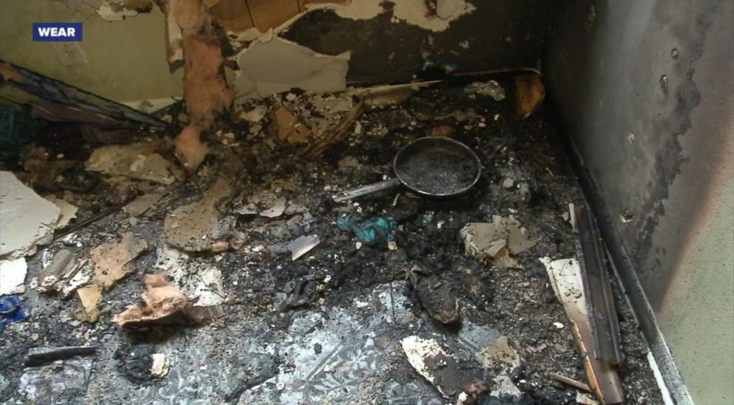
This is a picture of a house fire after the fire has been put out. The family were saved by a 7 year old girl who knew what to do because she had learned about fire safety at school.
Ask the children what should they do if a fire starts in their home? Should they try and put it out? Should they throw water on it? Does water always put out a fire?
Main: Explain the story behind this fire. The is a short clip in this link of Tracey, the 7 year old girl explaining what she did when a pan caught fire in her home. She did not try to put it out, rather she ran next door to ask for help and a phone to call the fire brigade. https://abcnews.go.com/US/year-girl-rescues-family-house-fire/story?id=52691433

You might want to show this video “Don’t put water on a grease fire” but watch first to make a decision about the maturity of your class https://www.youtube.com/watch?v=v3F4c5o4J7M
Activity: Record instructions for what to do if a fire starts in your house:
- if they see smoke or flames, they should tell someone straight away – a grown-up if possible.
- get out of the building as soon as possible.
- never go back into the building for anything.
- never hide in a cupboard or under a bed – get out of the house and call for help straight away.
Plenary: Tracey is being called a hero- why do you think this is?

Year 4 Health and well being
Week 1 | To understand what makes a balanced lifestyle. | Enquiry question  How do choices I make affect me? | Lesson plan 4a
Week 2 | To promote mental health and well being | Enquiry question  Why am I incredible?  Incredible you – Rhys Brisenden and Nathan Reed | Lesson plan 4b
Week 6 | To understand how to stay safe online. | Enquiry question  How do I stay safe online? | Lesson plan 4c

Year 4 summer term: Health and wellbeing
Lesson plan 4a
Aim: To understand what makes a balanced lifestyle.
Enquiry question: How do choices I make affect me?
Starter: What choices are we faced with every day? Give examples.
How do the choices we make affect our health, our mental health and out wellbeing? Can food affect our wellbeing?
Main: watch this video “what is a healthy lifestyle?” https://www.youtube.com/watch?v=zL2M67jbCzI

And discuss the following:
- “you are what you eat,” what does this mean?
- What is a balanced diet?
- “A lifestyle that means not sitting in a chair all day” – give examples
- “You need to use as much energy as you take in” – what does this mean?

Watch this video: “The choice” is shows how the choices a man makes in his life start to affect his health.
https://www.youtube.com/watch?v=_HEnohs6yYw
Activity: Children use “The choice” video as stimulus to create a cartoon strip showing choices they make every day and the effect each choice will have on their body or their mental health.
Plenary: if you want to be happy, look after yourself. What does this mean

Year 4 summer term: Health and wellbeing
Lesson plan 4b
Text: Incredible you – Rhys Brisenden and Nathan Reed
Aim: To promote mental health and well being
RSE link: the importance of self-respect and how this links to their own happiness.
Enquiry question: why am I incredible?
Starter: Look at the book cover- why do you think the illustrator chose these images? What does the cover make you think of? What do you think the book will be about? Incredible you – what does that mean? How can we be incredible?
Main: read “Incredible you” discuss:
- Why do people want to be someone else sometimes?
- What things affect our mental health and well being?
- How do you know if someone needs support?
- The author suggests some great things about being a cat or a fish. Can anyone think of other great things about being a fish or a giraffe or a mouse?
- Half way through the book the author stops thinking about how great animals are and says, “Think of the things that you can do”- why?
- Who can remember some of the suggestions? Write up examples that children remember from the book (e,g you can smell, taste, listen, look, you can make funny voices..)
- “If someone says you can’t sing, “they are wrong; you just keep singing your own special song!” – what does this mean?
- What message does the author have for us at the end of the story?
Activity: Think about what is incredible about you. Look at the page “Dream of the things you hope will happen one day” – what dreams do you have for the future? Record two boxes – the first box shows one thing that is incredible about you (you could choose something from the book or think of your own) and the second box is your dream for the future
Plenary: What does the author say about our dreams: “You can make them come true! I’m not joking, you can and yes I mean you!” Can you think of any dreams recently that have come true for people? How do dreams come true?
Talk about Kamala Harris - how did she become the first female American Vice President and first VP of colour? Did it happen by itself?
Show this story about Chris Nicik, the first person with Downs to compete an Ironman triathlon; how did Chris's dream come true? https://www.bbc.co.uk/sport/triathlon/54869998
Sometimes it’s hard to keep confidence and remember we are incredible. How can we help each other through difficult times? One of the suggestions in the book is to “write a kind note and sign your name with a squiggle” how would a kind, supportive note make someone feel? How would you feel if you received a kind note and you didn’t know who it was from?

Year 4 summer term: Health and wellbeing
Lesson plan 4c
Aim: To understand how to stay safe online.
RSE link: That people sometimes behave differently online, including by pretending to be someone they are not.
The rules and principles for keeping safe online, how to recognise risks, harmful content and contact, and how to report them.
Enquiry question: How do I stay safe online?
Starter: What’s great about the internet? What are the best things about the online world? How do you use the internet today?
How do you know you are staying safe, what potential dangers are there?
Main: Watch “CBBC Lifebabble: Staying safe online” https://www.youtube.com/watch?v=GAXBz5kC3CQ

- Discuss: People may not be who you think they are
- Age restrictions
- Never meet someone that you have met online – why not?
- Treat people the way you want to be treated – give examples
- What is a digital footprint? “There’s no such thing as a secret online” why not?
- “When you share something you are potentially sharing with billions of people” – you might think that’s a good thing, why might it not be a good thing?
- “What would Grandma think?” is this good advice? Why?
Activity: Under the heading: rules for socialising online, children record top 5 tips using the advice above.
Plenary: What do you need to do if you get a message that worries you? Take a screen shot and show it to an adult. Does everyone know how to take a screen shot? Check knowledge and practice.

Year 5 Health and well being
Week 2 | To manage change (loss, separation, divorce and bereavement) | Enquiry question  How do I move on form loss?  Waiting for wolf- Sandra Diekmaan | Lesson plan 5a
Week 3 | To understand the effect of alcohol on the body | Enquiry question  How does alcohol affect the body? | Lesson plan 5b
Week 4 | To understand the effects of smoking on the body | Enquiry question  How does smoking effect the body? | Lesson plan 5c
Week 5 | To understand the difference between legal and illegal drugs | Enquiry question  What is the difference between legal and illegal drugs? | Lesson plan 5d
Week 6 | To explore online safety. To consider the consequences of sharing pictures online. | Enquiry question  What are the consequences of sharing pictures online? | Lesson plan 5e

Lesson plan 5a
Text: Waiting for wolf by Sandra Diekmann
Lesson plan by Andrew Moffat a.moffat@excelsiormat.org
Enquiry question: How do I move on from loss?
RSE link: the characteristics of friendships, including mutual respect, truthfulness, trustworthiness, loyalty, kindness, generosity, trust, sharing interests and experiences and support with problems and difficulties.

Starter: Display the picture of Nigel watering the plant; tell the story discuss using the plan (see next page)
Main: Read “Waiting for wolf” and discuss:
- What has happened to wolf?
- Do you think Wolf knew he was about to die? Explain your answer.
- How does wolf try to prepare Fox for the change that is about to happen? Why doesn’t Wolf tell Fox the truth? Do you think this is the right decision?
- At what point do you think Fox understands what has happened? How do we know she knows?
- Why do you think Fox pulls the shining star blanket down from the sky?
- Why do you think Fox seeing her bright red paw stops her tears?
Activity 1: “Life is beautiful,” whispered Fox. Suddenly, all the things they had done together came flooding back in bright colours”
“He was gone, but all the wonderful things they had shared together would be with her always.”
What memories of her time with Wolf do you think Fox will treasure? Record a memory to help Fox celebrate her special time with Wolf. Choose and illustrate four memories.
Activity 2: The language used by the author has been carefully chosen to evoke emotion in the reader. Use the text below to as a stimulus for your own writing, extending Sandra Diekmann’s ideas and words and developing her description.
She called in to the starry sky, “Wooolf!” There was no answer. So she yelled louder in to the crushing silence…
She reached up in to the sky and pulled the shining star blanket down from the sky. Everything went dark…. She sat there for a long time, wrapped in the velvety star blanket….
Fox put the star blanket gently back where it belonged. The moon shone down peacefully over the lake and the stars danced in the sky…..
Activity 3:Study the different shapes that the artist has used to create the scene; the mountains, trees, the water, flowers, clouds and rocks.
Create a piece of art using this scene as a starting point. Show how some things are near and some are far away; study the shapes and forms and colours. You could choose another page from the book to recreate; for example, the page where Wolf says he will be ‘starlight tomorrow’ uses different patterns to show a mountain range.
Plenary: “Fox knew she wasn’t going to stay in the darkness any longer. She wanted to swim in the blue lake and run along the yellow sand.” why have Fox’s feelings changed? What has fox learned? How will this new thinking affect Fox in the future?
Why do you think Sandra Diekmann chose to write this story? Is there a message?

Nigel and Phedre met when they were both 16 years old and later got married and had children. When Phedre was 69 she died and she left her husband instructions to keep watering the plants in the bathroom when she was gone. Nigel faithfully watered the plants for five years until his children helped him move in to a retirement home, and the truth about the plants was discovered; they were made of plastic.
Nigel and Phedre's daughter Nicol said, "It was only when we flew over to help him move we realised the plants were plastic. He said, 'I wondered why they still looked so good!'."
"We really laughed about it and it was lovely to think that my mum was still there with
Year 5 summer term: Health and wellbeing
Lesson plan 5b
Aim: To understand the effect of alcohol on the body
RSE link:
Enquiry question: How does alcohol affect the body?
Starter: what is alcohol – what alcoholic drinks can children name? Tell the children this lesson is about how things we can put into our body can affect the way it works. What is the effect of alcohol on a person?
Why do people drink alcohol? (it’s available, it makes them feel good, peer pressure)
Main: Explain alcohol is a drug; a legal drug. Explain not all adults drink alcohol and in some countries and cultures alcohol is banned. Show children the pictures on worksheet 5bb and discuss whether they are alcoholic or non-alcoholic. How do they affect the body when we drink them? Highlight the pictures of beer, wine and vodka; which do children think contains the most alcohol? Order the images for strongest to weakest.
How is alcohol measured? Does anyone know the government guidance for safe drinking limits for men and women? Men should not drink more than 3-4 units of alcohol per day and women should not drink more than 1-2 units.
What is a unit? (one pint of beer is 3 units, one glass of wine is 2 units, one shot of spirit is 1 unit)

Activity: Using the worksheet 5b, children consider where people are and reasons why people are drinking
Answer the following questions:
- Is alcohol legal or illegal?
- Why do people drink alcohol?
- How does alcohol affect the body?
- What happens to the body if too much alcohol is consumed over a long period of time?
Plenary: remind children that there are lots of people who drink at home and go out and drink safely. Any drug is harmful in large quantities. Some people don’t drink at all – what are some of the reasons why some people don’t drink? What is an alcoholic? How does a person become an alcoholic? Where can they get help? Who can you talk to if you are worried about someone drinking at your home?

Year 5 summer term: Health and wellbeing
Lesson plan 5c
Aim: To understand the effects of smoking on the body
Enquiry question: Why do people smoke?
Starter: what is smoking? How do people smoke. What is the legal age you can start smoking? Why do you think children are not legally allowed to smoke? Show the non-smoking symbol; what does it mean?
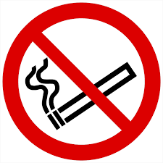
What substance makes smoking addictive? (nicotine). What does addictive mean? How does a person become addicted to nicotine, how does it affect them?
Main: Ask children to record in pairs all that they know or have heard about how smoking affects people and their bodies. Discuss ideas and address misconceptions that come up.
How does smoke get in to your body? Ask children to take deep breaths and feel how the air fills them up, then breathe out slowly. What is happening inside our body, where does the air go? When we smoke it is the smoke that fills our lungs, not air.
Why do you think some people smoke? Show the images on the worksheet 5c and discuss in pairs before feeding back. For each picture children explore why they think people are smoking.
Do these reasons fit any of the pictures?
looking cool, following friends, they don’t know the health risks, they don’t think they will become addicted, it’s relaxing for them, it’s become a habit, they feel stressed and smoking helps, peer pressure, they don’t think it affects them
Are there any good reasons to smoke? Why do some people choose to give up smoking? Do you think it’s hard to give up smoking? Why?
What is the effect of smoking on the body? When we breathe smoke in to our lungs, what happens to them?
Activity: watch this newsround clip from 2015 when a ban was put into force stopping adults smoking with children in the car. Children record arguments for and against this ban and then conclude by giving their opinion.
https://www.bbc.co.uk/newsround/34404561

Extension: what can you say to an adult wo lights up a cigarette when you are in the car?
Plenary: what is passive smoking? In what situations might passive smoking occur? What strategies can you take to avoid passive smoking?

Year 5 summer term: Health and wellbeing
Lesson plan 5d
Aim: To recognise the difference between helpful and harmful drugs, legal and illegal drugs
Enquiry question: What is the difference between legal and illegal drugs?
Starter: write “attitudes” on the board and ask children to explain what attitudes are. Give an example: place “agree” and “disagree” on the floor on either side of the room and ask children to imagine there is a line between them Now read statements such as “Children should always be in bed by 8:00” or, “plastic bags should be banned” or, “play times at school should be only 10 minutes,” and ask children to stand on the line according to their opinion / attitude.
Explain we all have different attitudes and there are no right or wrong answers.
Say there is no judgement here, this is about sharing ideas in a safe space. The more dialogue we have, the better informed we are and the better choices we make.
Main: Show children these pictures and ask them to think about which person might be a drug user:
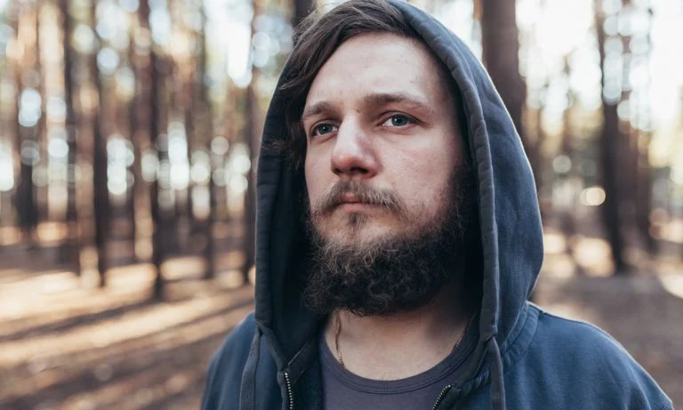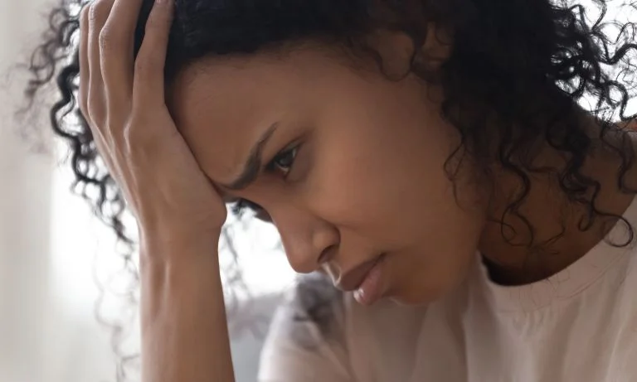
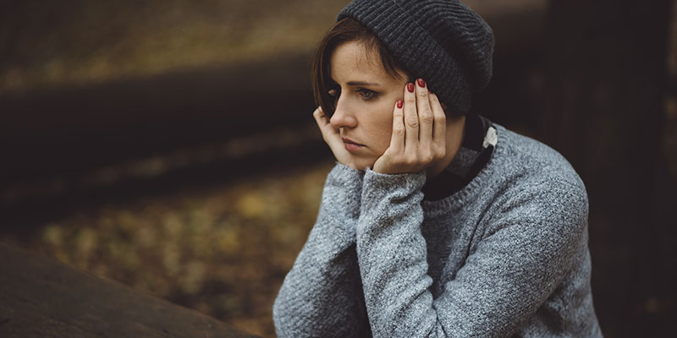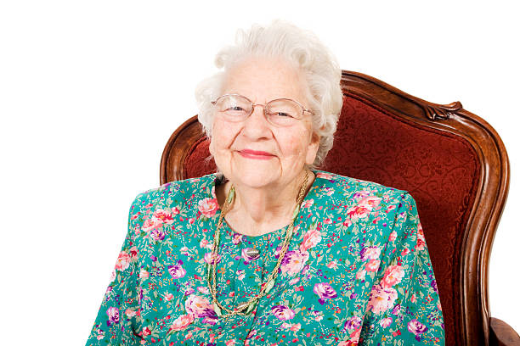

Could they all be drug users? Are all drugs illegal and bad for your health? Ask children to mind-map legal and illegal drugs.
Activity: Give children worksheet 5d. Children identify which drugs are legal and which are illegal. Any drug is harmful if taken in excess.

Plenary: What is the difference between helpful and harmful drugs?
When we talked about drug users, what did we base our stereotypes on? Where do you think those attitudes have come from? What can we do about that?

Worksheet 5d

Year 5 summer term: Health and wellbeing
Lesson plan 5a
Aim: To explore online safety. To consider the consequences of sharing pictures online.
RSE link: how information and data is shared and used online.
Enquiry question: What are the consequences of sharing pictures online?
Starter: why do people share pictures online? What sort of pictures do people share? What platforms do they use? What are the advantages of sharing pictures online? What can disadvantages be?
Main: Look at this picture – what do you see, where is it taken, what is happening? What do you think happened to this picture?
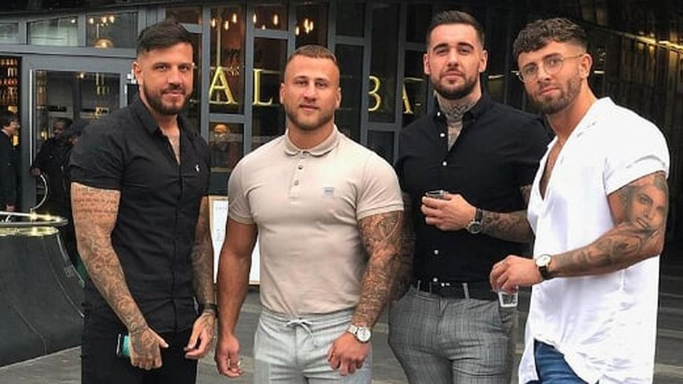

The picture shows friends Kevin, Alex, Jamie, Connor from Birmingham and Coventry. They took this photo when out in Birmingham and Connor uploaded it to his Instagram account. But after a few days the picture became a meme as people mocked the men for wearing skinny jeans.

What is a meme? (it is an image or video, usually humorous, spread rapidly on the internet)

Connor says, “At first it was funny, but then it all got a bit carried away. We started getting a lot of grief for it. We were just getting loads of stick for our outfits and it was getting personal. It’s a good job we’re quite thick skinned because at first it did get to us.”

“Everyone was just judging us and thinking we’re all stereotypical lads and we’ve got nothing else about us other than wearing skinny jeans.”

Discuss Connor’s comments – how did the comments make him feel at first, what changed?

“We were blown away by how negative everyone was. We didn’t ask for any of this. I think people forget about the people they’re trolling behind their phones or keyboards. We actually are real people and it does affect you.”

Why do you think people were so negative? What could Connor and his friends do about it?

Eventually the meme and the attention died down, as it always does. But a year later the photo resurfaced as someone made it into a video using “The Wellerman” sea shanty song https://www.youtube.com/watch?v=Ac13IiwDxcI

This video is funny, but how do you think Connor felt when the photo resurfaced after a year? What does this show about how people you don’t know can alter your image?

Connor said about the new video, “It’s just killed me, it’s hilarious! It took me of guard. You think it’s all over and then someone animates our faces and it looks like we’re singing. What can we do now? We’ve just got to embrace it. I don’t think I’ve ever laughed so much!” what do you think about Connor’s comments here? Is he really laughing? Is he glad the video happened? Why is he saying that? What will happen next time Connor goes for a job interview or meets someone new like a possible partner?

Connor was asked a year later whether he was still wearing skinny jeans; “of course! Why change now? We’re way too far in to change now.”

Original article for your background info: https://www.bbc.co.uk/news/newsbeat-55704468

Activity: Give out copies of the photo. Draw a timeline to show how these events started, what happened and how each new turn affected Connor and his friends.
Children record how Connor cold have stopped the comments and reaction when it got personal and it started to hurt (he couldn’t stop it).
Plenary: what can we learn from this story? Is it ok to have an Instagram account? What can we do to protect ourselves online?

Year 6 Health and well being
Week 1 | To recognise how content online doesn’t always reflect reality. | Enquiry question  How can online photos distort reality? | Lesson plan 6a
Week 2 | To explore the effects of commonly available drugs and substances. | Enquiry question  what is the impact of substance abuse? | Lesson plan 6b
Week 3 | Sex education To learn about human reproduction.  Christopher winters |  | Christopher Winters scheme
Week 4 | To recognise peer pressure. | Enquiry question  What is the impact of peer pressure? | Lesson plan 6c
Week 5 | To celebrate personal achievements and identify goals. | Enquiry question: | Lesson plan 6d
Week 6 | To consider how transition may affect me.  (moving to secondary) | Enquiry question | Lesson plan 6e

Year 6 summer term: Health and wellbeing
Lesson plan 6a
Aim: To recognise how content online doesn’t always reflect reality.
RSE link: that people sometimes behave differently online, including by pretending to be someone they are not.
Enquiry question: How can online photos distort reality?
Starter: What is online content? Who can access it? What platforms do people use? Look at the fake photos on worksheet 6a – what do you see? Where are they taken? Why are the people faking them?
Main: watch this video of a youtuber setting up a fake holiday for her followers (13 mins long) https://www.youtube.com/watch?v=CO024FmW9EU
There is lots to discuss in here; pause the video at different points to discuss what is happening and the consequences for all involved e.g.
- How does Roxy feel when she sees other people n holiday and she’s stuck at home?
- Why do you think she is setting up a fake holiday? 2:00 “I think my viewers might have trust issues after this” what is the consequence?
- 6:55 why does she post the best photo first?
- 7.07 “I really don’t want to have to post this, I feel so bad , I hate lying” does he have to post it? What other choices could she make now?
- 8.44 – 11:00 such a fail! How do all the negative comments affect her?
- “Welcome to my home country” what is the impact of Roxy’s choices here? How will the people living in Bali feel when they realise it’s all fake?

Activity: we never see Roxanne’s final photo; what do you think it looked like? Sketch the final photo you think Roxanne posted. Children record a response to this story; what does it show about online content? Can you always tell if a photo is fake? Does it matter? What are the consequences of so much fake content?
Plenary: how do you think Roxanne felt following this story? What can we learn from her, do you think she learned anything? Do you think this is a useful video for children to watch? Why? Why not?

Year 6 summer term: Health and wellbeing
Lesson plan 6b
Aim: To explore the effects of commonly available drugs and substances.
Enquiry question: what is the impact of substance abuse?
Starter: what is substance abuse? What substances are involved? Ask children to mind map with a partner what they know about the topic. Ask children to consider the effects of substance abuse and feedback.
Main: Watch this short animation CGI animated short film: Substance by Jamal Bradley https://www.youtube.com/watch?v=c650yL4X7Wk
The story is based on a true story. Watch from start to finish without stopping and then discuss:
- What was the storyline? How are the two men related, what is the story? (two brothers, one is clean, the other is a Dad with a daughter and is also a dealer. As the brothers play with the daughter in the house, drugs fall out of Dad’s pocket. Daughter retreats to the stairs to watch (it appears she is not surprised). Brothers sit on sofa, Dad is remorseful, uncle is angry his brother is dealing. They begin to fight, dad almost hits brother but stops himself. Dad takes daughter upstairs, brother sits on sofa. Daughter appears and hands over drugs, this suggests dad has given them to her to give to brother, so he can make a new start)
- When the little girl sees the drugs, is she surprised? Do you think she’s seen this before?
- When the two brothers are sitting on the sofa, how is each feeling?
- How does Dad feel when daughter picks up the substance?
- Why does Dad almost hit his brother, what stops him?
- When dad takes his daughter upstairs, what does uncle think is happening ?
- Why does Dad give the drugs to his daughter to giver to his brother? What is he showing his brother?
- Look at dad’s face once he has given the drugs to his brother; what bis he feeling?
- How does brother feel at the end?

Activity: Children to think about what the film’s purpose is; we all onow about how substance misuse affects a person’s body, this lesson cold have been about that, but we know already. What is this film showing- what is the hidden cost of substance misuse on a family?
This is a short film that was released in 2019, written by Jamaal Bradley and Michael yates and directed by Jamaal Bradley. There is a poster for the film; what do you think it looks like? Think about the main themes of the film and what the poster might show. Children design a poster for the film. Show other poster films to provide a model.
Plenary: Show the original poster for the film (worksheet 6b). why do you think this image was chosen?
What do you think happens next? Will it be easy for dad to stop dealing? Do you think the family will be ok?

Year 6 summer term: Health and wellbeing
Lesson plan 6c
Aim: To recognise and resist peer pressure.
RSE links: The importance of respecting others, even when they are very different from them (for example, physically, in character, personality or backgrounds), or make different choices or have different preferences or beliefs

About different types of bullying (including cyberbullying), the impact of bullying, responsibilities of bystanders (primarily reporting bullying to an adult) and how to get help.
Enquiry question: what is the impact of peer pressure?
Starter: put up word – segregation – what does it mean? When was segregation in place? Is segregation in place anywhere today? Children discuss in pairs and feed back
Main : Show the first picture on the worksheet 6c. Explain this picture is of Elizabeth Eckford. Explain before 1954 schools in America were segregated. Check understanding.
Watch this footage of the Little Rock 9 story; this news reel shows how the day unfolded. We see Elizabeth alone and isolated, refusing to engage with a reporter
https://www.youtube.com/watch?v=GKflZViTUf0

Discuss how Elizabeth felt walking in to school that day- why didn’t she turn around? Why didn’t she get angry and shout back at the crowd? Why/ how did the white crowd have power over Elizabeth? Why do you think the white people behaved I that way? Were all the white people behaving in the same way? What do you think happened the next day/ year?
Who did history prove to be in the right?
Main 2:
This footage shows an interview on the Oprah Winfrey show from 1996 where three of the students who attended Little Rock High at the time apologise to the black students from the story. They talk about the peer pressure that existed at the time and also the language that was used (the word nigger is used, but I feel it is important not to gloss over reality here; we are showing the effect of segregation and also how society has moved forward).
https://www.youtube.com/watch?v=ExWmMI2gEKw

There is lots to discuss in this interview; I would be stopping at different points and discussing how people feel, why they say that, what should they have done, why didn’t they etc

Activity: Children record responses to the following questions:
- What is peer pressure?
- How did peer pressure affect the situation at Little Rock High School in 1954?
- How could the students have resisted?
- What would have been the outcome is students had resisted to peer pressure?
- How do the white students feel today?
- What is your message to the white students who feel bad today about their actions 60 years ago?
- What is your message to the Little Rock Nine?
Plenary: What can we learn from Elizabeth Eckford? How do we make sure prejudice towards any group of people does not happen at our school?
In 1997 there was a reunion where Elizabeth and the woman who spat at her in the original photo met for the first time since being in high school. What do you think they said to each other? Look at the photo – what do you think happened?
The white woman then worked with Elizabeth visiting schools to talk about racism and inclusion.
What can we learn from Elizabeth and this story.

Year 6 summer term: Health and wellbeing
Lesson plan 6d
Text: The fate of Fausto by Oliver Jeffers
Aim: To celebrate personal achievements and identify goals.
Starter: Think about how far we have come now we are at the end of Y6; what achievements are you most proud of? There are obvious things you can do now that you were unable to do when you started school, like the 2x table or spell inconsequence, but are there other things you have achieved or learned that you will take with you?
Main: “Read, The fate of Faust” by Oliver Jeffers and discuss:
- How is the man behaving, why do you think he behaves in this way?
- How does the man measure his achievement?
- Why do you think the mountain and the trees allow the man to think he owns them?
- “You do not own me,” says the sea. Why is this an effective response to the main? Why does the sea remain so calm when the man is so angry?
- Why do you think the sea asks the man to stamp his foot?
- “and the lake, the forest, the field, the tree and the sheep and the flower carried on as before” why?
- “the fate of Fausto did not matter to them.” Why not?
Activity: One online review of this book argues there are different messages in this tale
- “You should be grateful and contented with what you have; it is enough, you are enough.”
- “It is about relationships and not telling people they have to belong to you or play with you or be with you. Fausto should have been more kind, more honest and friendly with those he met, instead of forcing his views on others.”
- Watch this short clip of Oliver Jeffers describing his inspiration for the book; what does he say it’s about? (The feebleness of man against the vastness of nature.)
What do you think the message is in this story?
Children record a response to the book. This could be in the form of art or a written response.
Plenary: How can we relate this to our achievements as we leave school at the end of year 6. Do we own this school, this classroom? What will happen when we are gone? Is that a good thing? How do you think the children who were in Y6 last year think about this place now, do they even think about it at all?
Consider again what you have achieved in your time at this school. Each pair to feed back something their partner is proud of. It’s not about what we own, it’s about what we do. Ensure we model respect and encouragement as children are feeding back.

Year 6 summer term: Health and wellbeing
Lesson plan 6e
Aim: To consider how transition may affect me (moving to secondary)
Starter: what does transition mean? How are we feeling about our move to secondary school? In pairs children record things they are looking forward to and changes they are not looking forward to. Feedback to class
Main: watch this video about tips for a transition day.
https://www.youtube.com/watch?v=3X0lDHqKUjc

Here a Y6 teacher gives tips he wishes he had when he was moving to secondary school. These tips are about transition day but are useful for the first day/ week at school too.
Write down the tips as they come so children can discuss their meaning, give examples and record afterwards:
- Relax and understand
- Be open
- Smile
- Ask questions
Bonus tip- Get to know a teacher
- Research
- Just say hi
- Explore
Bonus tip – you’re not expected to know everything
- Be honest, be yourself
- Look at the bag situation
- new places = new opportunities
Activity: Children create a poster based on these tips. Are there any other tips you think should be included?
Plenary: In tip 4 he says ask open ended questions, but he doesn’t really give any examples. What examples can you think of opening questions to get to know someone? What can you use to say something? Use the immediate situation – how you feel, what the activity is, where the other person is from, a compliment. How do you make a friend?

