Personal Development Curriculum 2020-2021
Including RSE guidance and No Outsiders
Spring term: Living in the wider world

Rationale
At Excelsior we believe passionately that our innovative Personal Development curriculum and No Outsiders ethos will give pupils the knowledge, skills and understanding they need to lead confident, healthy independent lives and to become respectful, active and responsible global citizens. Personal Development lies at the cornerstone of our MAT ethos. We are preparing children for life in modern Britain; developing and deepening their understanding of fundamental British values of democracy, individual liberty, rule of law, and mutual respect and tolerance. We believe all our children can leave our schools confident and assured of their place in this diverse and changing world.

Definition
Each child in Excelsior Trust is unique and individual, yet also belongs to a community. As they grow into citizens, children will engage with society; experience, live alongside and sometimes join different communities while retaining a sense of self. Personal Development is an umbrella term for the way in which we teach children be proud of who they are and know how they fit in the world in which they live.

The Curriculum
Following guidance from the PSHE Association, we teach Personal Development in three modules over the year: Relationships, Living in the wider world, Health and well-being. At Excelsior, we concentrate on each module for one term, providing seven or eight lesson plans for each year group to teach during that time.
The No Outsiders lessons are embedded into the curriculum to support each module and taught throughout the year. We recommend schools also use weekly No Outsiders assembly pictures to reinforce the school-wide inclusive ethos. The Relationships module also includes a CSE (Child Sexual exploitation) lesson plan in every year group and a Domestic Violence lesson plan in Year 3 and year 6. Sex and relationships lesson plans are taught in Year 3, Year 5 Year 6 during the Health and Wellbeing module.
We have used the RSE Guidance for September 2020 (DfE 2019) and referenced the “By the end of primary school” objectives on page 20-22 for each lesson plan. Each plan supports one of the five areas of the guidance for primary schools: Families and people who care for me; Caring friendships; Respectful relationships; Online relationships; Being safe.
RSE updates September 2020: Aims
These guidelines were updated following the DfE “Plan your relationships, sex and health curriculum” guidance, September 2020.

At Excelsior we will deliver Relationship Education within our Personal Development curriculum. Our aims in Relationship Education are to:
- Develop skills and attitudes in our pupils that will enable them to participate fully and contribute positively whilst thriving in modern Britain.
- “To put in place the building blocks needed for positive and safe relationships of all kinds.” (DfE Relationships Education, Relationships and Sex Education (RSE) and Health Education: FAQs)
- Ensure that pupils understand Britain is a country rich in diversity and difference. Individual characteristics make people unique; everyone has differences, and everyone is welcome in our school.
- Develop an inclusive environment with an understanding and appreciation of British values: democracy, rule of law, individual liberty, mutual respect and tolerance for those with different faith or belief and those without faith.
- Provide clear information to parents and carers about the Relationship Education curriculum and content in an accessible way so that they can support what their child is learning in school with their own teaching at home.
- Ask for feedback on this Relationship Education policy from parents and carers before it is ratified by Governors and in the future when it is amended. We welcome constructive dialogue so that we reach a mutual understanding of the aims. We will provide opportunities for parents and carers to air their views about our curriculum and we will consider all views given.
- Provide opportunities for parents and carers to join the school in the delivery of Relationship Education. This will be achieved through parent workshops where materials will be shared, and open lessons.
- Enable pupils to reflect on their own experiences, considering how they are developing character, personally and socially. Teach co-operation skills where pupils behave with integrity, feeling confident about their emerging selves and how they can contribute to school and to society.
- Enable children to reflect on their own mental health and consider how their actions affect the mental health of others.
- Provide opportunities for pupils to explore attitudes and beliefs that are different to their own or those of their family.
- Provide opportunities for pupils to consider the meaning and value of community and community cohesion in Britain today. To understand that communities are made up of people with diverse characteristics; for example, disabilities, ethnicities, sex, gender identity, sexual orientation, faith, age. British communities are diverse, and difference is a positive not a negative.
- Develop an understanding of the different families that exist in Britain today including families with same sex parents. The DfE guidance (September 2020) says, “Primary schools are strongly encouraged and enabled, when teaching about different families, to include families with same sex parents.”
- Develop an understanding of stereotypes and the harm they can do. Ensure all children know they are welcome and included regardless of personality. The DfE guidance (September 2020) says when teaching about gender and biological sex, “You should not reinforce harmful stereotypes, for instance by suggesting that children might be a different gender based on their personality and interests or the clothes they prefer to wear.” At Excelsior we believe it is not for any adult to question or define a child’s gender identity.
- Provide access to age appropriate resources when teaching about gender and biological sex. The DfE guidance (September 2020) says, “Materials which suggest that non-conformity to gender stereotypes should be seen as synonymous with having a different gender identity should not be used.” The materials we use will explore acceptance, non-judgement and inclusion; there is no suggestion that non conformity to gender stereotypes is synonymous with having a different gender identity and no adult will suggest to a child that their body is wrong and in need of changing. The DfE guidance September 2020 states, “teachers should not suggest to a child that their non-compliance with gender stereotypes means that either their personality or their body is wrong and in need of changing.”
- Ensure all students receive the support and respect they need as they move through the school and provide the skills to show empathy and support to peers if and when it is needed. The DfE guidance states, “Teachers should always seek to treat individual students with sympathy and support.”
- Develop an understanding of the protected characteristics listed in the Equality Act 2010 and gain a historical perspective of how equality and freedoms have been won over time and should not be taken for granted.
- Learn to understand, accept and respect a diverse community as something that generates benefits for all members. Develop an enthusiasm for diversity and difference in order to thrive as part of a vibrant and cohesive British society, therefore being resilient to potential radicalisation in later life.

By the end of primary school:
Families and people who care for me | Pupils should know  • that families are important for children growing up because they can give love, security and stability.  • the characteristics of healthy family life, commitment to each other, including in times of difficulty, protection and care for children and other family members, the importance of spending time together and sharing each other’s lives.  • that others’ families, either in school or in the wider world, sometimes look different from their family, but that they should respect those differences and know that other children’s families are also characterised by love and care.  - that stable, caring relationships, which may be of different types, are at the heart of happy families, and are important for children’s security as they grow up.  • that marriage represents a formal and legally recognised commitment of two people to each other which is intended to be lifelong.  • how to recognise if family relationships are making them feel unhappy or unsafe, and how to seek help or advice from others if needed.
Caring friendships | Pupils should know  - how important friendships are in making us feel happy and secure, and how people choose and make friends.  • the characteristics of friendships, including mutual respect, truthfulness, trustworthiness, loyalty, kindness, generosity, trust, sharing interests and experiences and support with problems and difficulties.  • that healthy friendships are positive and welcoming towards others, and do not make others feel lonely or excluded.  • that most friendships have ups and downs, and that these can often be worked through so that the friendship is repaired or even strengthened, and that resorting to violence is never right.  • how to recognise who to trust and who not to trust, how to judge when a friendship is making them feel unhappy or uncomfortable, managing conflict, how to manage these situations and how to seek help or advice from others, if needed.
Respectful relationships | Pupils should know  the importance of respecting others, even when they are very different from them (for example, physically, in character, personality or backgrounds), or make different choices or have different preferences or beliefs.  • practical steps they can take in a range of different contexts to improve or support respectful relationships.  • the conventions of courtesy and manners.  • the importance of self-respect and how this links to their own happiness.  • that in school and in wider society they can expect to be treated with respect by others, and that in turn they should show due respect to others, including those in positions of authority.  - about different types of bullying (including cyberbullying), the impact of bullying, responsibilities of bystanders (primarily reporting bullying to an adult) and how to get help.  • what a stereotype is, and how stereotypes can be unfair, negative or destructive.  • the importance of permission-seeking and giving in relationships with friends, peers and adults.
Online relationships | Pupils should know  - that people sometimes behave differently online, including by pretending to be someone they are not.  • that the same principles apply to online relationships as to face-to-face relationships, including the importance of respect for others online including when we are anonymous.  • the rules and principles for keeping safe online, how to recognise risks, harmful content and contact, and how to report them.  • how to critically consider their online friendships and sources of information including awareness of the risks associated with people they have never met.  • how information and data is shared and used online.
Being safe | Pupils should know  - what sorts of boundaries are appropriate in friendships with peers and others (including in a digital context).  • about the concept of privacy and the implications of it for both children and adults; including that it is not always right to keep secrets if they relate to being safe.  • that each person’s body belongs to them, and the differences between appropriate and inappropriate or unsafe physical, and other, contact.  • how to respond safely and appropriately to adults they may encounter (in all contexts, including online) whom they do not know.  - how to recognise and report feelings of being unsafe or feeling bad about any adult.  • how to ask for advice or help for themselves or others, and to keep trying until they are heard.  • how to report concerns or abuse, and the vocabulary and confidence needed to do so  • where to get advice e.g. family, school and/or other sources

The No Outsiders lesson plans listed here are found in “No Outsides in our school: Everyone different, everyone welcome” by Andrew Moffat (Speechmark, 2020)
Andrew Moffat is available for CPD training on No Outsiders and Personal Development. Please email a.moffat@excelsiormat.org for further details and information.

Year 1 Spring term: Living in the wider world
Week 1 | I know what rules are and why they are important RSE: Respectful Relationships that in school and in wider society they can expect to be treated with respect by others, and that in turn they should show due respect to others, including those in positions of authority | Enquiry question: why do we follow rules? | Lesson plan 1a
Week 3 | I know how to join in RSE Caring friendships that healthy friendships are positive and welcoming towards others, and do not make others feel lonely or excluded | Enquiry question:  I know how to join in | Lesson plan 1b
Week 4 | I know how to look after the local environment. (school) RSE Respectful Relationships  Practical steps they can take in a range of different context to improve or support respectful relationships  I know how to look after the local environment. (school) | Enquiry question: How can I look after my school? | Lesson plan 1c
Week 7 | No RSE link  I know where money comes from | Enquiry question: Where does money come from? | Lesson plan 1d
Week 8 | No RSE link  I know how to keep money safe. | Enquiry question: How do I save money? | Lesson plan 1e

Year 1 Spring Term: Living in the wider world
Lesson plan 1a: Respectful Relationships
Aim: I know what rules are and why they are important
RSE link: Pupils should know the conventions of courtesy and manners.
That in school and in wider society they can expect to be treated with respect by others, and that in turn they should show due respect to others, including those in positions of authority
Enquiry question: why do we follow rules?
Starter: what are rules for? What rules do we have in our class?
What would happen if we did not have rules? Which do you think is the most useful rule that we have in our class?
Main: watch this minions clip about rules https://www.youtube.com/watch?v=ddvTFgzkS5M
As the clip plays, record each rule on a flip chart. After the film discuss as a class which three rules we think are most important for our classroom of the ones suggested by the minions.
Activity: Children record and draw our chosen three rules to keep our class a safe and calm place.
Plenary: Are all rules about what not to do? Or can rules be about what we should do instead?
Ask children to turn these rules in to instructions for what to do instead of what not to do:
Don’t run in the corridor
Don’t fight in the playground
Don’t push in the line
Don’t be unkind
(this could also be a main activity for children)

Lesson plan 1b: Respectful Relationships
Aim: I know how to join in.
RSE link: that healthy friendships are positive and welcoming towards others, and do not make others feel lonely or excluded
Enquiry question: Why do we join in?
Starter: Recap “going to the volcano” book – why did everyone join in? Play ‘follow the leader’ – ask a child to stand at the front and perform different actions that the rest of the class can follow (tap head, clap hands etc) what does “joining in” mean? How does it feel to join in? Who was smiling when they joined in that game – why? How would you feel if you chose not to join in?
Main: what’s happening in this picture? What do you see, who are they, what do you think they are doing?
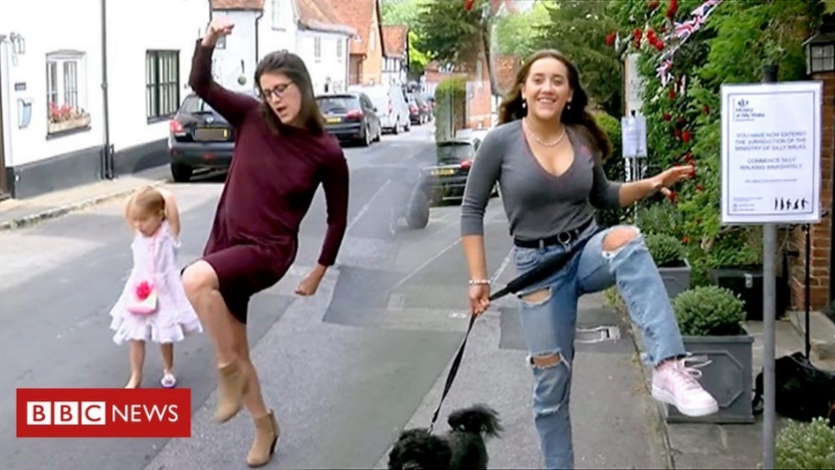
A village in Berkshire, UK became famous for silly walking during lockdown. James Ruffel put a camera in the front window of his house and a sign saying, “You have now entered the jurisdiction of the ministry of silly walks. Commence silly walking immediately”.
James thought as there were no cars and the street was quiet it would be a bit of fun and might cheer people up, but he didn’t expect anyone to do it. He left his camera running and when he checked later, he was amazed to see so many different people doing silly walks outside his house.
One elderly woman said, “I’m not as young as I used to be, and I saw these signs and I thought “Oh well I’ll try it”
Watch the video about this story here: https://www.bbc.co.uk/news/av/uk-england-berkshire-52812589/ministry-of-silly-walks-comes-to-sonning-during-lockdown
Discuss: Why did James want to cheer people up?
-Why do you think so many people joined in?
-why does the elderly woman say “I’m not as young as I used to be;” when she first saw the signs what do you think she felt?
-Why didn’t she say, “I’m too old for this, I’m not joining in.”?
-What can we learn from the elderly woman in this story?
-What can we learn from James?
Practice class silly walks – play follow the leader but this time using silly walks
Activity: draw a picture of you and your friend doing your silly walk. Child should write a sentence about joining in together.
Plenary: why do you think everyone on the video is so happy? What does this show us about joining in?

Lesson plan 1c: Respectful Relationships
Aim: I know how to look after the local environment. (school)
RSE link: Practical steps they can take in a range of different context to improve or support respectful relationships
Enquiry question: How can I look after my school?
Starter: who works in our school? To keep us safe and well? Make a list on the board, children will probably start with teachers, but who else keeps us safe?
What jobs do the following people do in school and how do they look after our school and help us to be safe? If they were not here, how would our days change?
- Site supervisor
- Cooks
- Cleaners
Main: There is a school in Bali, Indonesia where children look after their own environment to help make school a safe place. They use a project called Piket where children help the school run smoothly. Each child has a chore for the week. https://www.youtube.com/watch?v=wquwA9fjC58
Discuss: In the film,
- What jobs do we see adults doing in school?
- What jobs do we see the children doing in school?
- Why do those jobs need to be done? What would happen if they were not done every day?
- Who does those jobs in our school?
- How can we help to look after our environment?
Activity: Children record two jobs they can do around school that will help their environment (school)
Plenary: The film says before Piket, the children didn’t know that the jobs even existed. Why not?
What are the children learning? One child says, “I learned to pick up after myself and I learned to be peaceful and kind.” How do these things help our environment?

Lesson plan 1d: no RSE link
Aim: I know where money comes from
RSE link: n/a
Enquiry question: Where does money come from?
Starter: show coins to children. What is money? Why do we have money? How do we use money?
What was the last thing you saw an adult buy? Has anyone here ever bought anything in a shop?
Main: Talk about these images – what are they for? Where have children seen them? 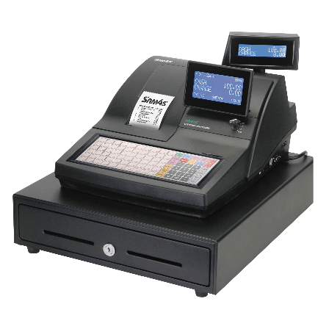 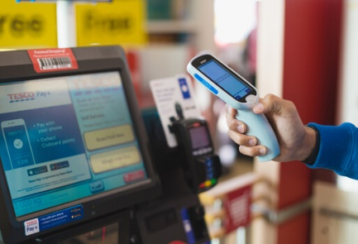 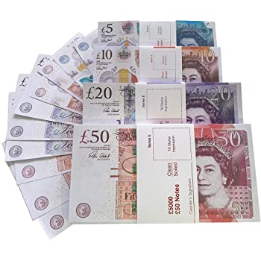 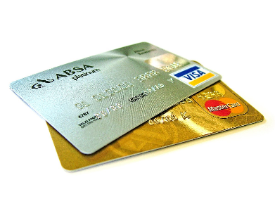
Activity: How do we get food? Is food free? What about clothes, pencils, cars, water, heat… is anything free?
So, where does money come from? Explain people work and they are paid in money so that they can buy things they need. Some people are looking for work and then the government will give them money to buy food and keep warm.
There are lots of jobs people can have. Give children a range of images to stick in books and label; children could write what they want to do when they grow up.
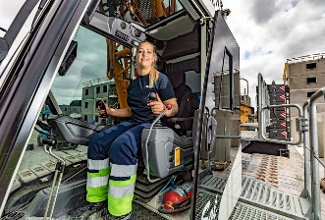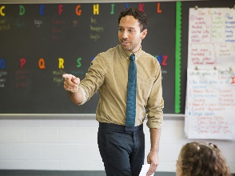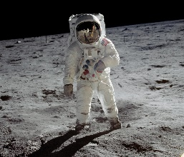

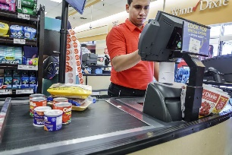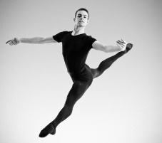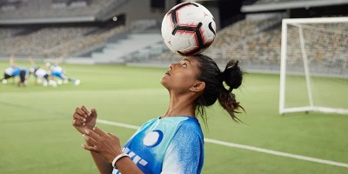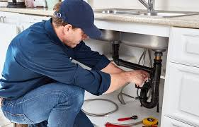
Plenary: Do people only work for money? What other reasons do people work for? Tell the children why you became a teacher. Talk about how it’s important to try and find a job you like; why?

Lesson plan 1e: no RSE link
Aim: I know how to keep money safe.
RSE link: n/a
Enquiry question: How do I save money?
Starter: show these image- what are they? What are they for?
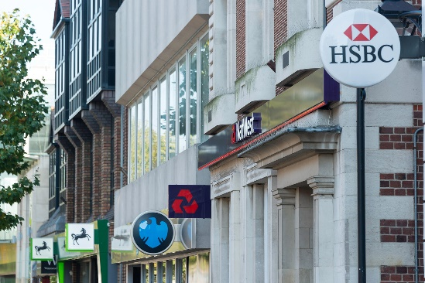
Why do people keep money safe? Where is the safest place for money? Why don’t people leave money lying around? Why do people save money, why not just spend it as soon as you get some?
Main: What sort of reasons do people save money for?
Show these images and discuss why people might save money for each one:
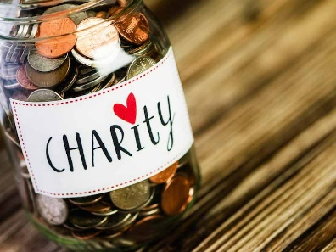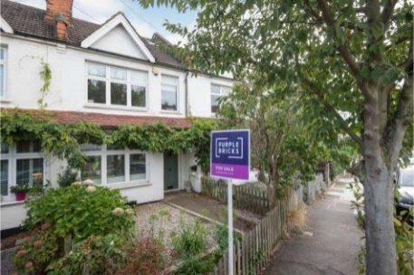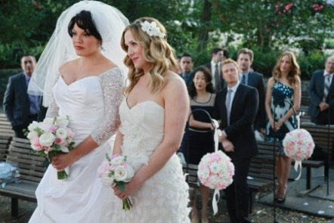
Activity: Ask children to arrange these items least expensive to most expensive. Which would you have to save up for?
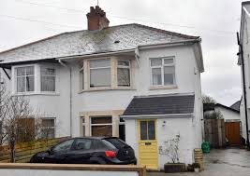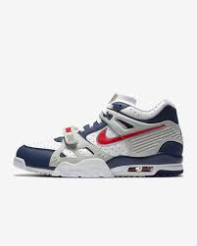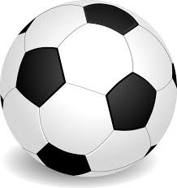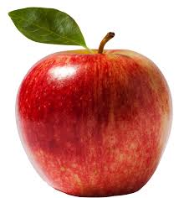
4
Plenary: If I save 50p for one week, it looks like a small amount. What can I buy with 50p? (perhaps show the amount of sweets I could buy for 50p) If I save 50p every week for a month, what happens to the amount? What can I buy for £2? What if I saved 50p every week for 8 weeks, how much would I have then? What could I buy with £8? Where should I keep this money safely?

6

Year 2 Spring term Living in the wider world
Week 1 | I know what groups and communities I belong to RSE Families and people who care for me Pupils should know that families are important for children growing up because they can give love, security and stability | Enquiry Question: What communities do I belong to? | Lesson plan 2a
Week 2 | I know who special people are in my community and how they help me. RSE Being safe how to ask for advice or help for themselves or others, and to keep trying until they are heard.  Where to get advice e.g. family, school and/or other sources | Enquiry Question: Who can help me? | Lesson plan 2b
Week 5 | I can suggest ways to look after the local environment. (surrounding area) RSE Respectful relationships: Practical steps they can take in a range of different context to improve or support respectful relationships | Enquiry question: How can we look after our community? | Lesson plan 2c
Week 6 | No RSE link  I know why it is important to save energy | Enquiry question: How can I save energy | Lesson plan 2d
Week 7 | No RSE link  I know where money comes from and what it is used for. (difference between needs and wants) | Enquiry question: What do I need, what do I want? | Lesson plan 2e
Week 8 | No RSE link  I know why it is important to save money | Enquiry question: why do we need to save money? | Lesson plan 2f

Lesson plan 2a: Families and people who care for me
Aim: I know what groups and communities I belong to.
RSE link: Pupils should know that families are important for children growing up because they can give love, security and stability
Enquiry question: What communities do I belong to?
Starter: Put these pictures on the white board – what do we see? What do you think these groups of people are? (they are all families). What is a family? What is it for? Who in this class belongs to a family? Why is family important? Emphasise families come in all sorts of shapes and sizes including families where there are carers and foster families.
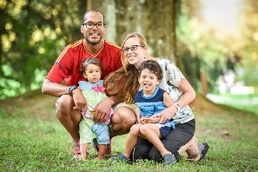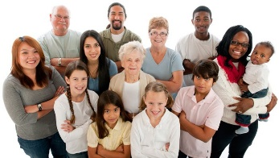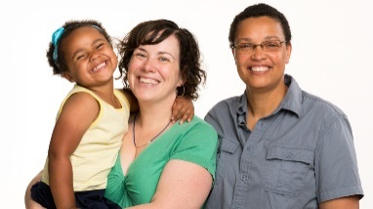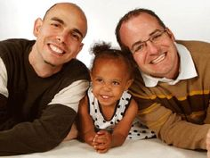
Are there any other groups we belong to? What is a community?
Main: Watch this short video about communities: https://www.youtube.com/watch?v=lGC0zxgRNJQ
Discuss: what is an example of a small community? (family)
What is an example of a large community? (school)
Do any children in the class belong in groups outside school?
The video talks about the child living in USA; what is the equivalent for us? Where is our school, town, city, country?
Activity: Under the heading, “My communities” children record family, school community, outside groups (faith, sports), and city. Children show the different groups they belong to.
Plenary: Is it Ok to be part of different communities with different people? Can you be friends with someone who is not in a community with you? What is the best thing about our class? (we’re all different and we’re all together and it works!)

Lesson plan 2b: Being safe
Aim: I know who special people are in my community and how they help me.
RSE link: how to ask for advice or help for themselves or others, and to keep trying until they are heard.
where to get advice e.g. family, school and/or other sources
Enquiry question: Who can help me?
Starter: recap last week’s lesson- what is a community, what communities or groups are we members of?
There are some people in our communities that help us to be safe and well- can anyone think of who those people are?
Main: Watch this video “People who help us jobs UK play and learn”. It shows a series of people with the caption, “I need help” and then it shows who can help them. Pause the video after each, “I need help,” so that children can discuss as a class who can help. https://www.youtube.com/watch?v=5uTOOQDEMLI
There is a question at the end of the video asking children if they have ever needed help- save that for the plenary.
Activity: Give children the following images to stick in books with the caption, “I need help”. Children record who can help in each scenario.
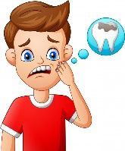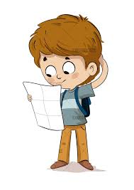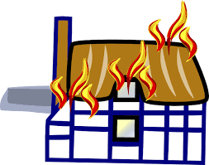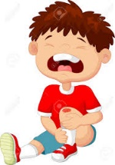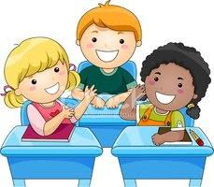
Plenary: Ask children if they have ever needed help; can children share experiences. You want to show that it’s not scary to ask for help and even if something feels frightening at the time, everything will be ok in the end. There is always someone to help.

Lesson plan 2c
Aim: I can suggest ways to look after the local environment. (surrounding area)
RSE link: Practical steps they can take in a range of different context to improve or support respectful relationships
Enquiry question: How can we look after our local environment?
Starter: what is a neighbour? What is a neighbourhood? Explain our neighbourhood is where we live; it’s our local area. How can we look after it? Does it need looking after?
Main: Lets look at environments we can control, where we can make a difference:
- Our classroom. Look at this photo
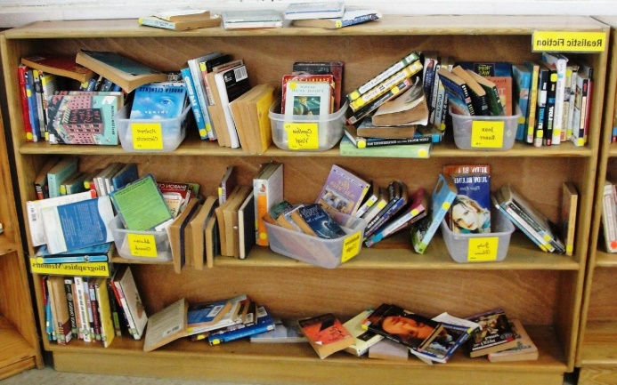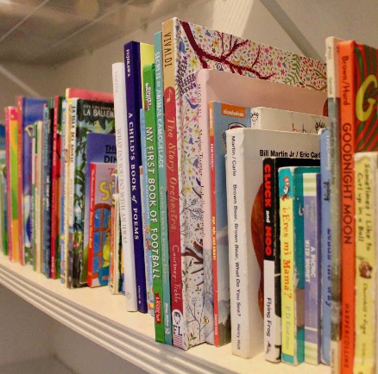

What is the difference? Which do you think makes finding books easier? Why? Which would you rather have in our classroom?

- Bedrooms: compare these photos
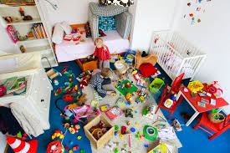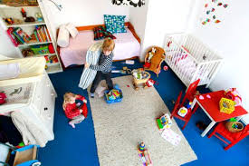
What is the difference? Write up words to describe each picture. How would you feel living in each room? Which room feels safer? Why?

- Streets: look at these photos discuss the difference and how living in each would make you feel. What is the consequence if streets have lots of litter – what does litter attract?
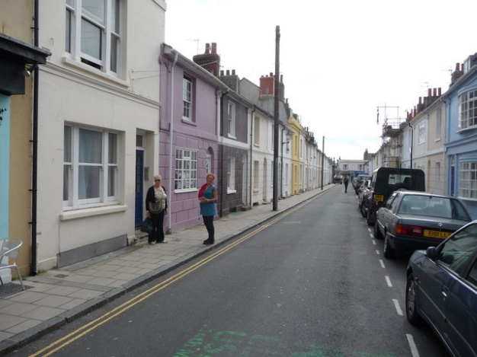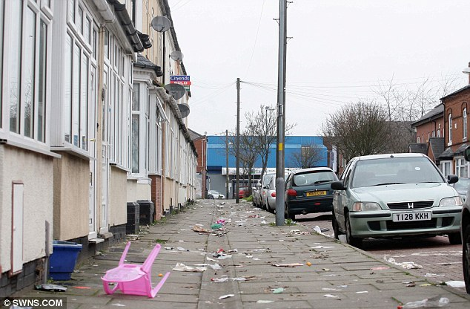
Activity: Think about who shares our local environment with us: bugs. What do bugs need to live healthily? Have a look at this website which shows how to make a bug hotel https://www.rspb.org.uk/get-involved/activities/give-nature-a-home-in-your-garden/garden-activities/build-a-bug-hotel/
And watch this video of how to make a simple bug hotel. https://www.youtube.com/watch?v=Smv_9vgN39A

Either make a bug hotel as a whole class and then children can write it up, or get children to make their own hotels as a DT activity. Talk about what bugs need and how this will help them.
Plenary: why do we need bugs in our local environment? How will this hotel help the bugs and how will it help us? Why is it important to look after our local environment? How does a clean and tidy environment make people who live in it feel?

Lesson plan 2d: no RSE link
Aim: I know why it is important to save energy
RSE link: n/a
Enquiry question: How can I save energy
Starter: what is energy? What energy are we using right now in class? Why is it important to save energy?
Main: Watch this video of children talking about turning off lights and TVs when we are not using them https://www.youtube.com/watch?v=B07C54veLwI

Activity: show these photos and ask the following questions:
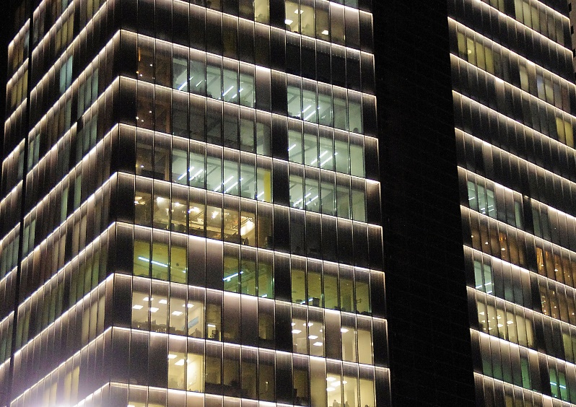

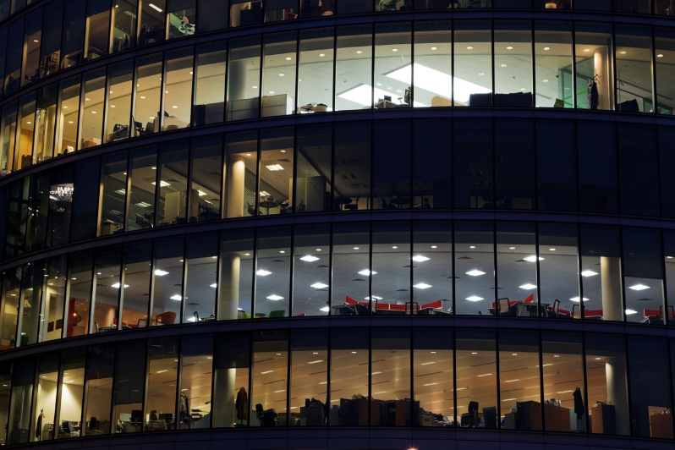
What do you see in the picture, where is it, what time of day is it, where are the people, why are the lights on, do they need to be on? If you could send a message to the building owner, what would you say? Why?
Activity: How can we save energy in our school every day? Think about lights, whiteboards left on, heating and doors left open. Children record how we can save energy.
Plenary: are there any other ways in school that we can save energy – e.g. are there electric hand driers in the toilets, are the lights in the toilets left on, are whiteboards left on in classrooms during lunch time? How can we make sure we are an energy saving school?

Lesson plan 2e
Aim: To understand the difference between things I need and things I want
RSE link: n/a
Enquiry question: What do I need, what do I want?
Starter: what is money, where does it come from, how do we get money? Does everyone have the same amount of money? Why not?
Look at these pictures- who has more money? How do you know? What are the people doing? How much money do you think each person has, where will they get their money from? Why isn’t everything in life free? Why don’t we all have helicopters and big houses?
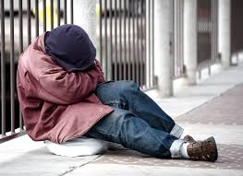

Main: Think about things in life that we all need and things that we want, and the differences between those. For example, in the pictures above, what do both people need? (Shelter, food, water, air).
Watch this video Economics for kids: needs and wants https://www.youtube.com/watch?v=FpNyTKgi1Io
It sets out things that we all (including the two people pictured above) need and compares with things we might want.
Show the children the following pictures and decide as a class which we need and which we don’t need (but we might want).
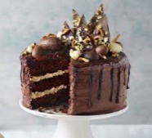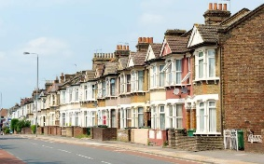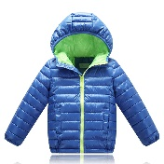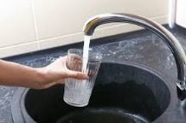

Activity: Children use the pictures above and the video as stimulus for recording under two headings: needs / wants; explain answers.
Plenary: Return to the picture of the two different people we looked at in the starter; what do they have in common? What needs do they have in common? What do we have in common with both people?

Lesson plan 2f
Aim: I know why it is important to save money
RSE link: n/a
Enquiry question: why do we need to save money?
Starter: what is money for? What are “savings”? Why do people save money? Why don’t people just spend what they have as soon as they get money?
Main: Watch A story about saving – Kids and money. The video tells the story of three moles who eat earthworms. One mole saves earthworms to survive the winter; the other two moles choose not to save worms https://www.youtube.com/watch?v=u4DJ9LNm78g
Stop the film at certain points and ask the children to predict:
4:08 when winter comes what do you think is going to happen?
4:26 who is going to be at the door?
5.44 who is going to be at the door this time?
6:42 how do you think baby mole managed to save so many earthworms?
Activity: recap how did baby mole manage to save so many earthworms?
Four holes:
1 worms to eat
2 save worms for winter
3 save worms for middle mole
4 save worms for big mole

Which hole always got filled first? Some days baby mole only had one worm to eat himself, why? Is that ok?

Children record mole’s plan but use members of their family or friends instead. Each child draws three jars: one jar for saving, one jar for giving (family or friends), and the last jar for spending. Explain the first jar is the most important; it’s the first place your worms go and is for saving. The second jar is for members of your family, or charity or for friends and the third jar is for saving any worms left over. Under each jar children can record what they are saving up for, where the “giving” money might go, and what they are saving their worms for.
Plenary: what can we learn from baby mole?
In the story, the mole saves his earthworms in his burrow. But in real life, how do people save money? What does your family save money for?
What are these pictures of, what are they for?
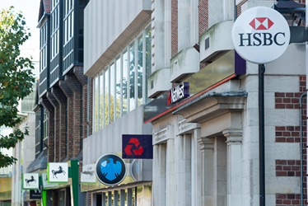

Year 3 Spring term: Living in the wider world
Week 1 | I know where money comes from and what it is used for. (difference between needs and wants) RSE Caring friendships  the characteristics of friendships, including mutual respect, truthfulness, trustworthiness, loyalty, kindness, generosity, trust, sharing interests and experiences and support with problems and difficulties. | Enquiry question: What is the difference between needs and wants | Lesson plan 3a
Week 2 | I know I am different and that we all have differences RSE Respectful relationships: The importance of respecting others, even when they are very different from them (for example, physically, in character, personality or backgrounds), or make different choices or have different preferences or beliefs. | Enquiry question: How are we different? | Lesson plan 3b
Week 3 | I show respect for diversity in my community Respectful relationships  The importance of respecting others, even when they are very different from them (for example, physically, in character, personality or backgrounds), or make different choices or have different preferences or beliefs. | Enquiry question: How do I make sure everyone is treated with respect? | Lesson plan 3c
Week 4 | to explore characteristics of family life Respectful relationships: To understand the characteristics of healthy family life, commitment to each other, including in times of difficulty, protection and care for children and other family members, the importance of spending time together and sharing each other’s lives. | Enquiry question: How do families work? | Lesson plan 3d
Week 5 | No RSE link  I know why it is important to save energy | Enquiry question: How do we save energy? | Lesson plan 3e
Week 6 | I know about different groups and communities Respectful relationships  the importance of respecting others, even when they are very different from them (for example, physically, in character, personality or backgrounds), or make different choices or have different preferences or beliefs. | Enquiry question: What is community? | Lesson plan 3f
Week 7 | I know how to get help in an emergency. Being safe: how to ask for advice or help for themselves or others, and to keep trying until they are heard.  where to get advice e.g. family, school and/or other sources | Enquiry question: Where do I get help in an emergency? | Lesson plan 3g

Year 3 Living in the wider world
Lesson plan 3a: Caring friendships
Aim: I know where money comes from and what it is used for. (difference between needs and wants)
RSE link: the characteristics of friendships, including mutual respect, truthfulness, trustworthiness, loyalty, kindness, generosity, trust, sharing interests and experiences and support with problems and difficulties.
Enquiry question: What is the difference between needs and wants
Starter: ask the children, how does money work? Does everyone have the same amount of money? Why not? How do we get money, what different ways are there of getting lots of money. Why do some people have very little money, what help exists for people who do not have enough money to live?
Main: How did Lockdown in 2020 affect different people in the world? Lots of people lost jobs- why? If you lose a job how does that affect your life? (be aware of children in the class who might be living through this now)
What is it like to run out of money? Who can help?
Watch this video about a community coming together to create a food back for people in Wales https://www.bbc.co.uk/news/av/uk-wales-54783783
Discuss: “It’s a position people find themselves in through no fault of their own. No stigma attached” what does that mean?
Make a note of the goods that we see in the foodbank – is it all food? What else? Why those things? Why not mobile phones, box of chocolates, expensive trainers?
Why is a lot of the food in tins?
Activity: Make a list of things you think a family needs for a week. Think about food that a family might need rather than things they might want. What is a necessity in order to be healthy and what is not needed?
Children will need to decide who is in their family first – a family of two will need less than a family of five. What food are you going to put into the food parcel for the family you invent?
This Trussel Trust website has a list of food that goes in to their food parcel. The list does include biscuits; are they essential? Why do you think biscuits are included? https://www.trusselltrust.org/get-help/emergency-food/food-parcel/

Plenary: Why does Allan know what it’s like to go hungry?
Why do people think they are the only ones struggling?
Will people be struggling for ever?
How has coronavirus helped communities? Was this food bank happening before coronavirus? How do you think a food bank makes a community of people feel?

Lesson plan 3b: Respectful relationships
Aim: I know I am different and that we all have differences
RSE link: the importance of respecting others, even when they are very different from them (for example, physically, in character, personality or backgrounds), or make different choices or have different preferences or beliefs.
Enquiry question: How are we different?
Starter: who has a pet? What pets do we have in the class? Make a tally and find the most popular.
Do dogs make good pets? What can dogs do? Why do they make good pets?
Main: Watch this video : The present - Official
https://www.youtube.com/watch?v=WjqiU5FgsYc

Discuss:
knowing what you know about the boy now, why do you think he is always playing on his x-box?
Why do you think mum bought him a dog?
What is different about the dog?
Why did the boy turn the dog away at first?
What did the dog end up showing the boy?
What is the message in this film?
Activity: Do you think Mum bought the different dog on purpose? Why? What does that show about Mum and the way she feels about her son?
Recording options:
- Write a message to the boy- what would you say to him?
- Write a message for the mum- what would you say to her?
- Imagine you moved next door to the boy, write a note to invite him out to play (Do you need you need to mention his leg being different in your note? How would that make the boy feel?)
- Record a cartoon strip showing the story in 6 boxes.
Plenary: The boy might feel he is the only one that is different. We don’t see any friends in the story; what could you say to the boy if he came to our school to make sure he did not feel like an outsider? We all have things about us that are different – how are we different?

Lesson plan 3c: Respectful Relationships
Aim: I show respect for diversity in my community
RSE link: the importance of respecting others, even when they are very different from them (for example, physically, in character, personality or backgrounds), or make different choices or have different preferences or beliefs.
Enquiry question: How do I make sure everyone is treated with respect?
Starter: What do you see in the picture, who uses a bus? If you have a disability can you still use a bus? What should be in place on the bus to ensure everyone has equal opportunity?
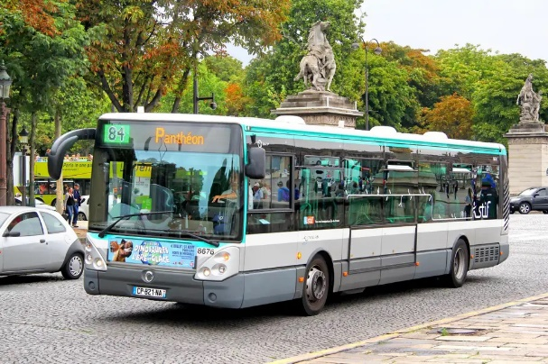
Main: Show this picture, explain this is Francois Le Berre. He lives in Paris, France and has multiple sclerosis which means his body works in a different way. Francois uses a wheelchair; so how does Francois access a bus?
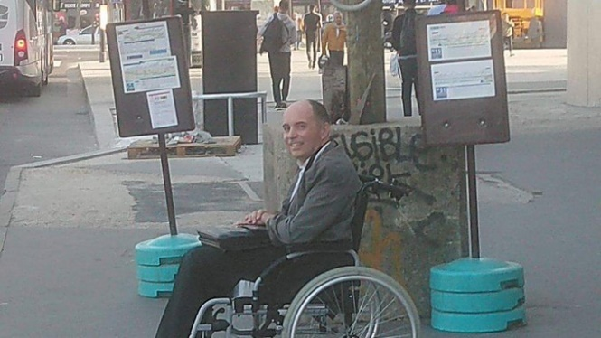
Buses have a space near the front where wheelchairs can fit. But what happens if the bus is full of people? One day when Francois got on a bus it was crowded and people were standing in the accessible space. What do you think Francois did?
The bus driver saw what was happening and made a decision. What do you think the bus driver did?
The driver stopped the bus and shouted to the passengers, “Terminating! Everybody off!”
Then he told Francois to stay on the bus, and once all the other passengers were off the bus, he drove off with just Francois on the bus.
The story made headlines and many people praised the bus driver on social media; people wrote, “Bravo to the driver, shame on the passengers” But others wrote, “You wouldn’t have moved either!” What do you think? Would people have moved in our city? Would you move?
Activity: Everyone in this story has options and choices to make about their actions. We know what happened but were there any other solutions to this problem?
Children record the story and include options for each of the characters:
When The bus arrives and it is crowded, what options does Francois have? What else could the driver and the other passengers do?
When Francois gets on the bus and people are standing in the accessible space. What could Francios say, what could the passengers do, what needs to happen at this point to solve the problem? What could the driver do?
Plenary: Is it up to Francois to ask people to make space for him? How do we make sure everyone feels welcome on public transport?

Lesson plan 3d: Families and people who care for me
Aim: to explore characteristics of family life
RSE link: To understand the characteristics of healthy family life, commitment to each other, including in times of difficulty, protection and care for children and other family members, the importance of spending time together and sharing each other’s lives.
Enquiry question: How do families work?
Starter: define family; what do different families look like? How can families change over time? How do families range in size; would anyone like to share how many people are in their immediate family; who has the biggest family in our class? What
Main: show this picture. This is the Ahmed family and they live in America. What is different about this family? They all have different skin, some of the children look the same age, they also follow different religions; Mum is Christian, Dad is Muslim; how do you think this family has evolved?
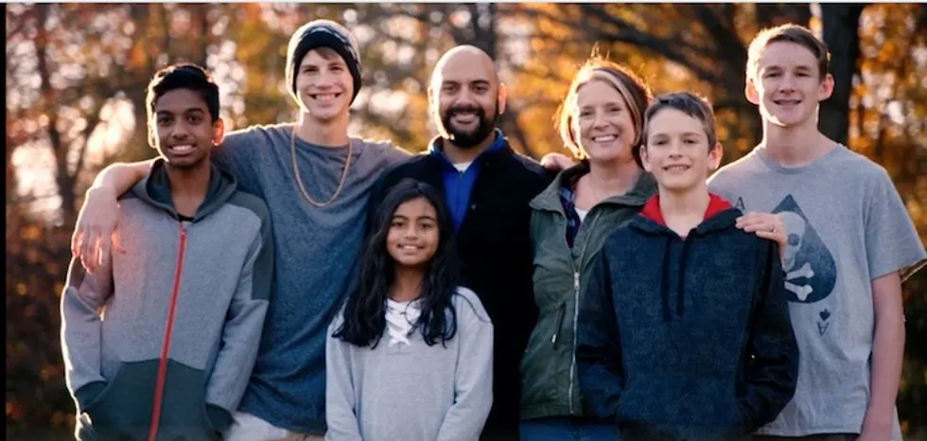
This family happened because both Mum and Dad had children from previous marriages. Ojeyo was 13 and Megha was 10; they lived with Dad. Khy was 18, Kayden 14 and Cooper 13; they all lived with Mum. When Mum and Dad got together a new family was formed – two families joined together to make one big one with seven people.
Is this a family? (yes!)
Watch the video in the link at the bottom of the page to learn more about the Ahmed family and how they get long. It’s not always easy – why not?
Activity: Under a picture of the Ahmed family answer the following questions:
- How can families change?
- How can people who follow different faith be in the same family?
- “We are jumbled up in a good way” what does Mum mean?
- How do they help each other?
- What can we learn from the Ahmed family?
Plenary: When talking about the different religion in their family, Dad says, “We don’t say that’s the right way or that’s the wrong way, there’s no wrong answers” what does he mean? Do you think his children are confused?
Why does Mum say, “Family means love”?

https://www.upworthy.com/this-blended-family-is-nothing-like-the-bradys-that-s-more-than-fine-with-them

Lesson plan 3e
Aim: I know why it is important to save energy
RSE link: n/a
Enquiry question: How do we save energy?
Starter: Watch this short clip about energy saving bulbs.
https://www.youtube.com/watch?v=_kocZ-j-o3I
In the film we see the penguin making electricity for the polar bear – is that where electricity comes from? Where does electricity come from? What is the advantage of an energy saving bulb? Why should we save energy?
Main: There are obvious ways of saving energy (we talked about it in Y2) how do save energy in school? (lights, whiteboards) What other ways can we save energy at school and home? Think of what you do every day that uses energy. Children work in pairs to come up with suggestions. Then show children these images and ask what they have to do with saving energy:
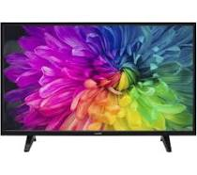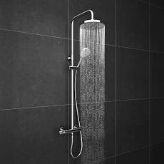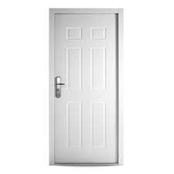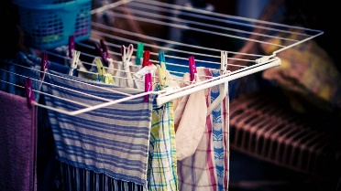

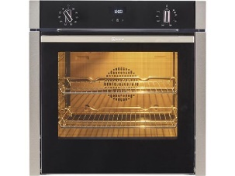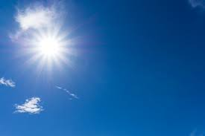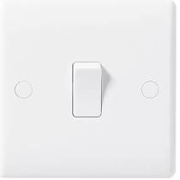

Activity:
Children stick images in to books and record how we can save energy using each one (answers in the link below)

Plenary: How long do we spend in the shower? Why is a shower timer a good thing? Shall we set ourselves a target for use of hot water? What would be a realistic energy saving time for shower use? Ask children to set a target and feed back tomorrow if they managed it.

https://blog.directenergy.com/8-ways-to-help-kids-conserve-energy-summer/

Prior to the lesson search online for an aspect of diversity that exists in your area. The aim is to show that there are different people in your area and that is a good thing. I live in Birmingham, an area of super diversity which makes this an easy lesson and I will focus on nationality. I will use Birmingham as the example in this lesson, you need to use your area. Some areas in the UK are less diverse but there will still be people of different faith you can talk about – find images of different places of worship or community groups so that you can demonstrate the diversity around you.
The second part of the main and activity about Leicester can be used by all schools.
Lesson plan 3f: Families and people who care for me
Aim: I know about different groups and communities
RSE link: the importance of respecting others, even when they are very different from them (for example, physically, in character, personality or backgrounds), or make different choices or have different preferences or beliefs.
Enquiry question: What is community?
Starter: what is a community? Are we in a community? Are any children part of a group or community outside school? Why do people join groups? What kind of groups / communities exist in our area?
What does diversity mean? How diverse is Birmingham? Guess how many nationalities live in Birmingham today… the last research on this in 2013 showed there are 187 different nationalities.
Main 1: There are 6 main religions represented in Birmingham today – what are they?
Christianity, islam, Buddhism, Judaism, Sikhism, Hinduism.
These are all places of worship in Birmingham:
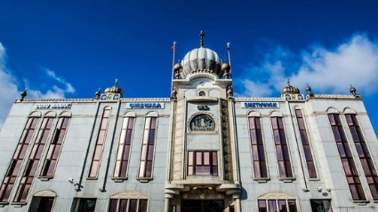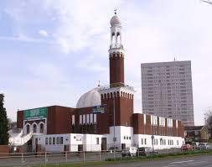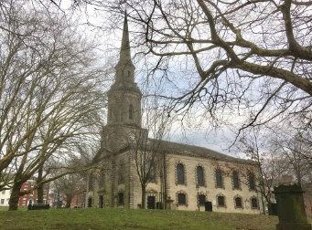

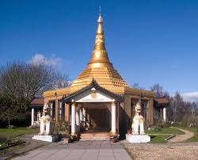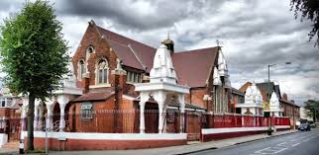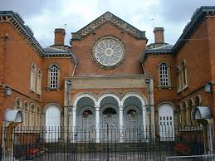

What different faiths worship at these places? What does this show us about Birmingham?

Main 2: Look at these pictures – what do you think these show? The two pictures are connected.
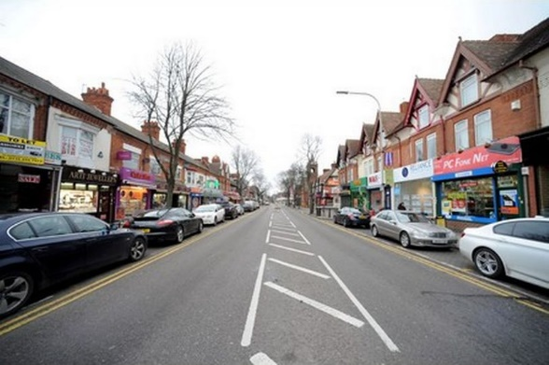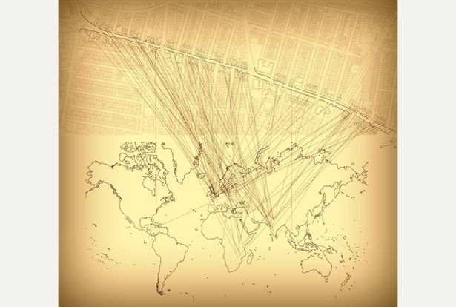

This is Narborough St in Leicester. In 2016 the street was named as the most diverse high street in the UK; there are 222 shops on the high street and the owners come from 22 different countries, which can be seen in the second picture.
Researchers said the street showed, “all these people, from all these different places, different cultures, working with each other and living in harmony. And it works too.”
"There is a Canadian couple who run a book shop on Narborough Road, they've been there a long time. Because their English is good and they know about forms and bureaucracy, they help the other traders. In return, they get a free haircut, or lunch at a restaurant on the house.” (What does “on the house” mean?)
The book shop is run by Ian, who gave an example of how the shop keepers help each other; "We were given a pair of nice chairs by the local music shop, which we used for a long time – and then we gave them to the local charity shop, who sold them for a decent amount of money. It's nice to be able to do that."
"In Narborough Road, and in diverse streets such as Narborough Road, the traders, from all of their different backgrounds, learn from each other.”
Activity: Design your own diverse high street like Narborough St. Label your shops to show where shop keepers come from. Perhaps you might like to put a place of worship on your high street. Create a diverse high street where the community help each other in the UK today.
Plenary: Everyone is different on Narborough St, is this still an example of a community? How can we define community in light of what we know about Narborough St.

Lesson plan 3g: Being safe
Aim: I know how to get help in an emergency.
RSE link: how to ask for advice or help for themselves or others, and to keep trying until they are heard.
where to get advice e.g. family, school and/or other sources
Enquiry question: Where do I get help in an emergency?
Starter: give an example of an emergency. How do you know if something is an emergency? What do you do if there is no adult to help nearby?
Show this picture – what do you see, what do you think the story is?
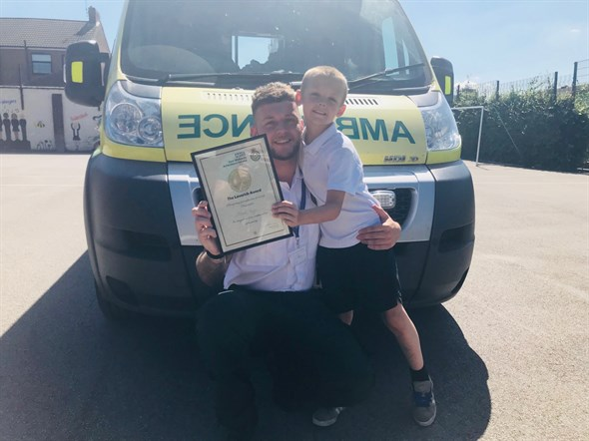
Main: The picture shows Mitchell Taylor aged 8 from Chesterfield. One day Mitchell came downstairs to find his mum on the floor; she was breathing but she could not speak or move. What do you think Mitchell did?
When he rang 999 who do you think he spoke to and what information did they need to know?
Watch this news item about the incident
https://www.youtube.com/watch?v=_Fff5vsRwBc

In this new article you can listen to the whole conversation between Mitchell and the ambulance. It lasts 2 minutes, listen to the clip and ask children the following questions:
https://www.derbytelegraph.co.uk/news/derby-news/999-call-boy-saves-mum-1768273

- What else could Mitchell have done, why didn’t he go to a neighbour or ring his nan?
- Do you think Mitchell was scared?
- How does Mitchell sound on the phone? Does he sound scared? Why do you think Mitchell sounded so calm?
- Why is the man on the phone asking those strange questions?
- Why did the man ask Mitchell to put the dogs in a different room?
- Why does he stay on the phone till Mitchell see’s blue lights? (what are the blue lights?)
Activity: Draw a cartoon strip showing what happened in Mitchell’s house and all of his responses. The cartoon should show Mitchell staying calm, ringing 999, listening to the instructions and waiting for the ambulance to arrive.
Plenary: what can we learn from Mitchell in this story? What do you think is the most important thing to remember when in an emergency?

Year 4 Autumn term: Living in the wider world
Week 3 | I can appreciate the values and customs of people around the world RSE Respectful relationships  the importance of respecting others, even when they are very different from them (for example, physically, in character, personality or backgrounds), or make different choices or have different preferences or beliefs. | Enquiry question: How are customs around the world different? | Lesson plan 4a
Week 4 | To understand how choices I make affect people around me  RSE Respectful relationships practical steps they can take in a range of different contexts to improve or support respectful relationships. | Enquiry question: How do I ‘pay it forward’? | Lesson plan 4b
Week 5 | To understand how choices affect individuals, communities and sustainability of the environment across the world. | Enquiry question: How do choices I make affect the environment? | Lesson plan 4c
Week 6 | I know why it is important to manage money. | Enquiry question: why save money? | Lesson plan 4d
Week 7 | To understand the concept of what interest, loans, debt and tax are. | Enquiry question: what is credit? | Lesson plan 4e

Lesson plan 4a: Respectful relationships
Aim: I can appreciate the values and customs of people around the world
RSE link: the importance of respecting others, even when they are very different from them (for example, physically, in character, personality or backgrounds), or make different choices or have different preferences or beliefs.
Enquiry question: How are customs around the world different?
Starter: what is a custom? How does it start? Can you think of a custom that we have in the UK?
How about birthdays? Are all birthday customs the same around the world? Does everyone celebrate birthdays? What birthday customs do we have in the UK? Does anyone know of birthday customs in other countries?
Main: Watch this video: 28 birthday customs from around the world – mental floss. https://www.youtube.com/watch?v=IWLGvaeDAlU

It is a fast guide to birthday traditions across the globe. Give children the worksheet below to fill in as they listen; the worksheet includes pictures for 8 of the customs described. Children should write the name of the country in each box next to the picture.
Activity: complete the worksheet by describing the customs pictured in the third box.
Plenary: Do you think everyone follows all these customs in each country? What does the video say about UK customs – that we do ‘the bumps’ where the person is bumped on the floor for every year. Does everyone do that on every birthday? What does this show us about customs and values (not everybody takes part but they still exist).
Here is a brilliant video to finish. It shows how people from 70 different countries sing their birthday song. Does everybody sing, “Happy birthday”? In the UK we share the melody with many countries, but many have a completely different melody. The video shows lots of different ways of celebrating birthdays (and also some countries that don’t sing at all!)
https://www.youtube.com/watch?v=jghYM7XQxEA
what does this video show us about the world today? (we have things in common and differences to people all over the world)
How

Birthday customs around the world
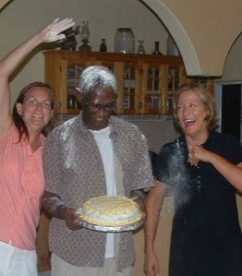
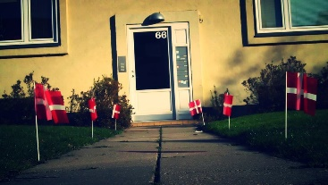
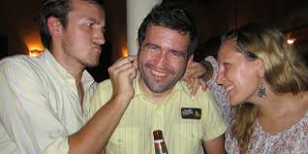
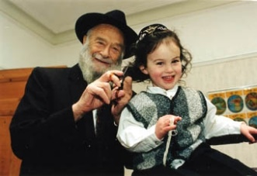
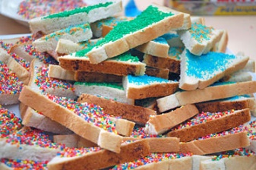
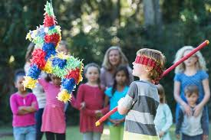
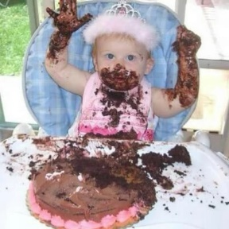
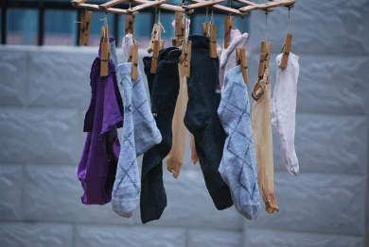

Lesson plan 4b: Respectful relationships
Aim: To understand how choices I make affect people around me
RSE link: practical steps they can take in a range of different contexts to improve or support respectful relationships.
Enquiry question: How do I ‘pay it forward’?
Starter: what is a good deed; give examples. How do good deeds affect others; how does a good deed make the person receiving fee, how does it make the person giving feel? What do you think ‘pay it forward’ means?
Main: watch this video: Inspirational video pay it forward
https://www.youtube.com/watch?v=X3ld9_p2bS0

Discuss:
What’s the video about?
What is it called ‘pay it forward’?
How did each choice affect people around them?
This video is made up, but could this happen in real life?
What is the film trying to tell us?
Activity: Look at this picture. What do you notice about the people in the picture, how are they different. This story is a ‘pay it forward’ story: what do you think is happening?
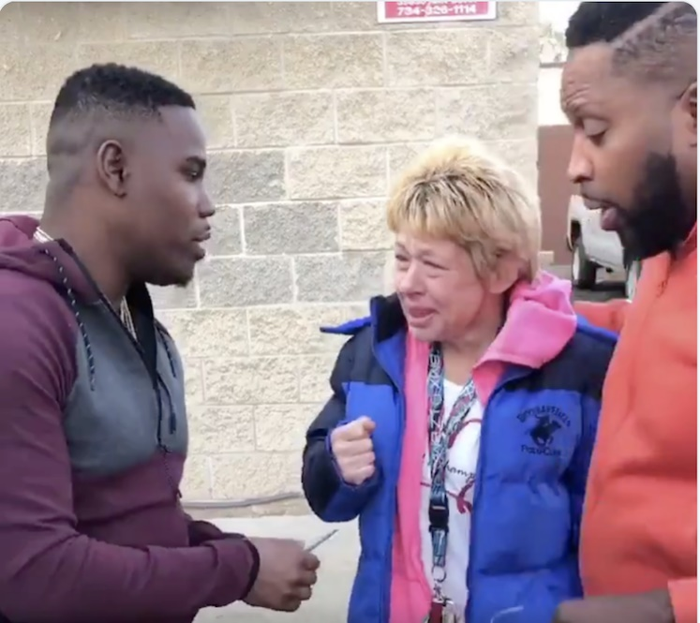
Two men noticed a woman was paying for her petrol using pennies. They stepped in and offered to help her out by paying the bill for her, giving her a handful of cash to make life a little easier.
The woman then broke down in tears and told the men her husband died only a week ago and she was finding it hard to cope. She thanked the men and one replied, "It's only right, we've got to stick together."
The woman says, "How can I repay you?" and the man replied,
"You don't have to replay me, that's for you." His friend also says, "Pay it forward."
A clip of the story went viral and people on twitter were praising the actions of the two men, one said, "We've got to take care of each other. That's what America needs right now."

Children record what ‘pay it forward’ means. Draw a carton strip of three linked images to show the impact of a pay it forward gesture.
Plenary: In both of the stories we looked at today, people could have made other choices; what other choices could people have made? How would different choices have affected the stories? Do all of our actions have consequences all of the time? Do any actions not have consequences?

Lesson plan 4c
Aim: To understand how choices affect individuals, communities and sustainability of the environment across the world.
RSE link: n/a
Enquiry question: How do choices I make affect the environment?
Starter: Think about the environment today – what is it? How is the world changing, how are humans affecting the environment? What is global warming, who does it affect? Are there any examples you have heard about?
Show this picture, what has happened? Where should this mattress go? Can you recycle mattresses? What else can you recyle? What does recyle mean?
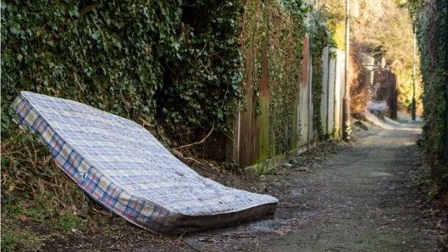

Main: What goods can we recycle? What do you see your family recycle at home? What do we recycle in school? How does recycling help us to be sustainable, what does sustainable mean?
Watch this video about how plastic is recycled and what happens to it
How it’s made recycling https://www.youtube.com/watch?v=KxDoUnELiUI

This doesn’t go in to what happens to the recycled material but is does show some impressive tyre and mattress crushers in action to give children an idea about what can be recycled and how https://www.youtube.com/watch?v=DiGix-zLWJ8

Activity: Children complete the worksheet below about what goods can be recycled and turned in to. Answers below. (you could choose to give the answers and children work in pairs to match the item with the recyclable product)
Plenary: We could choose not to act and carry on, disregarding recycling. What other options to families have to recycling? What is landfill? Which is better for the environment, why? What will be the consequence in the future if we choose not to recycle? As a child in a family who is in charge of your house? It may be that you are unable to make the changes you want right now, but as you get older what will change to enable you to be able to live more sustainably?
Children could write at the bottom of the worksheet, why should we recycle?

What can we recycle- answers
Mattress – recycling centre- underlay for carpets, pet cushions
Tyres – speed bumps, running tracks Paper – toilet paper, napkins, birthday cards
Cardboard- paper bags, cereal boxes Tin cans- new tin cans, bike parts
Aluminium cans – new aluminium cans Glass- jars, bottles fibreglass
Plastic drink bottles – backpacks, sleeping bags Plastic milk bottles- buckets, frisbees
Newspaper- egg cartons, paper plates, cat litter
What can we recycle?
object | Where can we recycle it? | What can it be recyled in to?
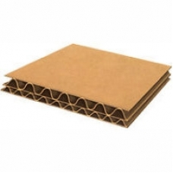
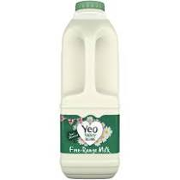
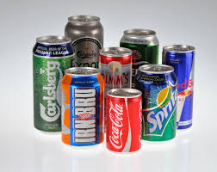
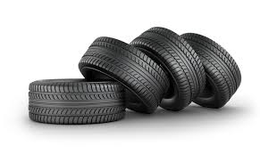
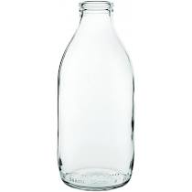
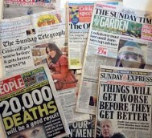
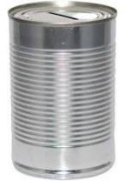

Lesson plan 4d: Families and people who care for me
Aim: I know why it is important to manage money.
RSE link: n/a
Enquiry question: why save money?
Starter: Why do people save money? What sort of things do people save money for? Has anyone here saved up for anything?
Does anyone have any tips for saving?
Main: watch How to save money as a kid – Just B. It shows a young teen giving tips on how to save https://www.youtube.com/watch?v=Y0mo0R21_ec&t=27s
Watch the whole video (2.36) and record the tips Just B gives. These are her tips:
- Get a purse or something to keep your money in
- Record a log about how much you are spending each week to help you see what your outgoings are and what you can cut down on
- Stop buying things you don’t need like sweets. The less money you spend on sweets the more you save.
- Collect coins, they all add up
- Ask your parents to help. Just B says make a deal with parents like if you pay for half they will pay for the rest.
Discuss – what do children think about the tips? Which tips are most useful, do any of these tips present potential problems?
Is it ok to pick up coins left around the house? Is that stealing?
Will parents always be able to ‘go halves’ on a phone or ipad? Should they do this?
Activity:
Write to Just B commenting on the tips she gives, tell her which you agree with and which you do not. Do you have any further tips to add? Do you think Just B understands the position that some families are in today; can everyone afford to buy children an iphone or ipad? Should parents just buy an iphone for their children because they want one? How about waiting for a birthday or waiting till you are older so you can buy your own?
Just B does not mention doing jobs to earn money. How can you warn a bit of money rather than just have someone give money to you or collect coins lying around the house?
Plenary: Do you have to spend money that is saved up? What will happen if you keep saving? When might money you have saved be useful?

Lesson plan 4e: Families and people who care for me
Aim: To understand the concept of what interest, loans, debt and tax are.
RSE link: n/a
Enquiry question: What is credit?
Starter: what is a credit card?

A credit card is a way adults can borrow money. Why do adults borrow money? What expensive items do adults borrow money to buy? Which of these might people buy on credit?
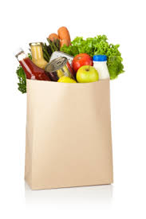

The answer is all of them. Lots of people today use credit to buy things today and pay it back later. People think they can have what they want now, and pay for it later.
Main: I would use props to explain this lesson – make it as visual as possible.

There are two types of cards – show credit and debit cards below. They look the same but the way they work is very different. Does anyone know the difference?
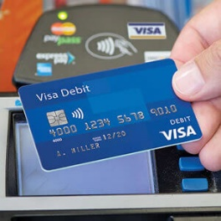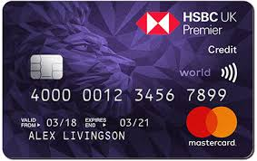

Show a pot of coins. Let’s imagine this is your bank account. Everything you earn goes in to your bank account. How do you spend your money? Either by drawing cash from an ATM or by using your debit card – show the children your debit card. Let’s buy a sandwich using our dbit card. It costs £2 so when I pay with my debit card, two pounds comes out of my account (take £2 out of the pot)
You could never have a credit card and always buy things when you have saved up enough money, then you know you will never be bin debt (what is debt? Debt is where you owe money)

Now show this picture on the board
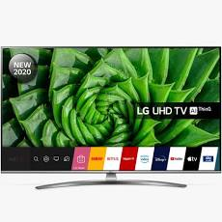
This is a new 65 inch smart TV and costs £645. How shall I buy it?
Currently in my bank account I have £500 saved, but I need to buy food this month and petrol for the car. I cannot afford to buy this TV.

A credit card would allow me to buy the TV. A credit card lets you borrow money from the bank and pay it back later. The bank will lend me £645 to buy the TV and I agree to pay it back. This is called credit.

If I pay the money back within a month, there is no charge to me. But what do you think happens after one month to the amount I owe if I do not pay it back in full in one month? The bank add interest which means I have to pay back more money.

I can pay back a small amount each month till the whole amount is paid off, but every month the amount I owe will grow and grow, till I owe much more than I first borrowed.

Watch this short cartoon made by the People’s Law School about credit cards.
https://www.youtube.com/watch?v=jxFckwpbOps

stop at 0.55 “aren’t credit cards free money? I think I read that somewhere..”
children answer – is it free money? Why does credit feel like free money at first?

Continue to 1:43 why is the credit card trying to get Aesha to spend more money? Why does credit card say, “I like it better when you people don’t ask so many questions.”

Finish the video at 2:16 what has happened at the end of the month? How has Aesha gone over the limit – what does that mean? Why did the credit card allow her to go over the limit? (because the more she spends the more interest the card charges)

Activity: Children answer the following questions:
What is a debit card?
What is a credit card
Advantages of using a credit card
Disadvantages of using a credit card
Other ways buying expensive items?
Plenary: How old do you have to be to own a credit card? Why do you think you have to be 18? Lots of people get into debt using credit cards, why do you think that is?
If you pay off your full credit card bill every month, there is no interest, why don’t people do that?
Instead of using a credit card, what are the other options of buying expensive goods?

Year 5 Autumn term: Living in the wider world
Week 1 | I know how and why laws are made | Enquiry question: how are laws made? | Lesson plan 5a
Week 5 | I understand the effects and consequences of anti - social behaviour.  RSE Respectful relationships practical steps they can take in a range of different contexts to improve or support respectful relationships. | Enquiry question: what is anti -social behaviour? | Lesson plan 5b
Week 6 | I know what my rights and responsibilities are in my local community  RSE Respectful relationships practical steps they can take in a range of different contexts to improve or support respectful relationships | Enquiry question: why is it my responsibility? | Lesson plan 5c
Week 7 | I know what my rights and responsibilities are towards sustaining the environment.  RSE Respectful relationships  that in school and in wider society they can expect to be treated with respect by others, and that in turn they should show due respect to others, including those in positions of authority. | Enquiry question: Is Greta Thunberg right? | Lesson plan 5d
Week 8 | I understand the role money plays in my life and the life of others. I know what is meant by ‘interest’ ‘loans’ and ‘debt’ and ‘tax’. | Enquiry question: why do we pay tax? | Lesson plan 5e

Lesson plan 5a
Aim: I know how and why laws are made
RSE link: n/a
Enquiry question: how are laws made?
Starter: what do we know so far about the democratic process? How does it work, how does democracy relate to laws being made? Has the UK always had democracy? What was in place before democracy, when did democracy first emerge and who could vote?
Main: Look at the list of the following words- can children define them and explain what they mean?
Democracy, parliament, house of commons, house of lords, magna carter, monarch, constituency, constituents, MP, Prime Minister, the government, the cabinet, the opposition, election,
Watch the first part of this video: An introduction to Parliament. https://www.youtube.com/watch?v=Qs-9B3FRXCA

It explains the above terms and gives a good introduction to how the democratic process works. Stop at 2:47 and go through the list, checking understanding. Children could work in pairs or groups to define and feedback definitions to the class.
Main 2: How does the election work- how are MPs elected to the house of commons?
Watch ITV news report 2017 on the battle between Newcastle and Sunderland to be the first to declare https://www.youtube.com/watch?v=xPa2wEVW68g

What is this about? Why do you think they want to be the first to declare the result? Who is watching, waiting?

This new report shows the count start in Sunderland: Vote count begins in Sunderland https://www.youtube.com/watch?v=QOXXsm0WAAg

How is it organised, why so many people, how are the votes being counted? Where else if this happening in the UK? What’s in the boxes? Why are people running?

In the end Newcastle were the first to declare – watch how the result is given here GE2017 result: Newcastle Central first to declare result https://www.youtube.com/watch?v=51a_x-aR1Ww

Watch till the results are given and the winner take the podium 1:47.
Why do all the candidates wear rosettes? Why do they shale hands at the end? They are looking round for someone half way through – who are they looking for? Why do you think that person wasn’t on the stage? What do the numbers represent? Why do you think Chi Onwurah won? What are the different reasons people vote?
Activity: Record descriptions for each of the words listed, see worksheet 5a
Plenary: Watch the rest of the video about how laws are made.
Some countries do not live in a democracy; what is a dictatorship? What is the difference between democracy and dictatorship? How would life be different under a dictatorship?

5a: UK democracy: describe the purpose of each

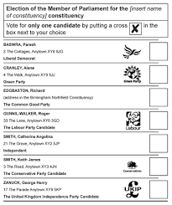  Ballot paper | 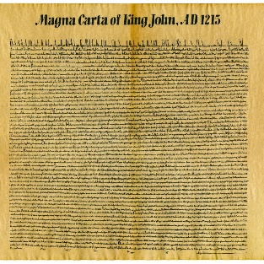  The Magna Carter | 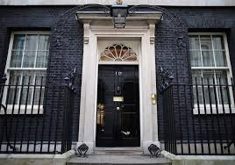  10 Downing St
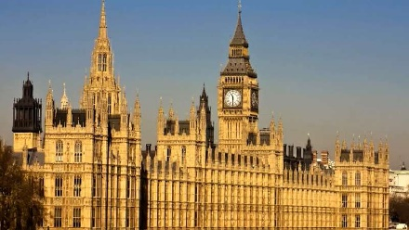  Parliament | 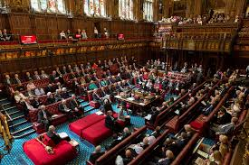  House of Lords | 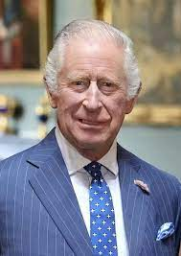  The monarch
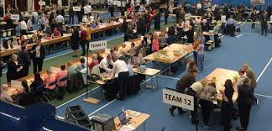  Vote count | 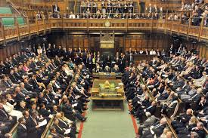  The government and opposition | 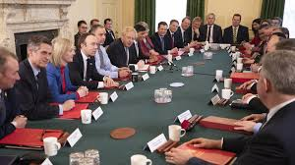  The cabinet

Lesson plan 5B: Respectful relationships
Aim: I understand the effects and consequences of anti - social behaviour.
RSE link: practical steps they can take in a range of different contexts to improve or support respectful relationships.
Enquiry question: what is anti-social behaviour?
Starter: what is meant by anti social behaviour?
“Any behaviour or act by a person or group likely to cause others harassment, alarm or distress or which causes a nuisance to the community or impact on the environment.”
Check understanding of key words in the quote
What are examples of anti-social behaviour?
Main: watch this short video about the effect of anti-social behaviour on a family in Dean. It is appropriate for KS2 because it doesn’t go in to descriptions of the behaviour but alludes to it. There is mention of alcohol and swearing.
In pairs children discuss the following:
- What is happening behind the man’s garden?
- How is the behaviour affecting him and his family?
- Who helps the situation, how is it resolved?
Activity: The youth workers say they are working with the young people to understand the consequences of their actions. Use the worksheet on the next page to outline consequences of behaviour for different people. What would you say to the young people who are behaving in that way to show them the consequences of their actions?
Plenary: There are other consequences to anti-social behaviour? Are these behaviours breaking the law? What is a police record and how do you get a police record? What is the consequence of having a police record when you apply for a job?

Anti-social behaviour
incident | What has happened? | Consequences
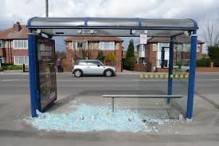 |  | For bus travellers-  For young children-  For local residents-
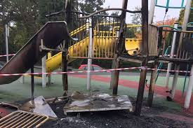 |  | For children-  For parents-  For community-
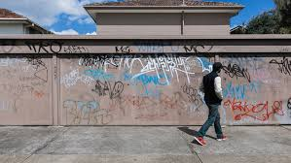 |  | For children-  For community-

Lesson plan 5c Respectful relationships
Aim: I know what my rights and responsibilities are in my local community.
RSE link: practical steps they can take in a range of different contexts to improve or support respectful relationships
Enquiry question: why is it my responsibility?
Starter: what is a community? How do you know if you are part of a community? Can you opt out of a community, what is the impact of opting out?
Main: show these four pictures and split the children in to groups to discuss what they think is happening. Children to write down five questions for each picture.
Then swap the pictures around the groups so that each group answers the questions set by a different group. Children write the answers under each question. See worksheets with each photo on next four pages.
Feedback questions and answers and then tell the children the story for each. Focus on why this is a story about rights, responsibilities and community and the different options each person in the story faced; what could have been other outcomes if people had chosen not to help?
Activity: Children to choose one of the following photos and stick in books, answering the following questions:
What is the story?
Why is this about rights?
Why is this about responsibility?
Why is this about community?
What other options did the people in the story have and what would have been the consequence?
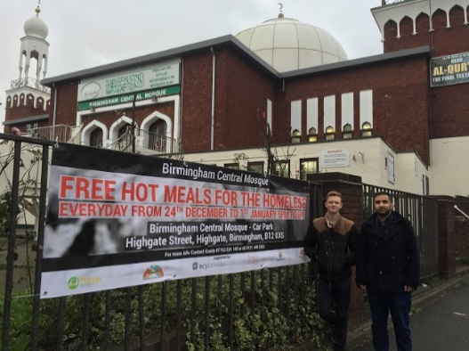
This Mosque in central Birmingham is opening its doors over Christmas, offering free meals to homeless people. The Mosque is expecting hundreds of people in Christmas week and about 150 on Christmas day. They are partnered with Birmingham soup kitchen and a local church, and local businesses have donated money.
Kasim Choudry said, "Birmingham is an amazing city that thrives on diversity and together as one community we can unite as one to tackle poverty"

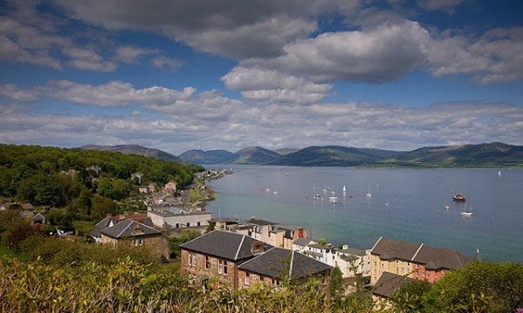
The Island of Bute in Scotland is preparing to welcome 15 families from Syria, including 50 children. Local people are eager to welcome their new neighbours; Craig Borland, the editor of the local newspaper said, "I want Bute to be a place where people who come here with little more than the clothes they are standing in can feel safe and at home.”
Angela Callaghan, who runs a furniture shop is organising food parcels and said, "“These people will become part of our community and will not have much time when they arrive to organise meals....so we’ll all rally round.”
In December the local cinema will screen the film, "It's a wonderful life" as a fundraiser to welcome the families and there are plans to organise a Syrian food night in the church hall.

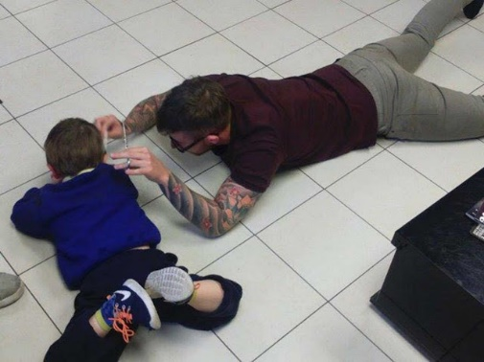
James Williams is a barber from Talbot, UK. He has been trying unsuccessfully to cut the hair of Mason, who was diagnosed with Autistic Spectrum Condition a few months ago. Mason gets upset when he has his hair cut and this photo shows the first time he has managed to get a proper hair cut, because the James has persevered and found a way to do it.

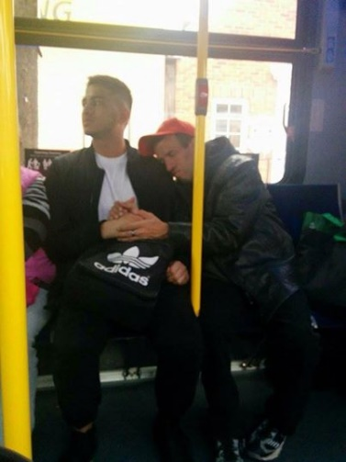
Godfrey Cuotto a 21 year old student from Ontario, Canada, was on his way home from work when a stranger approached him and asked to shake his hand. Godfrey realised the man needed comfort and sat for a thirty minute journey holding his hand while the man leaned against him. Godfrey later found out the man. called Robert, had cerebral palsey and was deaf.
Fellow passengers praised Godfrey and tweeted the picture. Godfrey later told a radio station, "Sometimes you have to be selfless and put someone else's needs above yours".
Plenary: Return to original question – do we want to change our definition of community? How do we build a strong community, why is it our responsibility?

Lesson plan 5d Respectful relationships
Aim: I know what my rights and responsibilities are towards sustaining the environment.
RSE link: that in school and in wider society they can expect to be treated with respect by others, and that in turn they should show due respect to others, including those in positions of authority.
Enquiry question: Is Greta Thunberg right?
Starter: Show a picture of Greta Thunberg. Who is Greta Thunberg? What is she famous for and what are her achievements? What is her aim and why?
Main: In 2018 Greta started protesting about climate change (check understanding of climate change). Watch this 3 minute clip describing how the strike came about
https://www.youtube.com/watch?v=ZOJ51zJJ6kc

discuss these Greta quotes- is she right? What do you think?
“We children aren’t being listened to or taken seriously so I and the other children decided to continue striking every Friday.”
“Why should we study for a future that may not exist?”
That’s not an achievement, to get awards. An achievement is to make change and mobilise people.”
“I felt like I had to do it there was no second option.”

Watch this excerpt from Greta Thunberg’s speech to world leaders at the United nations in 2019. https://www.youtube.com/watch?v=xVlRompc1yE

What do you think of her speech?
Why does Greta get emotional?
How do you think she makes the adults in power feel? Do you think they will change policies?

Now watch Russian Prime Minister Vladimir Putin’s response to Greta Thunberg. Before watching predict what his response will be.
https://www.youtube.com/watch?v=1CnyqLogH0Y&t=12s (watch up to 1.00)

“When somebody uses children in teenagers in their own interest it deserves only to be condemned.” -what is he saying about Greta here?
“Nobody explained to Greta that the modern world is complicated.”
“Has anyone explained about the cost of solar energy in Africa?”
What is his argument solar energy in Africa? Is he taking Greta seriously?

Here is US president at the time Donald Trump responding to Greta Thunberg’ speech. Before watching it, predict how he will respond to Greta’s words.
Read out his tweet from the day after her speech: “So ridiculous. Greta must work on her anger management problems, then go to a good old fashioned movie with a friend. Chill Greta, chill.”
https://www.youtube.com/watch?v=AJRpJ3xobjA

“some people put it to a level that is unrealistic; you can’t live your lives”
“Our numbers on air are tremendous. We have to do something about other continents.”
“I think Greta needs to start working on those other countries.”
What is he saying about Greta, what is he saying about America and climate change, is he taking Greta seriously?
Activity: Select from the Greta Thunberg, Donald Trump and Vladimir Putin quotes above; choose one from each and write your response.
What do you think about Greta’s actions; is she right to continue?
Plenary: Watch this one minute film as a summary; Greta gives a message to young people – get creative and don’t underestimate yourself. What can we learn from Greta? https://www.youtube.com/watch?v=8RGbAMS2gGg

Is there a correct answer to the enquiry question?

Lesson plan 5e
Aim: I understand the role money plays in my life and the life of others. I know what is meant by ‘tax’.
RSE link: n/a
Enquiry question: why do we pay tax?
Starter: Show these words: ‘interest’ ‘loans’ and ‘debt’ and ‘tax’. Ask children to work in pairs and share what they know about these words; what are they and how do they affect adults? What is debt and how does a person get in to debt? What is a loan and what is interest and how are they related? What is tax?
Main: Show this short video of a man getting his first pay check. Before watching ask how will he feel getting his wages for the first time? https://www.youtube.com/watch?v=dApGdXs-elc
Watch the video – we see him upset because tax, national insurance etc has been deducted and he wasn’t expecting that. Ask children do they know why he is upset? What has been deducted from his wage, what for?
One friend lists what is deducted: employee medicare, social security, “You have to pay taxes every time you get paid.”
“You earned $280 but they still had to take out $21.42 in taxes which is why you have this much.”
“But if I earned this much why can’t I get it?”
“Because you have to take out federal taxes.”
His friend says, “Welcome to the real world!” what does he mean? What does this video show us about the real world?

What does tax pay for? Ask children to think about what appears to be for free in the UK – things you don’t pay for directly– bin collections; NHS; do your parent pay for you to come to school? What else? (state pensions, unemployment benefits, sickness and disability allowances) who pays for all of that? That is what tax is for.
How much tax do people pay on wages?
up to £12,500 = no tax,
£12,500 - £50,000 = 20%,
£50,000- £150,000 = 40%,
over £150,000 = 45%
Why does the tax rate go up the more you earn?
Activity: Under the heading, “Why do we pay tax?” list the services UK residents receive through tax. Children could research this themselves.
Are there other ways we could receive these services? Do you think tax is a fair way of paying?
Plenary: Do all countries pay the same amount of tax?
USA 2021 (for single person): up to $9,875 = no tax
$9876 - $40,00 = 12%
$40,000- $85,000 = 22%
Top rate of tax for $518,000 and over = 37%

In Sweden the lowest rate of tax is 29% and if you earn over £32,000 you pay between 49% and 60%.

Why are these tax amounts so different? What does the UK offer citizens through tax that US citizens do not have? A Swedish person in a Guardian article 2020 said, “I am very happy to pay high taxes because I know I am getting value for the money later on. At my children’s school lunches are free,. My daughters receive a very good education and they have great teachers.'

Year 6 Autumn term: Living in the wider world
Week 5 | I can be critical of what I see and read in the media.  RSE Being safe how to critically consider their online friendships and sources of information including awareness of the risks associated with people they have never met. | Enquiry question: what is fake news? | Lesson plan 6a
Week 6 | I understand how resources in the community are allocated and the effect this has on individuals | Enquiry question: How are resources in my community allocated | Lesson plan 6b
Week 7 | I understand how resources are allocated and the effect this has on communities and the environment. | Enquiry question: How are decisions made in government? | Lesson plan 6c
Week 8 project begins | Enterprise | Enquiry question: how do we create a business?

Lesson plan 6a
Aim: I can be critical of what I see and read in the media.
RSE link: n/a
Enquiry question: what is fake news?
Starter: Where have you heard the term fake news used?
How do fake news stories spread? Think about how social media works. Can anyone think of an example of fake news that they have seen or shared?
How can you spot fake news? Does anyone have any tips for how to check if a news story is fake?
Main: what this short CBBC video : What is fake news and how to spot it
https://www.youtube.com/watch?v=icCdAl6TvNM

Main points to discuss from the film:
- Why is fake news made up?
- What are the tips to ask yourself before sharing
- has the story been reported anywhere else?
- Is it on the radio or TV?
- Have you heard of the organisation that made it?
- Is the story on an official website you know with a .com or .co.uk web address,
- Does the photo or video look dodgy?)
- What does ‘Think before you click’ mean?

Here is a brilliant article with different amazing headlines. You can click on fake or real and the answer is revealed when you do. Do the quiz as a whole class, talk about each story and vote on whether each is fake news or not., then see if you are right.
https://www.theguardian.com/newswise/2020/mar/20/the-newswise-fake-or-real-headlines-quiz

Activity: Children make up their own fake headlines and then share tips for how to check if a headline is real.
Plenary: sometimes in answer to a question, politicians might say something is fake news; why do they do that? What are they trying to say about the question? Why do people in power sometimes say something is fake news? Are they always right about that?

Lesson plan 6b
Aim: I understand how resources in the community are allocated and the effect this has on individuals
RSE link: n/a
Enquiry question: How are resources in my community allocated
Starter: Think about resources in the community that we have used in the last month and not paid for directly. Make a list e.g. who has walked on a pavement or road? Been to school, used a crossing, visited a park, dropped litter in a bin, been out after dark and used street lights, used a Dr or hospital, used a swimming pool, a bus, a leisure centre, a library etc
How are these services paid for? Who decides what is needed?
Main: The elected council decides how to spend their budget each year in the community (check understanding of councillors).
You are now the elected councillors for your classroom; you have a budget of £1000. Give the children the costs list; in pairs or small groups their job is to allocate resources for the year. They will not be able to afford everything so they will have to decide what is most important and what they will leave out.
Activity: write up the activity – children record how they met their budget and justify what they chose to leave out.
Plenary: what are the consequences arising from the items you chose to leave out? How do you think councillors choose what to spend on when they budget for the city? How can we influence the decisions?

Classroom budget: there are 195 days in a school year
equipment
Pencils 10p each
Window cleaning £10 per clean
Rubbers 10p each
Pritt sticks £1 each
PVA glue £2.50 for a large tub
Water £2 per day
Paint brushes 10p each
Paint pots 10p each
Lighting and heating £3 per day
Paint £1 per tube of one colour
Paper £2 for 500 A4 sheets
Art paper £5 for 100 sheets
Cardboard £6 for 100 sheets
Pencil cases 50p each
Reward cakes/ drinks 30p each
Exercise books £1 each
Rulers 30p each
First aid box for year £40
Colour crayons £20 box of 100
Handwriting pens £6 box of 20
Calculators 50p each
Maths counters class box £20
Pack of 30 picture books £90
Stickers £5 pack 100 stickers
Trophy for behaviour £6
Books to teach reading £60 for 30
Visiting zoo keeper with animals £400
Sports fees (clubs, equipment) £100

Your classroom budget for the year is £1000. What will you choose to spend it on?

Lesson plan 6c
Aim: I understand how resources are allocated and the effect this has on communities and the environment.
RSE link: n/a
Enquiry question: How are decisions made in government?
Starter: show photo of Marcus Rashford – who is this? What did he do in 2020 that made him famous – what happened?
Main: There are two sides to every argument; what are the arguments around free school meals during lockdown and who should pay for them?

Look at this news report about the debate: Public and councils offer free meals to children after government refuses to fund them - BBC News https://www.youtube.com/watch?v=9h8t6u_6Xyo

Discuss these questions in pairs and feedback:
- Why do some children need free school meals in the holiday?
- How has coronavirus affected families; why are more people needing meals?
- “I feel I have to do my bit for the community”- why?

Now watch Prime Minister Boris Johnson replying to Marcus Rashford. First predict as Prime Minister, how do you think he might reply?
https://www.youtube.com/watch?v=nlyKT4GVkhw

Discuss these questions in pairs and feedback
- The Prime Minister hasn’t spoken to Marcus since June (4 months ago) why not?
- “I understand holiday hunger.. the debate is how do you deal with it?”
- “We don’t want to see children going hungry this winter.”

Activity: Children record arguments for and against the government paying for free school meals during the holiday period 2020. Children can conclude by expressing their opinion if they wish.
Plenary: Decisions like these have to be made by someone and it is not always simple. There will always be people who agree and disagree with decisions; how do you think the government decide what to do? What factors influences those decisions? How can we get involved in the decision-making process?

