Personal Development Curriculum 2020
Including RSE guidance and No Outsiders

Rationale
At Excelsior we believe passionately that our innovative Personal Development curriculum and No Outsiders ethos will give pupils the knowledge, skills and understanding they need to ead confident, healthy independent lives and to become respectful, active and responsible global citizens. Personal Development lies at the cornerstone of our MAT ethos. We are preparing children for life in modern Britain; developing and deepening their understanding of fundamental British values of democracy, individual liberty, rule of law, and mutual respect and tolerance. We believe all our children can leave our schools confident and assured of their place in this diverse and changing world.

Definition
Each child in Excelsior Trust is unique and individual, yet also belongs to a community. As they grow into citizens, children will engage with society; experience, live alongside and sometimes join different communities while retaining a sense of self. Personal Development is an umbrella term for the way in which we teach children be proud of who they are and know how they fit in the world in which they live.

The Curriculum
Following guidance from the PSHE Association, we teach Personal Development in three modules over the year: Relationships, Health and well-being, Living in the wider world. At Excelsior, we concentrate on each module for one term, providing eight lesson plans for each year group to teach during that time.
The No Outsiders lessons are embedded into the curriculum to support each module and taught throughout the year. We recommend schools also use weekly No Outsiders assembly pictures to reinforce the school-wide inclusive ethos. The Relationships module also includes a CSE (Child Sexual exploitation) lesson plan in every year group and a Domestic Violence lesson plan in Year 3 and year 6. Sex and relationships lesson plans are taught in Y3 and Year 6 during the Living in the wider world module.
We have used the RSE Guidance for September 2020 (DfE 2019) and referenced the “By the end of primary school” objectives on page 20-22 for each lesson plan. Each plan supports one of the five areas of the guidance for primary schools: Families and people who care for me; Caring friendships; Respectful relationships; Online relationships; Being safe.

By the end of primary school:
Families and people who care for me | Pupils should know  • that families are important for children growing up because they can give love, security and stability.  • the characteristics of healthy family life, commitment to each other, including in times of difficulty, protection and care for children and other family members, the importance of spending time together and sharing each other’s lives.  • that others’ families, either in school or in the wider world, sometimes look different from their family, but that they should respect those differences and know that other children’s families are also characterised by love and care.  - that stable, caring relationships, which may be of different types, are at the heart of happy families, and are important for children’s security as they grow up.  • that marriage13 represents a formal and legally recognised commitment of two people to each other which is intended to be lifelong.  • how to recognise if family relationships are making them feel unhappy or unsafe, and how to seek help or advice from others if needed.
Caring friendships | Pupils should know  - how important friendships are in making us feel happy and secure, and how people choose and make friends.  • the characteristics of friendships, including mutual respect, truthfulness, trustworthiness, loyalty, kindness, generosity, trust, sharing interests and experiences and support with problems and difficulties.  • that healthy friendships are positive and welcoming towards others, and do not make others feel lonely or excluded.  • that most friendships have ups and downs, and that these can often be worked through so that the friendship is repaired or even strengthened, and that resorting to violence is never right.  • how to recognise who to trust and who not to trust, how to judge when a friendship is making them feel unhappy or uncomfortable, managing conflict, how to manage these situations and how to seek help or advice from others, if needed.
Respectful relationships | Pupils should know  the importance of respecting others, even when they are very different from them (for example, physically, in character, personality or backgrounds), or make different choices or have different preferences or beliefs.  • practical steps they can take in a range of different contexts to improve or support respectful relationships.  • the conventions of courtesy and manners.  • the importance of self-respect and how this links to their own happiness.  • that in school and in wider society they can expect to be treated with respect by others, and that in turn they should show due respect to others, including those in positions of authority.  - about different types of bullying (including cyberbullying), the impact of bullying, responsibilities of bystanders (primarily reporting bullying to an adult) and how to get help.  • what a stereotype is, and how stereotypes can be unfair, negative or destructive.  • the importance of permission-seeking and giving in relationships with friends, peers and adults.
Online relationships | Pupils should know  - that people sometimes behave differently online, including by pretending to be someone they are not.  • that the same principles apply to online relationships as to face-to-face relationships, including the importance of respect for others online including when we are anonymous.  • the rules and principles for keeping safe online, how to recognise risks, harmful content and contact, and how to report them.  • how to critically consider their online friendships and sources of information including awareness of the risks associated with people they have never met.  • how information and data is shared and used online.
Being safe | Pupils should know  - what sorts of boundaries are appropriate in friendships with peers and others (including in a digital context).  • about the concept of privacy and the implications of it for both children and adults; including that it is not always right to keep secrets if they relate to being safe.  • that each person’s body belongs to them, and the differences between appropriate and inappropriate or unsafe physical, and other, contact.  • how to respond safely and appropriately to adults they may encounter (in all contexts, including online) whom they do not know.  - how to recognise and report feelings of being unsafe or feeling bad about any adult.  • how to ask for advice or help for themselves or others, and to keep trying until they are heard.  • how to report concerns or abuse, and the vocabulary and confidence needed to do so  • where to get advice e.g. family, school and/or other sources

The No Outsiders lesson plans listed here are found in “No Outsides in our school: Everyone different, everyone welcome” by Andrew Moffat (Speechmark, 2020)
Andrew Moffat is available for CPD training on No Outsiders and Personal Development. Please email a.moffat@excelsiormat.org for further details and information.

Year 1 Autumn term: Relationships
Week 1 | No Outsiders in a Faith Community
Week 2 | Caring friendships  To understand how to share feelings | I can share how I feel | Lesson plan 1a
Week 3 | Being safe  To understand the importance of not keeping secrets that make them feel uncomfortable/ CSE | To know parts of my body which are private  Some parts are not for sharing – Julie K Federico | lesson plan 1b
Week 4 | Families and people who care for me  To recognise special people in their lives  RSE: that families are important for children growing up because they can give love, security and stability. | I can tell you about special people in my life | Lesson plan 1c
Week 5 | No Outsiders in a Faith Community
Week 6 | Respectful relationships  To share views and opinions with others | To agree and disagree | Lesson plan 1d
Week 7 | Respectful relationships  To show respect for other people | To show respect for other people | Lesson plan 1e

Year 1 Autumn term: Relationships
Lesson plan 1a: Caring friendships
Aim: To understand how to share feelings
LO I can share how I feel
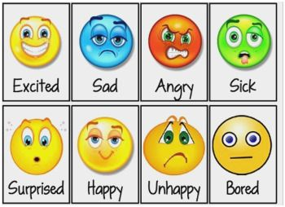
Show the feelings poster https://www.pinterest.co.uk/pin/530228556126913655/
What feelings do the children recognise? Has anyone felt like this? Choose a feeling and talk to your partner about a time you experienced this feeling.
Main: Watch “Inside out: guessing the feelings” https://www.youtube.com/watch?v=dOkyKyVFnSs
Play along, children to guess the feelings shown.
Can anyone act out a feeling so the class can guess? Ask a volunteer to act out one of the feelings on the poster so children can guess.
Activity: Children chose and record four of the feelings faces. Write a sentence about a time they experienced that feeling.
Plenary: Why is it good to talk about your feelings? If you share with someone how you feel, what can they do? What can we do in our class to help people share feelings? What can we say- “Are you ok?” Rehearse asking someone “Are you ok?” or, “How are you feeling?”

Year 1 Autumn term: Relationships
Lesson plan 1b: Being safe
Text: Some parts are not for sharing – Julie K Federico
Aim: To understand the importance of not keeping secrets that make them feel uncomfortable/ CSE
LO: To know parts of my body which are private

Starter: Starter: Show a cartoon fish on the white board. In pairs children identify and name the parts of a fish e.g. head, tail, fins, gills, body, mouth, eyes etc
Main: Read “Some parts are not for sharing – Julie K Federico” ask children what is this book about?
What parts of their body do fishes share?
What parts do fishes keep private?
Why are those body parts called private?
Activity: Play “Hi Five Game”:
Children in circle teacher rattles tambourine and children move around the circle. Teacher hits tambourine and children find a partner to hi-five. Repeat, children find new hi-five partner, repeat again. Now try the game with children holding hands on the tambourine signal. Talk about how it’s ok to play a game with our hands because our hands are not private. It’s ok to share hands.
Recording: Give children two gender neutral body outlines. Children stick outlines into their books. The children record, “It’s ok to share… “ (circle hands) and “some body parts are private” (circle chest / between legs)
Plenary: If someone one asks to touch our body parts that are private, what do we do? Who can we tell? Why must we tell?
Link to Rights respecting articles.
Circle time game to promote well-being: children in circle, child crouches on floor in middle as a bear, with cup on their back, closing eyes. A child from the circle takes the cup and everyone places hands behind their back. Everyone chants, “Mt Bear, Mr Bear, who has the honey pot?”. The bear has three guesses at who has the cup behind their back.

Year 1 Autumn term: Relationships
Lesson plan 1c: Families and people who care for me
Aim: To recognise special people in their lives
LO: I can tell you about special people in my life
RSE link: that families are important for children growing up because they can give love, security and stability.
Starter: who are the people we meet every day? Make a list with the children of everyone they have spoken to today; how many people are on our list? Which of these people are important or special to us? Why?
Main: Ask children to think about who are the people that are special to us in school and out of school. Draw the class name on the board and draw a circle around it. Now think who is important or special to us in school every day? Record people the children nominate on the board around the circle with cartoons/labels (if children nominate individual children in the class, record as “friends” rather than naming people. Think about who helps us in school; cooks dinner, looks after us at different parts of the day etc,
Activity: children repeat the exercise but for people out of school. Children draw themselves inside a circle. Around the circle children record people who are special to them and why. Encourage children to think about family members or people they live with.
Plenary: Why do we have special people in our lives? Why are families important? Why do families give us? How can we be a special person to someone else?

Year 1 Autumn term: Relationships
Lesson plan 1d: Respectful relationships
Aim: To share views and opinions with others
LO: To agree and disagree
Starter: Show the children two blocks of colour on the board; red and green. Ask children which colour they prefer and count how many children prefer each. Now show a dog and a cat and ask the same; a football and a skipping rope; a car and a boat. Ask the children, do we all like the same things? Is that ok?
Main: put agree and disagree on the board; what do they mean?
Tell the children as we grow older we can have different ideas; we can change our minds and we can sometimes agree, sometimes disagree, and that’s ok/. We don’t have to think the same things.
Show the children a bowl of jelly babies and a bowl of Maltesers. Tell them you think one of the sweets is the best and give a reason why. Ask if any child disagrees; they should say, “I disagree because….” and encourage the other children to join in with their opinions; “I agree with ____/ I disagree with _____ because….”

Activity: Give the children a choice of four pictures of cakes. Show the children four piles of photos, one pile for each cake photo, for example, chocolate, jelly, sponge, fruit. Follow these instructions:
- Children to come to the front one at a time and choose the cake they want by taking a photo from the pile.
- Children sit in a circle holding their cake photo so the image is hidden.
- The first child stands up; their job is to ask a child if they agree or disagree with their choice of cake. They should approach a child and say, “The best cake is ______,do you agree” that child will then hold up their photo and say either, “I agree” or, “I disagree”. Those children then sit together.
- Repeat till every child has a partner.
Recording: Children record with their partner, “My favourite cake is _____ and (name) agrees / disagrees.” And stick photo into their book, while drawing a picture of their partner’s cake.
Plenary: Show that as a class we are agreeing and disagreeing, and that’s a good thing. It’s to disagree about cake because there is no right or wrong answer, we can talk about it and we might change our minds but no one is wrong, we just disagree.

Year 1 Autumn term: Relationships
Lesson plan 1e: Respectful relationships
Aim: Valuing difference
LO: To show respect for other people
Starter: what does respect mean? How do we show respect in our class?
Main: Watch Sesame street respect Word on the street. https://www.youtube.com/watch?v=GOzrAK4gOSo
Pause after the big bad wolf section and discuss:
- What was the big bad wolf doing that was not showing respect?
- What did the wolf learn?
- Why did the wolf give the piggies a cake, do you have to give a cake to show respect?
- How do you think wolf will change their behaviour?
Watch the chicken song and discuss:
- The chickens say, “Respect is when you treat people fair; make them feel important and you show then that you care” what does that mean?
- Pause after the bear says, “how do you do that?” and ask the children to come up with an answer before playing the rest of the song
Watch the Global thingy and then discuss:
- Why were the animals upset with the phone?
- At the end, how did everyone start to show respect?
Watch the final section, then ask the children the same questions:
- What is respect?
- Who do you show respect to?
Activity: Recap how the big bad wolf changed their behaviour. Show the big bad wolf at the door of the piggies house showing respect rather than blowing their house down. Record a sentence to explain what is happening.
Plenary: Why is respect important? How can we show respect to each other in our class? Come up with three examples of actions we can do every day that demonstrate respect.
How does this link to No Outsiders?

Year 2 Autumn term: Relationships
Week 1 | No Outsiders in a Faith Community
Week 2 | Caring friendships  To recognise different types of behaviour | I can recognise different behaviours | Lesson plan 2a
Week 3 | Caring friendships  To understand that bodies and feelings can be hurt | I know how feelings can be hurt | Lesson plan 2b
Week 4 | Being safe  To understand the difference between appropriate and inappropriate touch/  CSE | To choose when to share my body  Your body belongs to you- Cornelia Spelman | Lesson plan 2c
Week 5 | No Outsiders in a Faith Community
Week 6 | Respectful relationships  To understand that bullying and teasing is hurtful (and what to do if it happens) | I know how to be a good friend | Lesson plan 2d
Week 7 | Respectful relationships  To understand how to share views and opinions with others  RSE: practical steps they can take in a range of different contexts to improve or support respectful relationships. | I can share my opinion | Lesson plan 2e

Year 2 Autumn term: Relationships
Lesson plan 2a: Caring friendships
Aim: To recognise different types of behaviour
LO: I can recognise different behaviours
Starter: write “behaviour” on the board. Ask children to nominate ‘safe’ and ‘unsafe’ behaviour and record on the board under the appropriate heading
Main: watch Animated short film: getting angry https://www.youtube.com/watch?v=8vzSckg8jk8
And discuss:
- What were the different feelings shown in the film?
- What were the different behaviours?
- What is the difference between a feeling and a behaviour?
- Why did the child get angry
- How could you tell they were angry?
- What do you think the child learned at the end of the story?
Activity: watch the film again up to the point where the child first starts to get angry. Ask for a volunteer to be the child in the film and to act out the part of the film where they start to get angry. Pause the action: what else could the child do other than get angry? What do they need? Has anyone got an idea for how to help the situation? Ask another child to enter the role play and help. Discuss how they helped/ what they said/ what was the effect?
Recording: Children record an image of the child in the film getting angry. Then record another image of someone helping; what are they saying? Show in your recording how to help someone calm down.
Plenary: if you see someone getting angry, what is a good first line to help? (“are you ok?”) why is that a good opening line. The title of the video is “Do not be angry”; is that a god thing to say to someone who is angry? Why not? What is a better thing to say?

Lesson plan 2b: Caring friendships
Aim: To understand that bodies and feelings can be hurt
LO: I know how feelings can be hurt
Starter: use this image
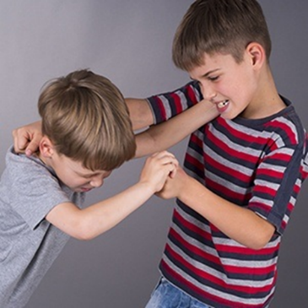
Discuss with the children what they see in the image; what is happening? Describe the feelings in the picture; is anyone being hurt?
Main: Contrast the first image with this image, showing them side by side
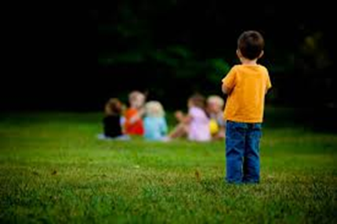
What is the difference in the two pictures? Which children in the pictures are being hurt? How are they being hurt? Does the hurt feel the same?
Activity: Talk about the second picture; where is it taken? Would that happen in our school? Discuss:
- What is the child thinking?
- What needs to happen to fix this situation?
- What could the child do? Perhaps the child is too shy to approach the group, how could children in the group help?
- What could you say if you saw this child alone?
Role play the situation; recognise how the child is feeling inside, think of things you could say to help.
Recording: Use the second image as a stimulus for recording; children write how the child is feeling and what they could say/ do to help the situation.
Plenary: Look again at the two pictures together. Which picture do you think shows more hurt? Why? If you saw the first one, what would you do? If you saw the second, what would you do?

Lesson plan 2c: Being safe
Text: Your body belongs to you- Cornelia Spelman
Aim: To understand the difference between appropriate and inappropriate touch/ CSE
LO: I can choose who touches me
Starter: Show an image on the white board of two cartoon figures hugging. With a partner children make a list of people they like to hug. When was the last time you hugged someone?
Main: Read Your body belongs to you- Cornelia Spelman”.
Ask children, what is this book about?
There are lots of different ways of touching. Look at the first image of the girl and her Dad; how is this girl feeling? Is she happy for Dad to hug her? How do you know?
Look at the image of the visitor who asks for a hug- how is the little boy feeling? How do you know? Should the boy hug the visitor if he doesn’t want to? (No)
What does the book say the boy should do if he doesn’t want to hug?
Activity: Role play: Sit the children in a circle and show them a teddy bear. Explain we are going to share the teddy bear but it’s up to you whether you hug the teddy or not – you can choose whether to give a hug.
Take the teddy to a child and say, “Teddy wants a hug.” The child either takes the teddy and hugs it or says, “I don’t want a hug right now,” or, “No thank you.” The child then takes the teddy to another child in the circle who chooses whether to hug it. Continue till every child has had a turn. Children sit down when they have had a turn so that the group know who is left.
Recording: Children draw the teddy bear, on one side they write “I like a hug,” and on the other side they write, “No thanks I don’t want a hug right now.”
Underneath they write, “I can choose who I hug.”
Plenary: Why is it up to you if you want hug someone? What is someone is upset when you say no? Is it always the right thing to say yes? (No, you choose when to share your body)
Link to Rights respecting articles.

Lesson plan 2d: Respectful relationships
Aim: To understand that bullying and teasing is hurtful (and what to do if it happens)
LO: I can recognise bullying
Starter: what is teasing? Show this image
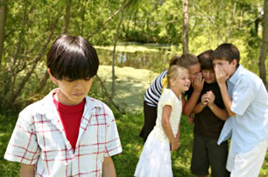
Discuss what is happening? Contrast to the image we looked at before
Which one shows teasing/ bullying? Do we know that the child in the second picture is being bullied/ teased? We know that the child in the first picture is being teased because the other children appear to be talking about them, and they are being deliberately left out/ laughed at. How are they feeling?
Main: Ask children, what is bullying?
Bullying is where one person is a target and it happens more than once. It makes a person feel like an outsider, left alone, on the outside. Both pictures show a child feeling like an outsider but only one shows teasing/ bullying. In the other the group of children may not know the child is there and may not be talking about them.
Activity: Return to the first teasing image; if we saw this happening what could we do to fix the situation? Children discuss with partners before feeding back; identify responses to the behaviour seen and write them on the board. Ensure telling an adult, approaching the child being teased to give support and approaching those doing the teasing to tell them to stop are included.
Recording: Use the teasing image as a stimulus for recording what to do if you see teasing/ bullying in our school.
Plenary: How do we make sure in our class teasing situations do not happen? Why is this lesson linked to No Outsiders? What do we say in our school about leaving people out?

Lesson plan 2e: Respectful relationships
Aim: To understand how to share views and opinions with others
RSE: practical steps they can take in a range of different contexts to improve or support respectful relationships.
LO: I can share my opinion
Starter: what is an opinion? Do we have to always agree? Can you disagree and still be friends?
Main: tell the children we are going to play a game called, “Would you rather?” In this game you are going to ask children to share their opinion on a choice, and we are all going to get a turn. Play the film Would you rather questions for kids https://www.youtube.com/watch?v=8-tNnGErKKo
Nominate at random a different child to answer each question and pause the video after each one to give the child time to consider and answer; they could give reasons for their choice as an extension. For some of the answers, ask the class if anyone has a different opinion and congratulate both children for sharing their opinions sensibly; it’s ok to disagree- we can still be friends!
Activity: Children choose one of the questions from the video and record it with their answer, giving a reason for their choice.
Plenary: Today we were showing respect towards one another; how were we doing this? (listening, sharing answers, accepting different answers)
Say you enjoyed this lesson because it was interesting to hear different children share their opinions. What you especially like about this class is that we all have different opinions and choices, but we always make sure we are still friends and on one is left out; we show respect to each other.

Year 3 Autumn term: Relationship plans
Week 1 | No Outsiders in a Faith Community
Week 2 | Respectful relationships  To understand how to recognise bullying | To recognise bullying  This is our house by Michael Rosen | Lesson plan 3a
Week 3 | Being safe  To recognise appropriate and inappropriate touch /CSE | To know what to do if I don’t like a touch | Lesson 3b
Week 4 | Families and people who care for us  RSE: that stable, caring relationships, which may be of different types, are at the heart of happy families, and are important for children’s security as they grow up. | To explore caring relationships  Our Twitchy by Kes Gray | Lesson 3c /3d
Week 5 | No Outsiders in a Faith Community
Week 6 | Being safe  To understand both bodies and feelings can be hurt/ Domestic Violence | To recognise safe and unsafe behaviour Marvin gets mad- Joseph Theobold | Lesson plan 3e
Week 7 | Families and people who care for us  To recognise different types of relationships: friends, relatives, family | To consider different types of relationships | Lesson plan 3e
Week 8 | Caring friendships  RSE: that most friendships have ups and downs, and that these can often be worked through so that the friendship is repaired or even strengthened, and that resorting to violence is never right. | To explore what makes a friendship | Lesson plan 3f

Year 3 Autumn term: Relationship plans

Lesson plan 3a: Respectful relationships
Aim: To understand how to recognise bullying
LO: To recognise bullying
Starter: show a photo of the class. Discuss what a brilliant photo of diversity this photo is (all classes have diversity other than race/ religion; look for ways we are different and embrace those differences; glasses, freckles, hair, language, families, disabilities, different journeys to school in the morning, talents, ‘X is good at this, Y is good at that’) reinforce how boring life would be if we were all the same and that you really like this class and everyone in it.
Main: Recap “This is our house”; what does George understand about diversity and difference? Is George a bully?
Define what a bully is: a bully makes someone a target repeatedly making them unhappy.
In the story, does George target the same person more than once? (No)
What would be different about George’s behaviour if he were bullying a child? Read a couple of the pages and ask children to change George’s language to demonstrate bullying (George would target one child, leaving them out and inviting everyone else in. So if George said, “This house is not for you because you’re a girl, but everyone else can come in” and did it again the following day, and again the next day, then Georges behaviour becomes bullying.
Main: There is one person targeted at the end of the story in a situation that could be seen as bullying. Ask the children if they can identify which child is bullied in the story. Is there anyone who is targeted by a group of children, made to feel like they are an outsider? Who is left out by all the children at the end of the story and targeted because of his difference? (George)
Show the page where George is left out. Why is this bullying? (because many children join in making one child feel like an outsider) Discuss: Are the children right to do this?
Recording: show the page on the board where George is left out; “This house isn’t for people with red hair,” said Charlene.
Children record the page and then write a paragraph to explain whether they think the children in the story were right to take that action or not, giving their reasons. Explain to the class that there is no right or wrong answer here; this is a chance for children to make a choice and give their opinion.
Plenary: Why do you think the author chose to make George a victim at the end of the story? (to show that anyone can be a victim of bullying and we all have differences)

Lesson plan 3b: Being safe
Aim: To recognise appropriate and inappropriate touch /CSE
LO: To know what to do if I don’t like a touch
Starter: With a partner make a list of ways we touch each other in school that are safe. E.g. playground chasing games, lining up, PE
Main: Read “It’s my body” by Lory Freeman. Ask children, what is this book about?
Who does the child like to share their body with? How do they share their body?
What doesn’t the child like? Why not?
What does the child say when they don’t wish to be touched? (Don’t touch me, I don’t like it)
Role play: We need to be confident about telling someone we don’t want to be touched so we are going to practice. Ask for a volunteer and explain their aim is to approach people in a game, but say that the volunteer doesn’t realise the other children don’t like being touched. The other children have to tell the volunteer as they are approached. The Volunteer can choose who in the circle to approach first; the volunteer calls their name as he/ she walks towards them but before they reach the child, the child should say “Don’t touch me I don’t like it!” and then give a different name for the child to walk towards. Once a child has been “touched” they should sit down so that we know who is yet to have a turn. Everyone should have a turn at being called and saying the line.
Recording: Give children copies of some of the four images where the child doesn’t like being touched. Children write “Don’t touch me I don’t like it” or another answer underneath each.
Plenary: Are there some parts of the body that are private? Where are they? In our game we were pretending to touch but in real life if someone asks top touch the private parts of your body what should you say and what should you do? Who can you talk to if you are worried?
Link to Rights respecting articles.

Lesson plan 3c: Families and people who care for us
Text: Our twitchy by Kes Gray https://www.youtube.com/watch?v=5MAxleu-yFM&t=21s
Aim: RSE: that stable, caring relationships, which may be of different types, are at the heart of happy families, and are important for children’s security as they grow up.
LO: To explore caring relationships
Starter: What are families for? What does a family look like? Do people in the same family always look the same?
Main: Read Our Twitchy by Kes Gray. Discuss what is the story about?
There are lots of real-life stories of animals adopting other animals and looking after them. The following pictures were taken from this website https://brightside.me/wonder-animals/18-kind-animals-that-adopted-other-species-572260/ where you can find out more about the animals and other stories. See worksheets 3d, children can match animal families to their names. How are these animal families related to the story of Our Twitchy?
Recording: answer the following questions:
- Why is Twitchy in a family with Milfoil and Sedge?
- Why do you think Milfoil and Sedge never told Twitchy about this?
- Why didn’t Twitchy notice mum and dad were so different?
- Why does Twitchy run away and try to change the way he looks?
- Do you think Milfoil and Sedge want Twitchy to change? Explain your answer.
- At the end they feel more like a family than ever before. Why?
Plenary: what is the name when a family bring up a child who has a different mum at the start of their life? What other kinds of families are there? What is the most important thing in a family?

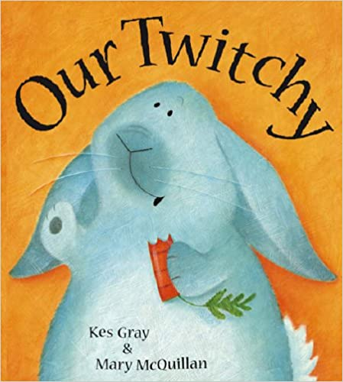 2004, Red Fox books

worksheet 3d
Look at the photos below, what do you see? Read the labels in the box on the next page and write the names of the animals below their photo.
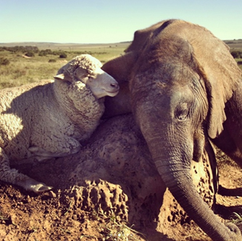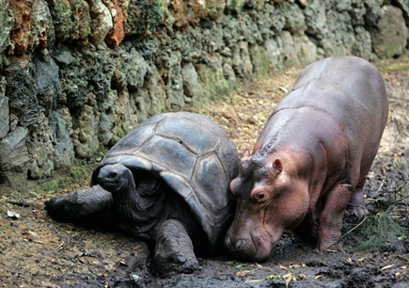

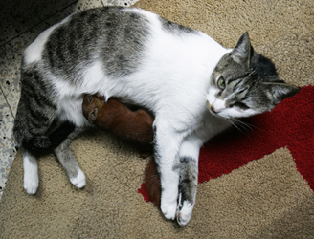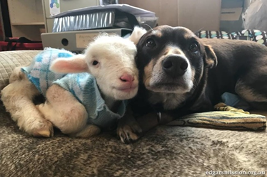

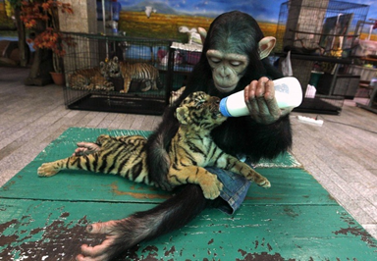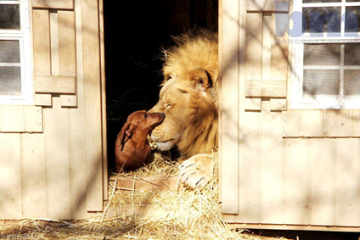
Dodo the chimpanzee and Aorn the tiger
Tita the cat and a squirrel
Bonedigger the lion and Milo the dachshund
Owen the hippo and Mzee the turtle
Albert the sheep and Themba the elephant
Ruby the dog and a sheep
Lesson plan 3e: Being safe
Aim: Feelings and emotions
To understand both bodies and feelings can be hurt/ Domestic Violence
LO: To recognise safe and unsafe behaviour
Starter: Put words on the board: safe and unsafe. Children discuss in pairs behaviours that are safe and behaviours that are unsafe
Main: Read” When Marvin gets mad”. Why did Marvin get mad? Look at his face when he says, “I want that apple!” how do you know he is mad? Focus on the page where there are 4 pictures- he stamped on the flowers etc; take each one and ask the children what the consequences are for each action. Try and get away from, “He’ll get told off”, think what happens to the hens when he knocks over the hen house. How is his behaviour making the other animals feel? Is his behaviour safe or unsafe? If the other animals are afraid when Marvin gets mad, what is the best thing to do; tell him to stop or find a safe place to wait?
Discussion: Usually we use this book to talk about how to calm ourselves down, but what can you do if someone else is being unsafe and making you feel afraid? Look at the page where Marvin frightens the animals. What do the hens and ducks do? (move out of the way) Why don’t the hens and ducks stand up to Marvin and tell him to stop? (Marvin is bigger than them, they will get hurt). The ducks and hens have decided Marvin’s behaviour is unsafe and they are moving out of his way until he calms down.
Is this a sensible thing to do? Why? How do you know if it is safe to stay and help Marvin calm down?
Has Molly, Marvin’s best friend, stayed around? Why not?
Look at the page where Marvin is shouting “Baaaaa!” where are the other sheep? Why are they keeping away?
Molly does talk to Marvin later; when does she talk to him? Why does she wait?
Recording: Write a letter to Marvin from Molly telling him that his behaviour is unsafe and you don’t like it. Explain how it makes you feel and say why you won’t stay with him to calm him down if it happens again. Tell Marvin what you want him to do next time he feels angry
Plenary: Is it ok for Marvin to hurt people? No it is not ok! We don’t see what happens at the end of the story when Marvin can’t reach a pear, but look at Molly’s face – what is she thinking? Is Marvin’s anger and violence acceptable? What do you think Molly will do if he continues to behave in a way that is unsafe? What advice would you give to Molly? Next time you see someone angry, what are you going to do? Where ios a dsafe place at school? Where is a safe place at home? If you feel worried about someone being angry or behaving in a way that is unsafe, what should you do? Talk to someone! Who can you talk to? Why should you talk?

Lesson plan 3e: Families and people who care for us
Aim: To recognise different types of relationships: friends, relatives, family
LO: To consider different types of relationships
Starter: Put the word ‘family’ on the board; children to work together to come up with a definition of family. Feedback definitions to class
Main: show this picture: what do we see?
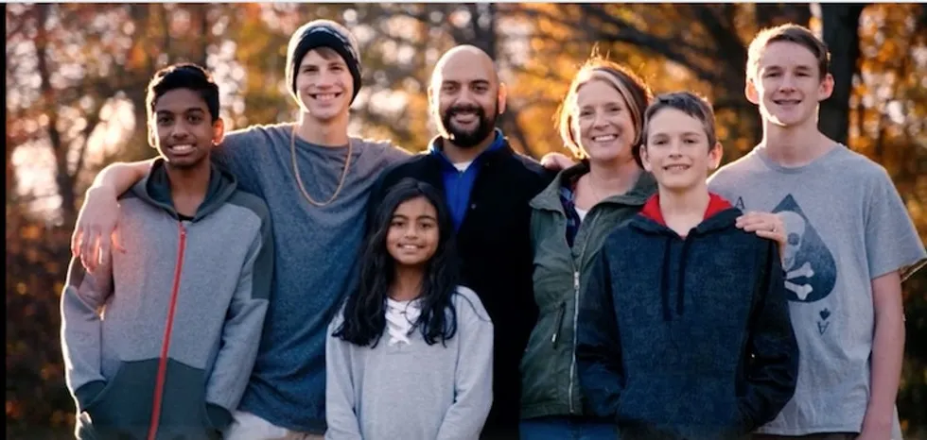
This is the Ahmed family; what do you notice about them? (all different race; so how are they a family?)
Faquir Ahmed had two children from a previous marriage; Ojeyo (13) and Megha (10). Faquir met Chayney Jennigan and they got married. Chayney also has three children from a previous marriage; Khy (18), Kayden (14) and Cooper (13) so now everyone lives as one family together. Do all families have to look the same?
When Chaney and Faquir got married they told their children, “us getting married is gaining additional people to love you.”
Faquir is Muslim, Christian, and the members of the family are different race. Chaney says, “Our family is all jumbled up in a good way.” Ojeyo says, “Our skin tones don’t match but it doesn’t matter, we’re a family.”
https://www.upworthy.com/this-blended-family-is-nothing-like-the-bradys-that-s-more-than-fine-with-them?c=hpstream
Look at this photo:
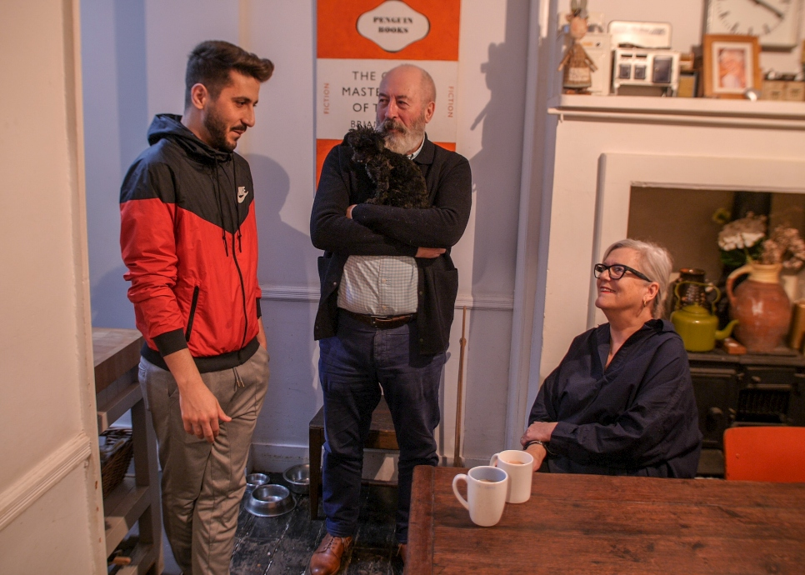
What do you see? Is this a family? What do you think the situation might be here?
Eid Aljazairli is from Damascus and arrived in the UK as a refugee. He now lives with Debbie Bliss lives in East London and heard about Eid learning to swim and training every day for the Olympics. She gave him a room in her house and raised money to help him train.
https://www.unhcr.org/news/latest/2019/1/5c3c6e054/syrian-refugee-strives-to-make-a-splash-at-tokyo-olympics.html
Is this a family? What is the difference? Do you think it feels like a family for Eid? What about the family Eid grew up in? Can you have two families?
Recording: Put three headings on the board: family, relatives, friends. Children to split the page in to three and record examples in each box; who are in your family, who are your relatives, who are your friends. Give a definition for each word.
Plenary: Author Harper Lee once said, “You can choose your friends but you sho’ can’t choose your family,” what does this mean? As you get older, what choices do you have about friends and family? How are new families formed? What is the most important thing in a family? (love, support, being there for each other)

Lesson plan 3f: Caring friendships
Aim: RSE: that most friendships have ups and downs, and that these can often be worked through so that the friendship is repaired or even strengthened, and
LO: To explore what makes a friendship
Starter: Show the children a large saucepan and say today we are going to make soup together. Show the class different sized jugs and measuring instruments. What are they for? Why are they different sizes? Has anyone made sup before? How did they make it? explain today we are going to make Friendship soup and decide what needs to go in it.
Main: watch Video lesson - Friendship soup recipe https://www.youtube.com/watch?v=H7w7yXkJTu0
Stop at 0.39 “tell me what to add” ask children in pairs to come up with ideas – what do you need to be a good friend?
Feedback and then watch the rest of the film, recording on flip chart the ingredients as you go along.
At the end look at the suggested ingredients. Why are the measurements different, some larger than others? Why is “arguments” in the mix? Why only a teaspoon? Can friends have arguments?
Recording: Children record their own friendship soup recipe.
Plenary: Consider how friends work through arguments? If you break friends, can you make friends again? How? What tips would you give someone who broke friends? Children record tips under their recipes.

Year 4 Autumn term: Relationships
Week 1 | No Outsiders in a Faith Community
Week 2 | Being safe  CSE To understand the concept of ‘keeping a secret’ and when it is and isn’t appropriate | To define a ‘good secret’ and a ‘bad secret’ | Lesson plan 4a
Week 3 | Respectful relationships  RSE: the importance of permission-seeking and giving in relationships with friends, peers and adults.  The conventions of courtesy and manners. | To explore and understand courtesy | Lesson plan 4b
Week 4 | Being safe  To understand what physical contact is acceptable and unacceptable/ CSE | To recognise an uh-oh feeling No Tresspassing- This is my body! – Pattie Fitzgerald | Lesson plan 4c
Week 5 | No Outsiders in a Faith Community
Week 6 | Respectful relationships  To develop strategies to solve conflict and dispute | I have skills to solve conflict | Lesson plan 4d
Week 7 | Respectful relationships  To be able to listen and respond to a wide range of people | I understand there are different points of view | Lesson plan 4e
Week 8 | Respectful relationships  To feel confident to raise and express their own concerns | I can express my own opinion | Lesson plan 4f

Year 4 Autumn term: Relationships
Lesson plan 4a: Being safe
Aim: To understand the concept of ‘keeping a secret’ and when it is and isn’t appropriate
LO: To define a ‘good secret’ and a ‘bad secret’
Starter: what is a secret for? Sometimes secrets are exciting; have you ever been asked to keep an exciting secret (e.g. surprise party)?How did it feel to hold that secret inside?
Are all secrets ‘good secrets’? When might a secret be a ‘bad secret’?
Main: watch “Good secret bad secret – boys” https://www.youtube.com/watch?v=hYlUT5CBXCo
After the film discuss:
- Why was Kevin moody?
- How did the boy help Kevin? (asking “What’s the matter?”
- How does the boy explain ‘good secrets’ and ‘bad secrets’?
- What advice does the boy give? (“tell an adult you trust”) why is this good advice?
- The boys feel brave, safe and strong at the end – how?
Activity: Copy the following statements on to cards and put them face down. Ask a child to pick a card and read it out, before deciding whether these are secrets you should share or not; are they good secrets or bad secrets? Does the class agree?
- We are having a surprise party for my Nan
- My brother keeps hurting me
- My parents are getting a divorce
- I have a new online friend and I am going to meet them tomorrow
- I am moving house
- My Mum is going to have a baby
- My sister keeps taking all my pocket money. She says if I tell she will hurt me
- My Mums friend hugs me and tells me it’s our secret
- We are getting a big cake for my Mum. It’s a surprise!
Recording: Under headings “Good secret”/ “Bad secret” children record examples. Children then write the name of their trusted adults.
Plenary: What can we learn from the boy speaking in the film? When his friend is moody, what is his response? What makes him a good friend?
Remind the children that you can be a trusted adult if anyone is every worried about something; you want to make sure that we are all brave, safe and strong in our class.

Lesson plan 4b Respectful relationships
Aim: RSE: the importance of permission-seeking and giving in relationships with friends, peers and adults.
The conventions of courtesy and manners.
LO: To explore and understand courtesy
Starter: write the following words on the board, discuss and define them: manners / courtesy. Why do we have manners? Can anyone give an example of manners and courtesy that we have in our classroom? If we didn’t have any manners in our classroom, what would it be like as a place to learn?
Main: Explain we are going to watch a short video about manners and etiquette at the dining table – explain what etiquette means (a way of behaving politely). Ask children first to predict the top 5 tips that are going to be discussed, then watch William Hanson Top 5 tips for flawless dining. https://www.youtube.com/watch?v=zuUtiR91Geg

Discuss the five tips: why do you think William Hanson has chosen these? Are there any ore you can think of? What about talking with your mouth full, or leaving the table while others are eating, or saying “Thank you” to the person who cooked it
- Wait for others
- Offer to others first
- Resting position
- No phones
- Finished position
Activity: in small groups prepare a five minute presentation based on William Hanson’s video but with the topic, “Five tips for flawless classroom” check understanding of “Flawless”. Children could discuss topics like sharing equipment, entering and leaving the classroom, lining up, asking for help (putting hands up) checking everyone has what they need or that everyone understands on my table, using drinking bottles (asking if anyone on your table wants a drink before getting your own bottle?) etc
Recording: Write up your 5 tips for a flawless classroom and why they are important under the title “manners and courtesy in my class”
Plenary: William Hanson says, “Good manners are selfless not selfish” what does this mean? How can we make a classroom environment that is more “selfless not selfish”? Do we want to? Why?

Lesson plan 4c: Being safe
Aim: To understand what physical contact is acceptable and unacceptable/ CSE
LO: To recognise an uh-oh feeling
Starter: In pairs children discuss safe and unsafe scenarios. How does your body react when you feel unsafe? (heart racing, clammy hands, feel sick, butterflies in stomach)
Main: Read “No Tresspassing- This is my body!”– Pattie Fitzgerald. Ask children, what is this book about?
In what ways are Katie and Kyle similar and in what ways are they different?
What is Mum’s special rule about parts of the body that are private?
Which people are allowed to check or touch the parts of your body that are private, and when? (Mum, Dad, Doctor, at bath time to help get clean, or when you are ill to check things are ok)
Explain the thumbs up and thumbs down rule. How do you know when a feeling is an uh-oh feeling, or when it’s a happy feeling?
What should you do if someone touches your parts that are private and you are worried?
Recording: give children copies of the following images from the book:
The doctor checking the girl
The man tickling the boy
The boy telling Mum and Dad and pointing
The thumbs up and thumbs down

Children stick in images and write sentences explaining what is happening and what these pictures show us about touching. The last sentence should describe what an uh-oh feeling is.
Plenary: The book is called No Trespassing – why?
Mum says an uh-oh secret should never be a secret- why?
Who can you tell if someone touched you and gives you an uh-oh feeling
We talked about what an uh-oh feeling is – check everyone understands a definition and knows what to do if they get one.
Link to Rights respecting articles

Lesson plan 4d: Respectful relationships
Aim: To develop strategies to solve conflict and dispute
LO: I have skills to solve conflict
Starter: what is conflict? Can anyone think of an example of conflict that happens in school? (no names). What strategies do we currently have to resolve conflict?
Main: This school in America made a short film to help resolve conflict, called the 5 finger rule. Watch the video Conflict resolution for kids 5 finger rule for kids https://www.youtube.com/watch?v=Z1N6uhd05kg
Discuss their solutions:
- Ignore
- Move away
- Explain
- Stop
- Teacher
What do we think of these solutions? The first is to ignore, but is ignoring always a good choice? By ignoring, does the behaviour stop? Which of the five rules do you think is most proactive and effective and should come first?
If someone is upsetting you, what is the most effective response? To tell them, “I don’t like that,” or “please stop it.”,or even, “Why are you doing that?”, “Do you want to join in? Shall we start again?” “Hello, my name is …. what’s yours?”
Role play: ask two children to role play a conflict. Give a child some lego and ask another child to approach and take over. Encourage the first child to decide on an effective resolution; they could use the 5 finger rule or choose another. The aim is to resolve the conflict without anger. Encourage children to think of / role play alternative responses.
Recording: Children record their own version of the 5 finger rule; explain each finger and give examples.
Plenary: why is conflict resolution sometimes hard? When you see children fighting, what does that show about their conflict resolution skills? How can we help more children to have better conflict resolution skills? What is a great line to help someone who looks angry? (“are you ok?”) why is that a great line to use?

Lesson plan 4e: Respectful relationships
Aim: To be able to listen and respond to a wide range of people
LO: I understand there are different points of view
Starter: what is a point of view? Where does it come from? Is there always one point of view that is right? What is the difference between a “fact” and a “point of view”? Ask children to think of an example of both.
Main: ask the children if they know the story of the three little pigs. Recall the story; who are the good guys, who is the villain? Do you think there might be a different point of view? What different points of view about this story could exist?
Read “The true story of the 3 little pigs by A. Wolf” as told to Jon Scieska. https://www.youtube.com/watch?v=vB07RfntTvw&list=PLIhseSrDronL3TTM5Vj0XNX1YEVMdSRe_

Before the children hear the story, does anyone have an idea what the different point of view might be? Look at who write the story; whose point of view is this going to be?
After the story discuss, which version of the story do you think is the truth? Are they both the truth?
Recording: children write to A.Wolf in response to his story. Children can decide whether they agree with his version of events or not. What should happen to the Wolf; he is currently in jail. Is that fair?
Plenary: Today we looked at made up stories but in real life are there different points of view? Is there anything happening in the news at this moment that people are arguing about, showing different points of view? How can you make your mind up which to believe? Watch The Guardian’s 1986 point of view advert: https://www.youtube.com/watch?v=_SsccRkLLzU
What is it about? What can we learn from this film?

Lesson plan 4f: Respectful relationships
Aim: To feel confident to raise and express their own concerns
LO: I can express my own opinion
Starter: Write the word “segregation” on the board and ask the class, “What is segregation?”
After discussion, show the class the first video:
Main: Watch “Kids talk about segregation” https://www.youtube.com/watch?v=Sff2N8rez_8 pause the video at 0:27 and check understanding of terms segregation, and also refer to the different language used in the film such as; “children of colour”. Before you go on, remind children what we say in our school about segregation. Remind children about No Outsiders but even though in our school we say there are no outsiders, not everyone in the rest of the world agrees with us. Watch the rest of the film and discuss the following questions.
Main Activity: Ask children in pairs to discuss and make notes on the following questions:
- Some children say they feel awkward because they are different. What can the school do about that?
- In our school what do we say about being different?
- How do we make sure everyone in our class feels welcome?
- “People of colour live with people of colour and white people live with white people” is this true?
- Do you think the children in the video are confident? How do you know?
- Do you think the children have been told what to say or are they expressing their own concerns? How do you know?
Recording: Think about how the children speak and write three tips for raising concerns. For example, tip No1 could be, ‘plan what you are going to say’ - do you think the children in the film did this? How do you know? Did any child falter or stumble over their words? Do the children talk about their own experience or experiences of people they know?
Write a paragraph to add to this video about segregation. Think about what we say in our school about children being different and working together. Are we proud to be different in our school? What do we say about segregation?
Plenary: How would No Outsiders help the children in the video? One of the children in the video says, “Some people might not feel comfortable around people that aren’t part of their race,” what message would you give to him about our school?

Year 5 Autumn term: Relationships
Week 1 | No Outsiders in a Faith Community
Week 2 | Being safe  CSE  RSE: how to report concerns or abuse, and the vocabulary and confidence needed to do so. | To know when to tell a secret  Some secrets should never be kept- Jayneen Sanders | Lesson plan 5a
Week 3 | Caring friendships  To recognise a range of feelings in others and have a range of strategies to help | To recognise when someone might need support | Lesson plan 5b
Week 4 | Being safe  To learn to recognise and manage dares | To recognise and manage dares | Lesson plan 5c
Week 5 | No Outsiders in a Faith Community
Week 6 | Respectful relationships  To feel confident to raise and express their own concerns | I can express my own opinion | Lesson 5d
Week 7 | Respectful relationships  To recognise and care about other people’s feelings and if necessary, challenge their point of view. | To listen and respond respectfully to a wide range of people. | Lesson 5e
Week 8 | Respectful relationships  RSE that marriage represents a formal and legally recognised commitment of two people to each other which is intended to be lifelong. | To understand different types of relationships  - arranged marriage  -marriage  - civil partnership | Lesson 5f

Lesson plan 5a: Being safe
Text: Some secrets should never be kept- Jayneen Sanders
Aim/ RSE: how to report concerns or abuse, and the vocabulary and confidence needed to do so.
LO: To know when to tell a secret
Starter: With a partner identify times where secrets are good. E.g. when planning a surprise birthday party for someone. Are there any other times secrets are good secrets?
Main: Read text. Ask children, what is this book about?
When did Alfred first think something was wrong with the way Lord Henry played?
What should Alfred have done the first time he asked Lord Henry to stop, and he was ignored?
Why didn’t Alfred use his pupil voice and speak up?
What advice would you give to Alfred at that point in the story?
Is anyone allowed to tickle or touch the parts of your body that are private?
What should you do if someone tries to?
Why do you think Lord Henry told Alfred the tickling was their secret?
Recording: Alfred feels scared to tell his Mum about the secret. On the board make a list of the reasons for this. Children write a short letter to Alfred taking each reason in turn and giving an argument for speaking up. Conclude by telling Alfred what he should do.
Plenary: Ask the children if they have any questions about the story?
If you are worried about someone making you feel unhappy, or if you hear about someone else being unsafe, what should you do?
Who can you tell at home and at school?

Lesson plan 5b: Caring friendships
Aim: To recognise feelings in others and have a range of strategies to help
LO: To recognise when someone might need support
Starter: Recap what does “mental health” mean? How do mental health affect us? Can you always tell how someone is feeling? What are the signs that someone is struggling with their mental health?
Activity: watch Talking mental health by Anna Freud NCCF https://www.youtube.com/watch?v=nCrjevx3-Js

Give the children the question sheet 5b and ask them to fill in answers as they watch the film. You might want to pause the film at certain points so children can write comments.
Then discuss the answers and thoughts about the film.
Recording: Look at the section at 2:33 “How are big feelings affecting Jay?”
Am I in a jungle?
Am I in the sea?
My head is going crazy
Come and save me.

My tummy hurts, I can’t get to sleep at night, I can’t concentrate at school,

It feels like I have a volcano inside getting hotter and hotter

Use these quotes as a stimulus for children’s own writing about big feelings or an art session.
Plenary: “I can see now that life is too big to deal with on my won”- what does this mean? What can we learn from Jay?
What can we do for someone if we think they might need support?

Talking mental health
- What is mental health about?

- Why do we need to talk about mental health?

- What are some of the small feelings we have every day?

- What can we do when small feelings are bothering us?

- How do big feelings affect our mental health?

- Describe how big feelings are affecting Jay.

- Who do Jay’s friends suggest she talks to?

- How does Jay ask for help- what words does she use?

- How can you be a good listener?

- What did jay learn about talking to someone?

Lesson plan 5c: Being safe
Aim: To learn to recognise and manage dares
LO: To recognise and manage dares
Starter: what is a dare? Sometimes dares can be fun; the ice bucket challenge is an example of a dare that, when carried out carefully, can be fun. In 2014 people around the world challenged each other to carry out the ice bucket challenge to raise money for ALS disability. Watch How the ALS ice bucket challenge started” video to show how it all started: https://www.youtube.com/watch?v=qqobbcK0R-o
Main: The ice bucket challenge was an example of a dare that some people didn’t manage carefully. Some people were hurt very badly; look at these photos where the dare went wrong
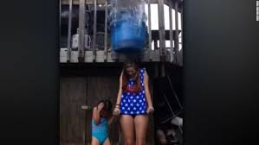
What's happening in this photo? What will happen next? When the person took the dare, were they thinking about consequences?
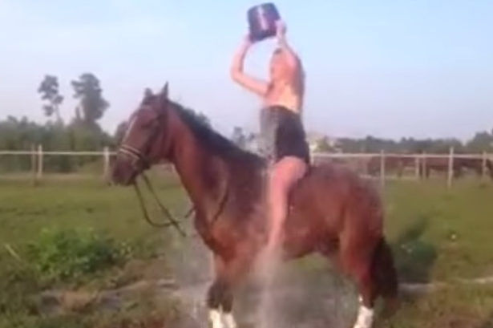
What do you think will happen next in this photo? What should the person have done differently?
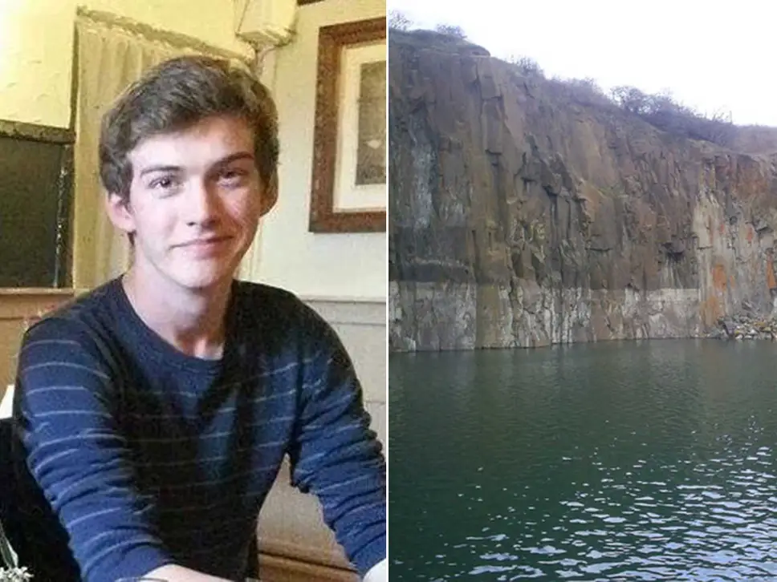
This teenager died after a suspected ice bucket challenge on the edge of a quarry. It is thought he did the challenge before jumping into the water. Why / how do you think that happened?
Millions of people were dared to do the ice bucket challenge and the challenge went well and was funny. But some people did not manage those dares.
Activity: Read “egg drop” by mini grey https://www.youtube.com/watch?v=4lxBq9nJkig
We don’t know why the egg decided to jump off the tower; was it a dare? Put the class in to pairs and say to the children they are now eggs! Label Egg A and Egg B. Egg A is going to dare Egg B to jump off the tower and fly! Egg B need to show they can manage this dare; think about the consequences and manage the decision. This is about being assertive; when you know something is a risk, you need the skills to turn it down
Recording: Create a cartoon strip for the story of egg drop showing the egg climbing the steps and convincing himself that he can do it. The last picture is the consequence.
Plenary: are all dares dangerous? How do you know if a dare is safe? What can we learn from the ice bucket photos?

Lesson plan 5d: Respectful relationships
Aim: To feel confident to raise and express their own concerns
LO: I can express my own opinion
Starter: Write the word “segregation” on the board and ask the class, “What is segregation?”
After discussion, show the class the first video:
Main: Watch “Kids talk about segregation” https://www.youtube.com/watch?v=Sff2N8rez_8 pause the video at 0:27 and check understanding of terms segregation, and also refer to the different language used in the film such as; “children of colour”. Before you go on, remind children what we say in our school about segregation. Remind children about No Outsiders but even though in our school we say there are no outsiders, not everyone in the rest of the world agrees with us. Watch the rest of the film and discuss the following questions.
Main Activity: Ask children in pairs to discuss and make notes on the following questions:
- Some children say they feel awkward because they are different. What can the school do about that?
- In our school what do we say about being different?
- How do we make sure everyone in our class feels welcome?
- “People of colour live with people of colour and white people live with white people” is this true?
- Do you think the children in the video are confident? How do you know?
- Do you think the children have been told what to say or are they expressing their own concerns? How do you know?
Recording: Think about how the children speak and write three tips for raising concerns. For example, tip No1 could be, ‘plan what you are going to say’ - do you think the children in the film did this? How do you know? Did any child falter or stumble over their words? Do the children talk about their own experience or experiences of people they know?
Write a paragraph to add to this video about segregation. Think about what we say in our school about children being different and working together. Are we proud to be different in our school? What do we say about segregation?
Plenary: How would No Outsiders help the children in the video? One of the children in the video says, “Some people might not feel comfortable around people that aren’t part of their race,” what message would you give to him about our school?

Lesson plan 5e: Respectful relationships
Aim: To recognise and care about other people’s feelings and if necessary, challenge their point of view.
LO: To listen and respond respectfully to a wide range of people.
Starter: Write “point of view” on the board. How is a point of view formed? Are babies born with a point of view about whether cats are better than dogs or what the best pizza is? How are those opinions formed? Sometimes people finish a sentence about their opinion with “FACT!” why do they say that? What is a fact? Can an opinion be a fact?
Main: How do you challenge a point of view? What is the difference between a discussion and an argument? How do you stop a discussion turning in to an argument?
Watch ‘Kid President How To disagree’ It’s an amusing film but it does have good discussion points about how to challenge a point of view, or how to disagree. As they watch the film, ask children to make notes on the five steps given by Kid President.
What do we think of the five steps? Which one is most important? Would you add any more steps?
https://www.youtube.com/watch?v=dG5fkAgJmqc
Recording: List the five steps as headings and write a paragraph for each one explaining the purpose. Extension: ask children to add one further step of their own.
The five steps are:
Treat people like they are people
Listen Listen Listen
Pause breathe love
Distract them
Acceptance
Plenary: Consider tip 4 “Distract them” why do you think Kid president included this step? Is he being serious? What is he trying to do here? How can humour affect an argument? Can anyone think of an alternative distraction to “baby koalas are awesome!”?

Lesson plan 5f: Respectful relationships
Aim: RSE that marriage represents a formal and legally recognised commitment of two people to each other which is intended to be lifelong.
LO: To understand different types of relationships arranged marriage, marriage, civil partnership
Starter: Put the pictures of weddings (see below) on the board. Ask children to discuss what they see; how are the weddings similar/ different?
main: Has anyone been to a wedding? What was it like?
What are weddings for? What different kinds of weddings can people have? Discuss the following:
Arranged marriage
Marriage
Civil partnership
What are the differences?
If children are unsure about what an arranged marriage is, watch this video: Our arranged marriage https://www.youtube.com/watch?v=yjULwNcN3nM

This news clip shows that heterosexual couples are now allowed to hold civil partnerships https://www.youtube.com/watch?v=Pl2_QKoPK_w

This video “Our wedding day” shows a wedding day in 2019. It shows the different parts of a wedding day https://www.youtube.com/watch?v=UzYRtGaFOi0

Recording: Today in the UK, who does the law say is allowed to get married? (man and a woman, woman and a woman, man and a man). Was the law always like that? How recently have gay people been allowed to marry in the UK? (2014)

Children record definitions for the three types of marriage discussed in the lesson, showing how they are different.
Then children write what each marriage has in common (a commitment).
Plenary: Do you have to get married? Do all people get married when they are older? What dos the Equality Act 2010 say about being in a marriage or civil partnership? (marriage or civil partnership is a protected characteristic – you cannot face discrimination because of your type of marriage) why do you think type of marriage is protected by law?

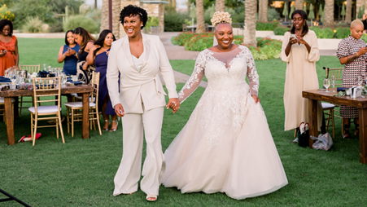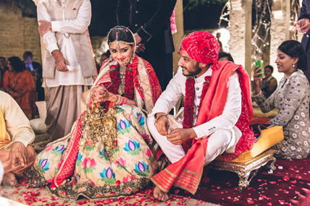

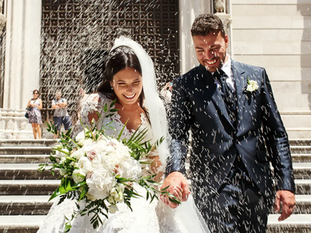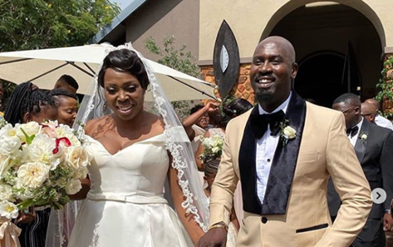
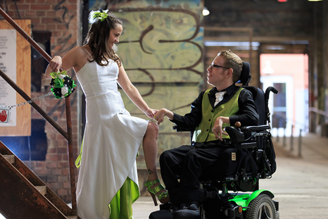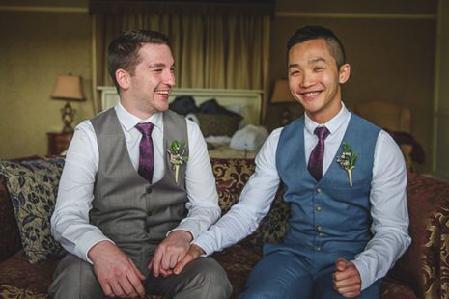
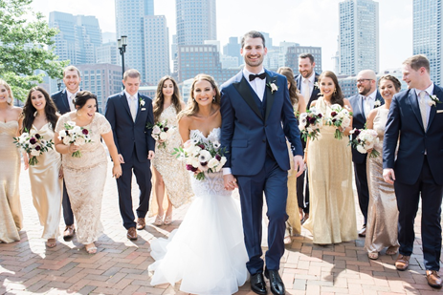

Year 6 Autumn term: Relationships
Week 1 | No Outsiders in a Faith Community
Week 2 | Being safe  Online relationships  CSE  RSE: how to respond safely and appropriately to adults they may encounter (in all contexts, including online) whom they do not know.  RSE: how to recognise who to trust and who not to trust, how to judge when a friendship is making them feel unhappy or uncomfortable, managing conflict, how to manage these situations and how to seek help or advice from others, if needed. | To understand the concept of ‘keeping a secret’ and when we should or should not agree to this.  To understand when it is the right decision to break a confidence. | Lesson plan 6a
Week 3 | Being safe  Respectful relationships  RSE: the importance of self-respect and how this links to their own happiness.  RSE: That in school and in wider society they can expect to be treated with respect by others, and that in turn they should show due respect to others, including those in positions of authority. | To have self-respect and respect others  https://www.youtube.com/watch?v=E0v_idyvjco | Lesson plan 6B
Week 4 | Being safe  Domestic violence  RSE how to recognise if family relationships are making them feel unhappy or unsafe, and how to seek help or advice from others if needed. | To recognise ways in which a relationship can be unhealthy and whom to talk to if they need support. | Lesson plan 6C
Week 5 | No Outsiders in a Faith Community
Week 6 | Respectful relationships  To understand that marriage is a commitment freely entered into by both people.  (forced marriage) | To understand that marriage is a commitment freely entered into by both people.  (forced marriage) | Lesson plan 6D
Week 7 | Being safe/ respectful relationships  Cyberbullying  RSE: that people sometimes behave differently online, including by pretending to be someone they are not  RSE: that the same principles apply to online relationships as to face-to face relationships, including the importance of respect for others online including when we are anonymous | To manage conflict | Lesson plan 6E
Week 8 | Respectful relationships  RSE: how to ask for advice or help for themselves or others, and to keep trying until they are heard. | To consider when perseverance is the right choice | Lesson plan 6F

Lesson plan 6a: Being safe / Online relationships
Text: I said no- - Zack and Kimberly King
Aim: RSE: how to respond safely and appropriately to adults they may encounter (in all contexts, including online) whom they do not know.
RSE: how to recognise who to trust and who not to trust, how to judge when a friendship is making them feel unhappy or uncomfortable, managing conflict, how to manage these situations and how to seek help or advice from others, if needed.
LO To create a safety guide for children
Starter: What do we already know about uh-oh feelings, about good and bad secrets and about parts of our bodies that are private? In pairs discuss and write a list.
Main: Read I said NO! What is this book about?
Discuss what the author means by red flags and green flags?
What sort of scenarios does the author use to describe a red flag situation?
What does the author say you should always do when you feel you are in a red flag situation?
How might someone encourage you to do something you don’t want to do? (offer sweets, money, presents, say you’re their special friend)
How do you know if a situation is a red flag situation? (when someone tells you it’s a secret- always question, why does it have to be a secret?)
Recording: In pairs children make a Red Flag safety guide. What information needs to be on this poster? Think of examples of red flag situations to include and give solutions. Include on the guide who a child can talk to
Plenary: If a child feels they are in a red flag situation, what should they do? Why do we say in our school all our children must use their pupil voice?
How does this relate to online safety?
If you are worried about something or you hear something that worries you about someone else, who can you talk to in school?

Y6 Relationships lesson plan 6B: Being safe / Respectful relationships
Aim: RSE: the importance of self-respect and how this links to their own happiness.
RSE: That in school and in wider society they can expect to be treated with respect by others, and that in turn they should show due respect to others, including those in positions of authority.
LO: To have self-respect and respect others
Starter: recap the lesson last week; what was the learning? What does transgender mean? Look at the aims of this lesson “the importance of self-respect and how this links to their own happiness” what does this mean?
Show the second aim: “That in school and in wider society they can expect to be treated with respect by others, and that in turn they should show due respect to others, including those in positions of authority.” Say you are going to show film of a child taking about their experience I school. As you watch the film, ask children to consider how it relates to the two aims.
Main: watch “Transgender teen shares powerful message” https://www.youtube.com/watch?v=E0v_idyvjco

After the film discuss how it relates to the aims of this lesson
Recording: children answer the following questions about Corey
1. What activities did Corey love to do when she was young?
2. why did Corey only do these activities in the house?
3. Should Corey’s parents have stopped Corey doing these activities? Explain your answer.
4. what was school like for Corey? How could school have done things differently?
5. Do you think home schooling was the right decision? Explain your answer.
6. Why did watching a documentary about Jaz Jennings make such a big difference to Corey?
7. “There’s nothing wrong with me, I’m transgender!” how does Corey feel?
8. What does transition mean? How did Corey transition?
9. What did Corey’s new school do differently?
10. What is Corey’s message to us?
Plenary: In the middle of the film Corey says, “I felt so stupid, like a freak, like a misfit” but at the end she says “#I am a misfit” like she is proud. What has changed for Corey? Is she proud to be a misfit? Why?
Revisit the aims of the lesson; why is Corey’s story about these aims?

Relationships Lesson plan 6C: Being safe
Text: Angry Arthur by Hiawyn Oram https://www.youtube.com/watch?v=-RIFZzmwO0E&t=16s
https://www.foyles.co.uk/witem/childrens/angry-arthur,hiawyn-oram-satoshi-kitamura-9781842707746
Aim: RSE how to recognise if family relationships are making them feel unhappy or unsafe, and how to seek help or advice from others if needed.
To recognise ways in which a relationship can be unhealthy and whom to talk to if they need support.
LO: To recognise domestic violence
Starter: What does domestic violence mean? In pairs come up with a definition and feed back to class. Come up with a class definition to check understanding.
Main: Read ‘Angry Arthur’.
Discussion: Today we‘re going to look at behaviours that are unsafe and what to do about them. Turn to the first page where Arthur’s anger destroys the front room. Has Arthur hurt anyone in this picture? Arthur may not mean to hurt anyone in the story but if you were in the room in the picture, or in the street over the page, what would you be feeling? How might you get hurt?
Arthur’s family seem calm in this story, just saying, “That’s enough,” but in real life if Arthur was an adult and he did that to a room what would happen? Is this behaviour acceptable? Is it normal? (No!)
Imagine Arthur was an adult. Do adults sometimes behave like Arthur? What is the right way for adults to solve problems? What is the wrong way for adults to solve problems?
Recording: Put children into pairs and give them copies of the people images attached. Some of these people may be behaving in a violent way in the home, some of them may be victims of violence in the home. Can you tell which is which? Arrange the images in to two columns: aggressor (check meaning) / victim. Give reasons why you are placing each person in to each column.
Discuss as a class.
In reality, any of the images could be aggressors, any of them could be victims – you can’t always tell by looking (when can you tell?). Domestic violence can happen in any family. In 2019 an estimated 2.4 million people suffered domestic violence; men can also be victims.
Plenary: No one is allowed to hurt others at home. If Arthur was an adult and he behaved like that, what could happen to him? (he could be arrested). Hurting other people in the home is an example of domestic violence- it is against the law. If Arthur was an adult he would not be allowed to hit, punch or kick people or make them frightened. What can you do if you feel unsafe at home? 1. Make yourself safe 2. Tell someone

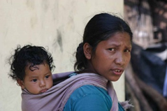
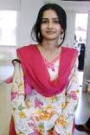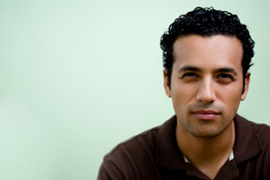
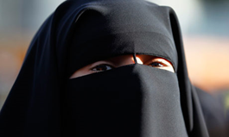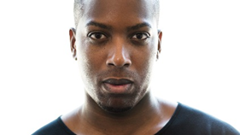

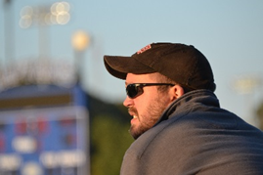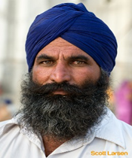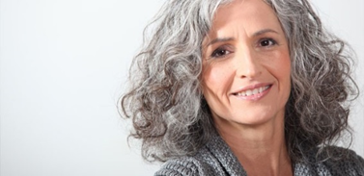

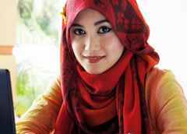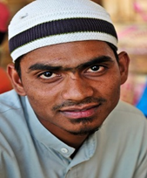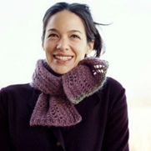

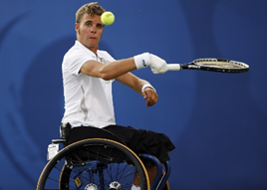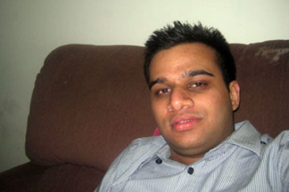

Y6 Relationships leson 6D: Respectful relationships
Aim: To understand that marriage is a commitment freely entered into by both people.
LO: To understand that marriage is a commitment freely entered into by both people.
Starter: ask the children what is forced marriage? When might a marriage be forced? What is the difference between an arranged marriage and forced marriage?
Main: Watch The wedding busters https://plan-uk.org/about/our-work/child-marriage
up to 2.14 where “Father doesn’t understand why we are ruining it.”
Put following questions on the board for children to discuss:
- How old are child brides?
- Why does Sonhita think she has to get married?
- What is Sonhita’s dream?
- Why are the ‘wedding busters’ trying to get a “child marriage-free zone”?
- What do the wedding busters do? Do you think it works? Why?

Watch the rest of the film up to 4:05 where Monufa wants to be a nurse
- How does Monufa feel about marriage?
- How does Dad feel?
- Why doesn’t anyone ask Mum?
- If parents won’t listen, what will the marriage busters do? Can they legally stop the marriage?
- How does dad change his mind?
- When Mum is asked, what does she say?

Watch the last bit of the film. First predict how many marriages have been stopped.
- Only 7 marriages have been stopped. Why is this so low?
- “It needs to be a declaration by the community” why? What does this mean?
- What do some parents do instead? Why?
- What does Sonhita say she wants for her daughter? Why?
- When girls stay in school a country does better – why?
Recording: Optional activity: write a letter to Monufa or to Monufa’s daughter saying how you feel about her situation or giving advice to the daughter.
Plenary: what does UK law say about marriage? Who can get married? How old?
Can anyone in the UK force you to get married? What does the law say?

Y6 Relationships lesson 6E: Being safe / Respectful relationships
Aim: RSE how to recognise who to trust and who not to trust, how to judge when a friendship is making them feel unhappy or uncomfortable, managing conflict, how to manage these situations and how to seek help or advice from others, if needed.
LO: To manage conflict
Starter: what is conflict? In school in our class how do you know who to trust and who not to trust (no names please). What about online? What is the difficulty with online relationships and trust?
Main 1 : Watch Nadia’s bullying story – CBBC Anti-Bullying week https://www.youtube.com/watch?v=Py9Qw7FtAVg
Stop the video at 1:22; “I didn’t know what to do”
In pairs, children discuss Nadia’s situation and come up with a plan for her. Feedback to class suggestions. Are there common solutions suggested?
Watch the rest of the video. Discuss:
- Why was it difficult for Nadia to know who to trust and who not to trust?
- Is there anything Nadia could have done differently at the beginning to avoid this?
- What do you think of Nadia’s solution? What other options were there for her?
- “I try not to let the kids at school bother me” - is the situation solved? Can it be solved?
Main 2: watch “I was cyberbullied by my best friend” CBBC Abbie’s story https://www.bbc.com/ownit/its-personal/dml-abbies-cyberbullying-story?collection=anti-bullying-week
After the video children answer the following questions:
- How did this situation begin?
- Why did Tasha make the website about Abbie? How could she have resolved this differently?
- What could the other children have done about this? What did Abbie need just one person to do?
- “For weeks and weeks she kept adding more stuff and it got more likes” why didn’t Abbie do something about this?
- How is Abbie now? Can Abbie and Tasha be frineds again? Explain your answer.
Plenary: How do we make sure this situation does not happen in our school? If you see something online about someone in your class that is meant to hurt them, what can you do? If it was about you, what would you want others to do? Why is this lesson about No Outsiders?

Y6 Relationships leson 6F: Respectful relationships
Aim: RSE: how to ask for advice or help for themselves or others, and to keep trying until they are heard.
LO: To consider when perseverance is the right choice
Starter: What is a national anthem? What is the UK natinal anthem? What is it for? Why does the person who crated this video dedicate it “to all my British brothers and sisters”?
https://www.youtube.com/watch?v=I8KSAtos-dk
Main: Does anyone know what the Canadian national anthem sounds like?
https://www.youtube.com/watch?v=kRPGPAnPNa8
who is the Canadian national anthem for? Did anyone notice in the lyrics if any group of people were left out of the national anthem? Watch again and read the lyrics: who is the song for?
The lryics to the second line are, “True patriot love in all thy sons command”; who does that miss out?
Show a picture of Frances Wright
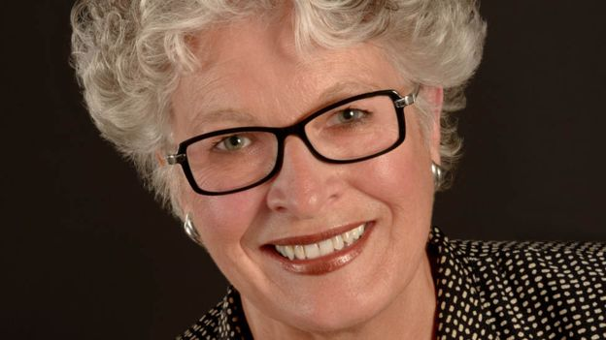
Frances Wright was a Girl Guide leader. What do you think she did about the national anthem? She got one word changed – which word do you think? (sons) why? How long do you think it took, and how do you think she did it? Did she make it on her own? Frances was one of many women and men who campaigned to make the change.
This is Vivienne Poy
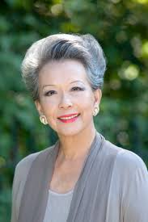
And this is Nancy Ruth
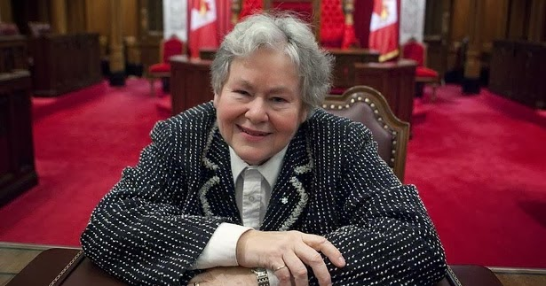
And this is Mauril Belanger
Recording: On the next page is a time line sowing how the change to the national anthem happened over 20 years. Children work in pairs to order the stages and dates.
Plenary: was it just one person who chnaged the word? What can we learn from this story about perseverence? Do you think it was significant that Justin Truideau said he was a femenist? Why? Why didn’t any of the camapigners just do the job on their own? Why didn’t they give up?

Oh Canada time line taken form this article https://www.bbc.co.uk/news/stories-42977303
This is the answer sheet. The next page is for children : children to work in pairs to have a go ordering the time line.

1880 O Canada is written but at the time the Canadian national anthem is “God save the Queen” as Canada is part of the British Empire.
1919 The ‘sons’ line is put in to the song. The original line was, “thou dost in us command.” The sons line was put in after World War 1.
1980 O Canada is proclaimed Canada’s national anthem. The government talk about changing the word “sons” but it does not happen.
(1982 Canada becomes a completely independent country )
1998 Historian Vivienne Poy starts a campaign to have the word “sons” changed. She finds out “Sons” was not in the original song.
2000 Vivienne Poy is told if they are going to change the national anthem for women, they should also change the words to include fisherman and bankers as well as soldiers.
2003 A bill to change the words almost gets a vote but one male senator deliberately wastes time, asking to speak on the issue and then refusing to say anything so that they ran out of time and the vote is abandoned.
2003 Vivienne passes the bill on to another senator to carry forward; Nancy Ruth. Nancy said, “I wanted women to be included in the song of their country. I wanted to be included in the song of my country at least once before I die.”
2013 Nancy Ruth persuades the Prime Minister to include the change in his speech at the opening of Parliament. The Prime Minister’s office gets 35,000 emails complaining about the proposals and he changes his mind.
2015 Justin Trudeau becomes prime minister; he calls himself a feminist.
2016 Nancy Ruth retires, she continues her campaign right up until the final weeks she is in office.
2016 Mauril Belanger puts forward a Bill to vote on the change. He is suffering from Amyotrophic lateral sclerosis and uses an ipad to make his speech, which ends with the words, “by the way Mr Speaker, it is 2016).
June 2016 The Bill is passed. Mauril Belanger dies two months later.

Here are 12 stages in the story of ‘O canada’. Work with a partner to put the stage in the correct order and with the correct dates. The dates are listed at the bottom of the page.
Historian Vivienne Poy starts a campaign to have the word “sons” changed. She finds out “Sons” was not in the original song.

Vivienne passes the bill on to another senator to carry forward; Nancy Ruth. Nancy said, “I wanted women to be included in the song of their country. I wanted to be included in the song of my country at least once before I die.”

The ‘sons’ line is put into the song. The original line was, “thou dost in us command.”

Justin Trudeau becomes prime minister; he calls himself a feminist.

O Canada is written but at the time the Canadian national anthem is “God save the Queen” as Canada is part of the British Empire.

The Bill is passed. Mauril Belanger dies two months later.

Vivienne Poy is told if they are going to change the national anthem for women, they should also change the words to include fisherman and bankers as well as soldiers.

Nancy Ruth persuades the Prime Minister to include the change in his speech at the opening of Parliament. The Prime Minister’s office gets 35,000 emails complaining about the proposals and he changes his mind.

A bill to change the words almost gets a vote but one male senator deliberately wastes time, asking to speak on the issue and then refusing to say anything so that they ran out of time and the vote is abandoned.

Nancy Ruth retires, she continues her campaign right up until the final weeks she is in office.

O Canada is proclaimed Canada’s national anthem. The government talk about changing the word “sons” but it does not happen.

Mauril Belanger puts forward a Bill to vote on the change. He is suffering from Amyotrophic lateral sclerosis and uses an ipad to make his speech, which ends with the words, “by the way Mr Speaker, it is 2016).

1880 1919 1980 1998 2000 2003 2003 2013 2015 2016 2016 2016

