Autumn Term  Relationships | No Outsiders in a Faith Community | Families and people who care for me | Caring Friendships | Respectful Relationships | Online relationships | Being Safe
Week/Year Group | Year 1 | Year 2 | Year 3 | Year 4 | Year 5 | Year 6
Week 1 | 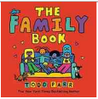  The Family Book  All families are  Different | 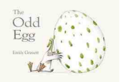  The Odd Egg | 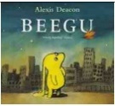  Beegu | Dogs Don’t Do Ballet | 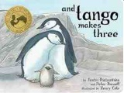  And Tango Makes  Three | Teddy
Week 2 | To understand how to share feelings  L1a | To recognise different types of behaviour  L2a | To understand how to recognise bullying  L3a | CSE To understand the concept of ‘keeping a secret’ and when it is and isn’t appropriate  L4a | CSE, RSE: how to report concerns or abuse, and the vocabulary and confidence needed to do so.  L5a | How to respond safely and appropriately to adults they may encounter (in all contexts, including online) whom they do not know.  L6a
Week 3 | To understand the importance of not keeping secrets that make them feel uncomfortable/ CSE  L1b | To understand that bodies and feelings can be hurt  L2b | To recognise appropriate and inappropriate touch /CSE  L3b | The importance of permission-seeking and giving in relationships with friends, peers and adults.  L4b | To recognise a range of feelings in others and have a range of strategies to help  L5b | The importance of self-respect and how this links to their own.  L6b
Week 4 | To recognise special people in their live  L1c | To understand the difference between appropriate and inappropriate touch/CSE  L2c | Stable, caring relationships, which may be of different types, are at the heart of happy families, and are important for children’s security as they grow up  L3c/d | To understand what physical contact is acceptable and unacceptable/ CSE  L4c | To learn to recognise and manage dares  L5c | How to recognise if family relationships are making them feel unhappy or unsafe, and how to seek help or advice from others if needed.  L6c
Week 5 | 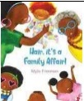  Hair, it’s a family  Affair - I am proud  of my family | 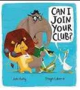  Can I join your Club | We are all wonders | 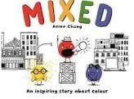  Mixed | 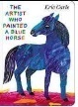  The Artist Who  Painted a Blue  Horse | 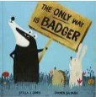  The Only Way is  Badger
Week 6 | To share views and opinions with others  L1d | To understand that bullying and teasing is hurtful (and what to do if it happens)  L2d | To understand both bodies and feelings can be hurt/ Domestic Violence  L3e | To develop strategies to solve conflict and dispute  L4d | To feel confident to raise and express their own concerns  L5d | To understand that marriage is a commitment freely entered into by both people. (forced marriage)  L6d
Week 7 | To show respect for other people  L1e | To understand how to share views and opinions with others  L2e | To recognise different types of relationships: friends, relatives, family  L3e | To be able to listen and respond to a wide range of people  L4e | To recognise and care about other people’s feelings and if necessary, challenge their point of view.  L5e | Cyberbullying  RSE: that people sometimes behave differently online, including by pretending to be someone they are not  L6e
Week 8 |  |  | Most friendships have ups and downs, and that these can often be worked through so that the friendship is repaired or even strengthened, and that resorting to violence is never right  L3f. | To feel confident to raise and express their own concerns  L4f | RSE that marriage represents a formal and legally recognised commitment of two people to each other which is intended to be lifelong.  L5f | How to ask for advice or help for themselves or others, and to keep trying until they are heard.  L6f
British Values focus  Democracy | Our Pupil Parliament | Our Governing Body | Birmingham City Council | The origins of Democracy and other systems of Governance | UK Parliament and voting systems | The Separation of Power: The Executive and The Judiciary

